Analyzing and mapping soil parameters as indicator of soil quality
Stefan Koco, PhD, NASC-SSCRI and University of Presov, Slovakia
Jozef Vilcek, Prof. PhD, NASC-SSCRI and University of Presov, Slovakia
Stanislav Torma, PhD, NASC-SSCRI, Slovakia

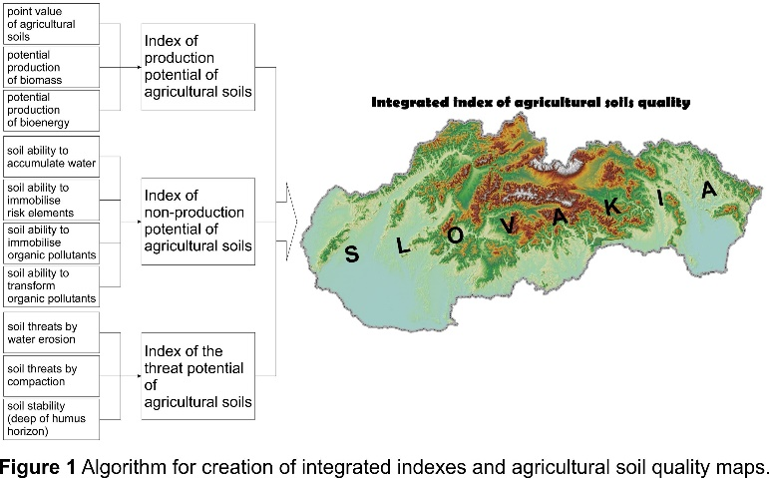
Abstract (300 word limit)
An evaluation of soil quality in terms of its benefits to society is the basis for the formulation of land use strategies, especially for agriculture land, and regional development because soil can be included among capability factors for development. On the basis of existing spatial databases and maps of soil parameters relating to production, environmental parameters and soil threat, indices of agricultural soil quality in Slovakia were developed and their distribution shown on maps. The final integrated index of soil quality was created in the GIS environment by the intersection of the above-mentioned partial indices, while preserving an equivalence rule – that is, all rated parameters had the same weight. The results show that in Slovakia 1.0% of agricultural soils are of very high quality, 30.3% are of high quality, 37.9% are of medium quality, 30.5% are of low quality and 0.3% are of very low quality. Most high-quality soils are in the lowlands and basins, which are mostly in the south of Slovakia. The result maps allow the identification of the partial indexes as well as the soil quality index for whole agricultural soil in Slovak Republic. The results are useful for agrarian landscape planning at specific sites as well as for the landscape structure management and optimization. The practical output from this result is the ability to obtain information about the quality of each agricultural soil in Slovakia.
Acknowledgements: This work was supported by the Slovak Research and Development Agency under Grant No. APVV-15-0406.

Image

Recent Publications (minimum 5)
- Andrews S S, Karlen D L, Cambardella C A (2004) The soil management assessment framework. Soil Science Society of America Journal 68: 1945-1962.
- Barančíková G, Koco Š, Makovníková j, Torma S (2010) Filter and Transport Functions of Soil. Soil Science and Conservation Research Institute: 34 (in Slovak).
- Karlen D L, Stott D E (1994) A framework for evaluating physical and chemical indicators of soil quality. SSSA Special publication 35: 53-72.
- Vilček, J, Bujnovský R, Koco Š (2010) Index of Environmental Potential of Agricultural Soils. Soil Science and Conservation Research Institute: 44 (in Slovak).
- Vilček J, Koco Š, (2018) Integrated index of agricultural soil quality in Slovakia. Journal of Maps 14 (2): 68-76.

Biography (150 word limit)
Dr. Stefan Koco, senior researcher in National Agricultural and Food Centre - Soil Science and Conservation Research Institute, Presov, Slovakia and assistant professor in University of Presov – Department of Geography and Applied Geoinformatics. He was and/or is the principal investigator of research works from the branch of soil erosion, soil organic carbon stock, soil science, soil conversation and ecology, geographic information systems and remote sensing. The results of his scientific work are presented in 5 books and brochures. He is author or co-author more than 70 original scientific papers. He is a member of Slovak Geographical Society (SGS).
Email: s.koco@vupop.sk

Notes/Comments:

