Soil quality from the point of view of nutrient transport
Stanislav Torma, PhD, National Agricultural and Food Centre, Slovakia
Stefan Koco, PhD. ¹National Agricultural and Food Centre, Slovakia; ²Presov University in Presov, Slovakia
Jozef Vilcek, Prof., PhD. ¹National Agricultural and Food Centre, Slovakia; ²Presov University in Presov, Slovakia

Abstract (300 word limit)
The transport soil function plays a dominant role in terms of transport and accumulation of substances in a vertical and horizontal direction in the soil. The aim of this paper is to evaluate the soil transport function on the base of present knowledge of nutrients (nitrogen and phosphorus) transport in the soil. The evaluation of nutrient transport consists from the vertical transport in framework of the soil profile (especially the nitrates leaching) and horizontal transport caused by locality slope (water erosion). The amount of nitrified nitrogen in the soil is very important in this case. The phosphorus transport in the soil depends on “soil volume”, e.g. it depends on the soil depth and skeleton contents in the soil and naturally on the locality slope, too. The soil transport functions were classified in five categories: (1) very weak, (2) weak, (3) moderate, (4) strong and (5) very strong. According to the soil transport function information, the areas of individual categories of soil transport function in agricultural soils in Slovakia were created. Very weak, weak and moderate transport of nitrogen was recorded in almost 90% of agricultural soils in Slovakia and in 73% of agricultural soils in case of phosphorus transport. To these categories belong the deep soils (more than 0.6 m depth) with low amounts of gravel located on plains. More than a quarter of the area belongs to the category with strong and very strong transport of phosphorus. Especially in these localities (hilly landscape with shallow soils and/or with high content of gravel) can come to increased content of phosphorus in the water bodies and thus also to a decrease in water quality.
Acknowledgments
This work was supported by the Slovak Research and Development Agency under Grant No. APVV-15-0406.

Image
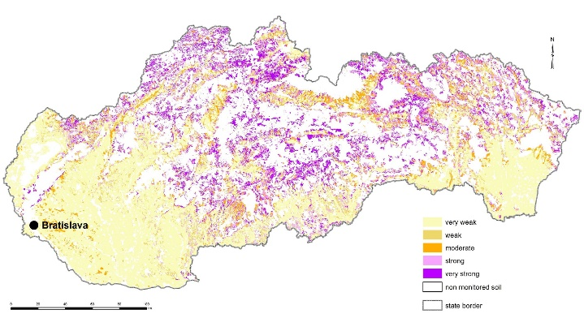

Figure 1 The soil categories of phosphorus transport in the agricultural soils in Slovakia

Recent Publications (minimum 5)
- Addiscott, TM (1996) Fertilizers and nitrate leaching. In Agricultural Chemicals and the Environment Issues; Hester, R.E., Harrison, R.M., Eds.; CABI: Oxfordshire, UK, pp. 1–26.
- Carpenter SR, Faraco NF, Correl DL, Howarth RW, Sharpley AN, Smith VH (1998) Nonpoint pollution of surface waters with phosphorus and nitrogen. Ecological Applications 8(3):559-568.
- Di HJ, Cameron KC (2002) Nitrate leaching in temperate agroecosystems: Sources, factors and mitigating strategies. Nutr. Cycl. Agroecosyst. 64:237–256.
- Ju, XT, Kou CL, Zhang FS, Christie P (2005) Nitrogen balance and groundwater nitrate contamination: Comparison among three intensive cropping systems on the North China Plain Environmental pollution 143(1):117-125.
5. Torma S (2003) The categorization of soil accumulates function concerning nutrients. Phytopedon (Bratislava) 2:92-96.

 Biography (150 word limit)
Dr. Stanislav Torma, senior researcher in National Agricultural and Food Centre - Soil Science and Conservation Research Institute, Presov, Slovakia. He was and/or is the principal investigator of research works from the branch of plant nutrition, fertilization, nutrition balance, soil science, soil conversation and ecology. The results of his scientific work are presented in two monographies, 11 books and brochures and two academic texts for students and one university textbook. He is author or co-author more than 20 scientific reports, more than 120 original scientific papers, almost 150 special papers. He is a member of Slovak Society of Soil Science and International Union of Soil Science (IUSS).
Email: s.torma@vupop.sk

Notes/Comments:

