Production and environmental parameters of agricultural soils in Slovakia
prof. Jozef Vilcek, NAFC SCCRI, University of Presov, Slovakia
Stefan Koco, PhD, NAFC SCCRI, University of Presov, Slovakia
Stanislav Torma , PhD, NAFC SCCRI, Slovakia

Abstract (300 word limit)

Mainly due to stronger pressures on agricultural land loss, it is necessary to inform the general public about the irreplaceable status and importance of soil in the Earth's ecosystems. Nowadays, it is more than obvious that land, in addition to production functions, provides a whole range of other tasks that are necessary for life conservation. Although the situation in land use and protection in Slovakia is relatively good, it is important, especially for the new generations, at least to keep the current state of soils, both in quantity and quality. The agricultural land of Slovakia is currently able to feed its inhabitants, and even a part of it can be used for non-food purposes. It does not mean, however, that such land is some free capital with which we can gamble in the future. Here too, the rules of good agricultural practice for soil fertility must be applied. The aim of this paper is to quantify and analyse the potential of agricultural land in Slovakia, both in terms of their sufficiency as well as production, energy, economic and environmental parameters. Correlation environmental parameters with the map of the soil production potential is very strong and the average value (weighted average) of environmental indexes of Slovak soils (55.3 points) is very similar to the average value of the soil production potential (53.9 points). The value of agricultural soil ability to meet ecological functions is 1.42 €.m⁻² (production functions 0.13 €).

Acknowledgement

This work was supported by the Slovak Research and Development Agency under Grant No. APVV-15-0406.
Image

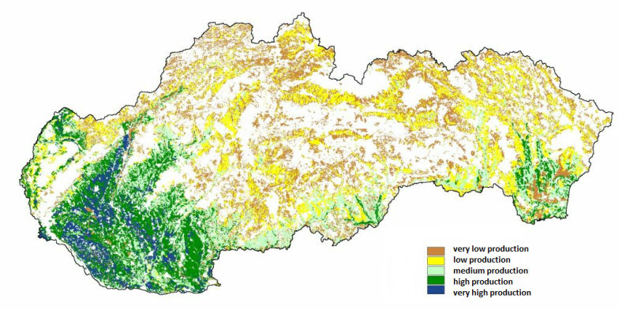
Figure 1 Potential production of biomass in agricultural soils in Slovakia

Recent Publications (minimum 5)
- Vilcek J (2014) Mapping and evaluation of the environmental functions of agricultural soils in Slovakia. Geografický Časopis 66:287-304.
- Vilcek J, Torma S (2015) Winter wheat (Triticum aestivun L.) growth potential in the Slovak rural landscape. Archives of Agronomy and Soil Science 62:235-245.
- Vilcek J (2013) Bioenergetic potential of agricultural soils in Slovakia. Biomass and Bioenergy 56:53-61.
- Vilcek J, Bujnovsky R (2014) Soil environmental index for Slovak agricultural land. Pedosphere 24:137-144.
365:519-530.
5. Vilcek J, Koco S (2018) Integrated index of agricultural soil quality in Slovakia. Journal of Maps 14:68-76.

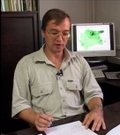 Biography (150 word limit)
Prof. Dr. Jozef Vilček, Professor at the Department of Geography and Applied Geoinformatics, Faculty of Humanities and Natural Sciences of University of Presov in Presov. Professionally he focus on the pedology and geoecology. He is a member of Slovak Accreditation Commission - the advisory body of the SR Government, the Scientific grant agency - Commission for Earth Sciences, Slovak academy of Agricultural Sciences and others institutions. Outside of the university, he is the head of the regional department of Soil Science and Conservation Research Institute in Prešov.
.
Email: j.vilcek@vupop.sk

Notes/Comments:

