Abstract Template

Title: Working Neighborhoods and Circular Economy: Case Study Guatemala City, Central America

Doc. Peter A. Kumble, MLA, PhD¹
¹ Department of Landscape and Urban Planning
Faculty of Environmental Sciences
Czech University of Life Sciences
Prague, Czech Republic

Keywords: bioeconomy; circular economy; social sustainability; composting; Guatemala City; Central America

- Abstract Body (up to 250 words)
This research reports on a successful project aimed at providing livable-wage jobs for disadvantaged youth from the poorest neighborhood in Guatemala City, Central America. Specifically, what are the requirements for establishing a business that demonstrates the principles of circular economy while embracing social sustainability.

This venture developed a municipal composting business using organic waste generated by a large fruit and vegetable processing market.

This research project explored the following questions:
- Could usable compost be made from the organic waste rather than adding it to the landfill?
- What were the requirements involved in making compost in the challenging climatic conditions of Guatemala City which is situated high in altitude and experiences periods of extremely dry and hot temperatures during portions of the year and heavy rainfall and near freezing temperatures at other times?
- If successful, could this effort create jobs and train workers from the Zone 3 neighborhood, thus becoming a model for circular economy while adhering to the pillars of sustainability, with an emphasis upon social sustainability?
- And finally, could one employ university students as planners, designers, and managers of such a venture as part of their educational curriculum?

- Image:

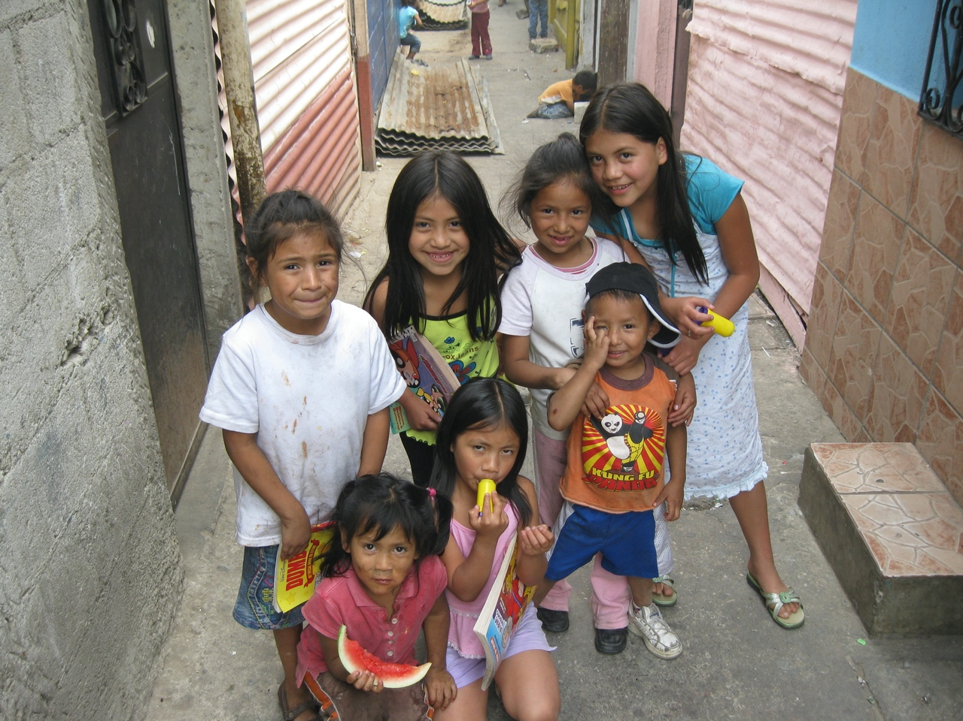

- Biography:
Dr. Peter Kumble is an applied landscape ecologist and Landscape Architect with extensive experience in community planning, natural resource management, and the day-to-day operation of a professional consulting firm. He holds a doctoral degree in Applied and Landscape Ecology. His research has focused on a broad range of topics:
- Mitigating the impacts of ecotourism upon natural and cultural resources with field research in North America, Belize, Guatemala, Brazil and central Europe
- Landscapes of Compassion: Development of a municipal compost operation in Guatemala City
- Evaluating the impacts of wind turbines in the landscape

- Publications: SELECTED FEW
- Kumble, Peter. 2019. Reflection on Service Learning for a Circular Economy Project in a Guatemalan Neighborhood, Central America. Sustainability. 11: 4766
- Kumble, Peter. 2019. Participatory Planning, Visioning and the Design Process: Framework Thinking. Participatory Process in Urban Planning. Pp. 74-88. Faculty of Technical Sciences, Novi Sad, Serbia. Visegrad Fund: Bratislava, Slovakia.
- de Lima, Ismar, Peter Kumble, Rosiane Dias Mota, Lara Cristine, Eguimar Felicio, and Maria Geralda de Almeida. 2016. Ethnic Tourism and the Kalunga community in Brazil. Tourism, Society and Culture (ISBN 978-956-9037-00-9). pp 126 – 154.
- Sekáč P., Šálek M., Wranová A., Kumble P., Sklenička P. 2017. Effect of water features proximity on farmland prices in a landlocked country: the consequences for planning. Soil and Water Research. 12: 18-28.
- Kumble, Peter. 2011 Annotated Bibliography of Literature on Ecotourism and Related Ecotourism Impacts. Journal of Landscape Studies.
- Kumble, Peter and Christopher C. Houston. 2009. Elements of a Conservation Botanic Garden for Ecotourism: Belize Botanic Garden as a Case Study. Journal of Landscape Studies.
- Sklenicka, Petr, E. Brabec, P. Kumble, K. Molnarova, K. Pixova, and B. Pittnerova. 2009. Remnants of Medieval Field Patterns: Principles of Conservation and Restoration. Agriculture, Ecosystems and Environment 129, 465–73.
- Kumble, Peter. 2006. Site-Specific Approaches for Managing The Impacts Of Ecotourism In Belize, Central America. Sustainable Tourism II. Pp. 217 – 226. WIT Press, England: Ashurst, Southampton.

- Department/Lab/University/Company details: 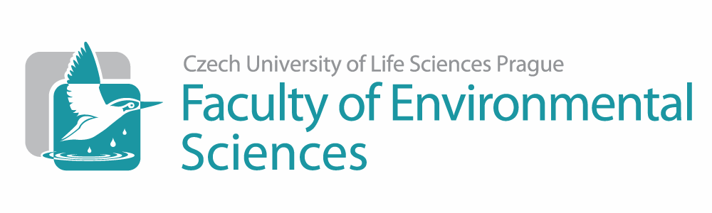
Czech University of Life Sciences
Department of Landscape and Urban Planning
Faculty of Environmental Sciences
Kamycka 129
Prague, Czech Republic 165 00
https://www.fzp.czu.cz/en

- Presenting author details
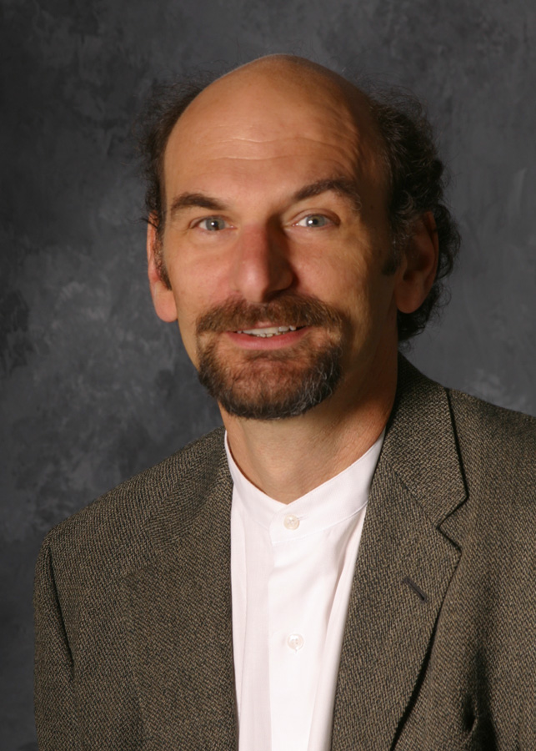

Full Name: Dr. Peter Andrew Kumble, MLA, PhD
Contact number: +420 722215170
Twitter account:
Linked In account: I have one but seldom use it…
Session name/ number: Social and Cultural Issues
Category: (Keynote presentation)
Passport Number: USA 567173503

