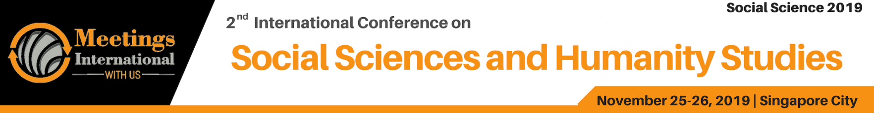

Abstract Template

Title: Protecting Journalists’ Information in The Digital Age to Face of Legislative Onslaughts

1 AlAshry Miral Sabry

Associate Professor at Future University (FUE), Faculty of Economics & Political Science, Political Mass Media Department

Keywords: Protecting Journalists, Information in The Digital Age, Legislative Onslaughts.

- Abstract Body (up to 250 words)
Protecting journalists’ confidential sources can be taken as settled. There is ‘widespread recognition in international agreements, case law and declarations that protection of journalists’ sources are a critical aspect of freedom of expression that should be protected by all nations.
But it’s not the reality in the Middle East, many of journalists have been attacked their information when they send it to the media organizations. On the other side, source protection laws are increasingly at risk of erosion, restriction and compromise in the digital era, a development that can be seen to challenge the rights to freedom of expression and privacy (Article 12; Article 19 UDHR, Article 19 ICCPR 1976).
This study examining how journalists in the Middle East (Yemen, Palestine, Libya, Syria, Egypt and Iraq), are coping in their dealings with confidential sources in the digital age to face of Legislative Onslaughts.

The source protection laws are increasingly at risk of erosion, restriction and compromise in the digital era, a development that can be seen to challenge the rights to freedom of expression and privacy (Article 12; Article 19 UDHR, Article 19 ICCPR 1976).
Through this, the study seeks to conduct in-depth interviews they were divided into two categories the first one with 22 correspondence reporters in conflict zone, the questions featured following themes: The source protection laws are increasingly at risk of erosion, restriction and compromise in the digital era, a development that can be seen to challenge the rights to freedom of expression and privacy (Article 12; Article 19 UDHR, Article 19 ICCPR 1976). So that the study examining how journalists in the Middle East (Yemen, Palestine, Libya, Syria, Egypt and Iraq), are coping in their dealings with confidential sources in the digital age to face of Legislative Onslaughts, through in-depth interviews they were divided into two categories the first one with 22 correspondence reporters in conflict zone , the questions featured following themes( participants’ general profile; journalists’ familiarity with laws/rules impacting on source confidentiality , the importance of, and reliance on, confidential sources; keeping abreast of information impacting on source protection; and perceptions and attitudes towards source protection. Protections and Threats to Journalists’ Sources on Digital Age).

Second category with in-depth interviews with 10 professor from Media and Law department to know the different kinds of legal protections applicable locally (e.g. constitutional protections, state-based laws, memoranda of understanding), and the new law under discussion in Egypt the view of journalists this law didn’t protect us but put in prison

Image:
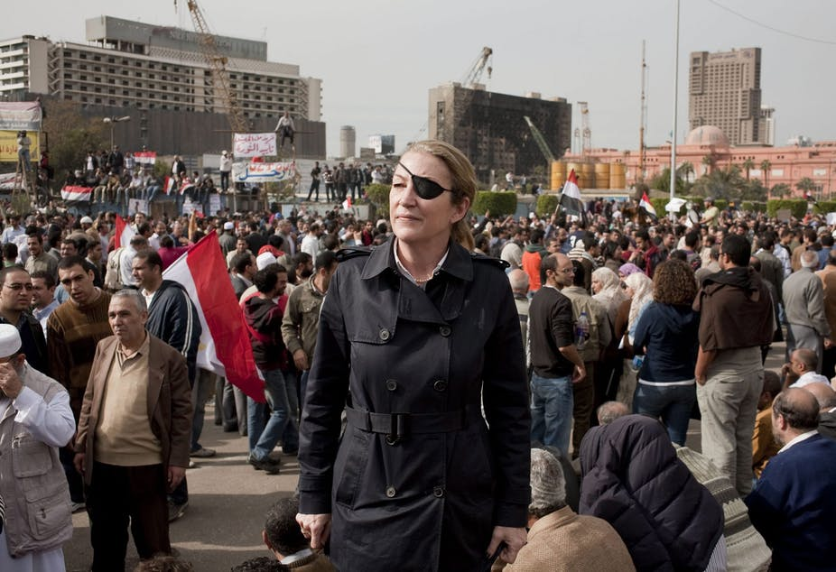
- Reference:

1 Mergel, I. (2013) Social media adoption and resulting tactics in the US federal government. Government Information Quarterly, 30, 123-130
Mezran, K., & Varvelli, A. ( 2017 ). Libyan crisis: International actors at play, the Atlantic council. Ledizioni ledi Publishing. https://www.ispionline.it/it/EBook/LIBIA_2017/LIBIA_WEB.DEF.pdf, (accessed 16/1/2018), Google Scholar.
Omotayo (2013). The Nigerian Freedom of Information Law: Progress, implementation challenges and prospects. Available at: http://digitalcommons.unl.edu/cgi/ viewcontent.cgi?article¼3192andcontext¼libphilprac (accessed 6/5/2018), Google Schola

Biography:

AlAshry Miral AlAshry, Associate Professor at Future University (FUE), Faculty of Economics & Political Science, Political Mass Media Department
. Media Advisor at International Federation of African Women Freelancer journalist covering war in Libya . she is Specializae about Journalism, freedom of expression, press freedom, journalists’ safety and protection. She has published widely on a range of topics, about laws, legislations and media ethics, the role of journalist and media coverage war and conflicts in the Middle East.
Presenting author details
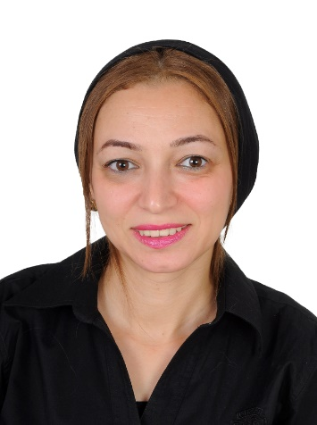

Full Name: Miral ALAashry
Contact number: 00201222674849
Linked In account: Miral ALAashry
Category: (Oral presentation)



