

Abstract Template

Title: New Socio-Economic Thought for a Small and Narrow Earth

Mamoru Kaneko1,
1Faculty of Political Science and Economics, Waseda University, Tokyo, Japan

Keywords: Small and narrow Earth, Ultimate contractarian theory, Practical management of the world

- Abstract
As the human population is getting larger, the Earth is getting smaller and narrower. The general idea of the property right that an individual can keep his own rights on properties and talents is no longer kept, while it is deeply presumed in our thinking. Partial adjustments do not change the present situation of the world; we should change our thinking drastically. The alternative is the ultimate version of the Hobbesian theory together with Einstein’s peace principle; everybody in the Earth has the power to demolish the entire Earth, which eliminates inequalities in endowed rights on environments, properties, and individual talents. It leads to the evaluation criterion on social phenomena, formulated as the Nash social welfare function (Kaneko-Nakamura (1977)). This theory relies upon lot of idealizations; it is absolutely normative and can be directly used only in very specific cases such as stopping genocides, capital punishments, etc. For practices, we need a decentralized management of the Earth, i.e., we need the world federal government so that it consists of independent (but not sovereign) states and they should obey the Constitution of the federal government. The Constitution should be based on the above normative theory; for example, it suggests a class of progressive income taxations for each state. Designing the Constitution is a duty of social sciences (with the help of natural sciences). I talk about the basic scenario of the contractarian theory and practical managements of the Earth by the federal government.

Image:
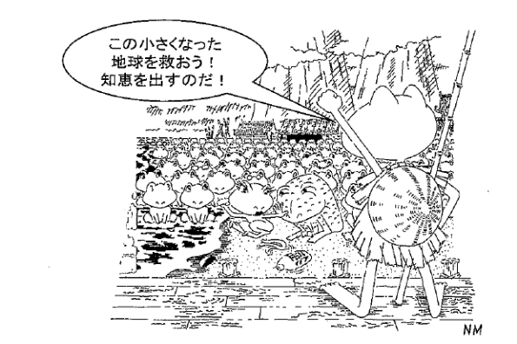
- Reference:

1. Einstein, A., (1968), Ideas and Opinions. New York: Bonanza Books.
2. Hobbes, T. (1991: the original 1651), Leviathan, Cambridge University Press, Cambridge
3. M. Kaneko, and K. Nakamura, (1979), The Nash social
welfare function, Econometrica 47, 423-435.
4. Kaneko, M., (2018), Exploring New Socio-Economic
Thought for a Small and Narrow Earth, Advances in
Applied Sociology 8, 397-421.
5. M. Kaneko, and J. J. Kline, (2008), Inductive Game
Theory: A Basic Scenario, Journal of Mathematical Economics 44, (2008), 1332-1363.

Biography:
Mamoru Kaneko completed his PhD at Tokyo Institute of technology, and has taught at University of Tsukubai, Hitotsubashi,University, Virginia Polytechnic Institute, and Waseda University. In 1970’s, he started working on game theory and economics, and he was motivated by “Leviathan” by T. Hobbes for all later works. After 1985, he has been working on mathematical logic and conceptual foundations for game theory and economics, i.e., inductive game theory, since these could be keys to reconcile the ideal contractarian argument and practical managements of the Earth.

Presenting author details


Mamoru Kaneko: mkankeoepi@waseda.jp
Category: Oral presentation
Passport Number: TK1377176



