Title :

A Journey of Symbols Found on Terracotta Discs and Its Impact on Religion Astronomy & Nonmetallic Coins
Dr.O.P. Srivastav,
Centre of Advanced Study,
Department of History,
Aligarh Muslim University,
Aligarh, 202002, INDIA.
WhatsApp: +91-9411654394
opsrivastav2001@yahoo.com

Key words: T C Disc, Symbol, Coin, Astronomy, Numismatic

I.Abstract Body
The Terracotta discs are casually described as minor objects like amulets, beads, bangles, toys, tools and other small objects of daily use. By studying these small implements archaeologists have tried to arrive at some inference regarding the society beings and the stages of the life. The symbols which are found on terracotta disc are very much identical with punch marked coins. Perhaps the idea of symbols on punch marked must have been derived from terracotta disc. Here I am enumerating few points in support of considering Terracotta disc as the non-metallic coins that the majority of the symbols found on punch-marked coins are very similar to those found on Terracotta disc. These symbols are as follows a. Human figurine b. Sun c. Crescent d. Mountain e. Swastika f. Wheel g. Star h. Tree i Arrow j. Fish k. Eye l.

Circles and other geometrical lines etc. Some astronomical signs also have been observed in the form of element of nature and animals. Symbols serve as the instrument of human expression in the form of art and act as vehicles for communicating social ideologies. Another important characteristic of symbols is its concurrence with religion. Since religion itself is based on a belief in the supernatural power or God, it started playing a pivotal role in trying to explain the different aspects of their respective religions. There are religious symbols, like ‘swastika, om, cross, crescent, sun to name a few. As far as astronomical symbols are concerned they are also depicted on different types of terracotta object in the form of animal or in nature symbols.

II. Image
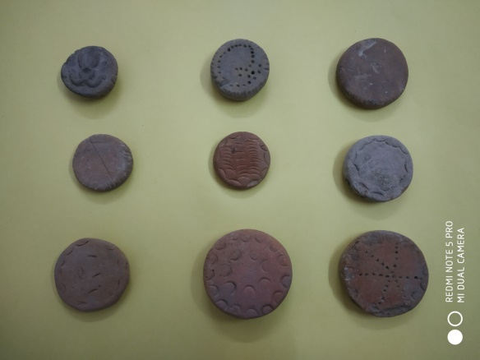

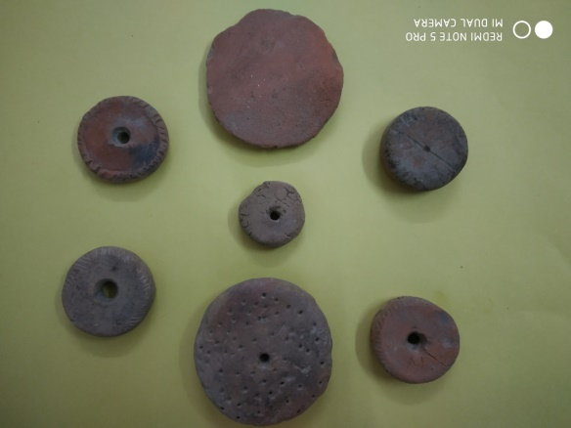

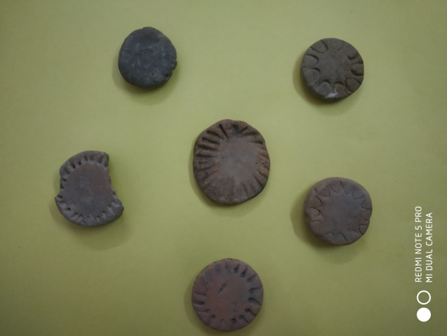
III. References
1. IAR 1969- N.R. Banerjee; IAR 1955-56 to till date
2. R.C. Gaur; Excavations at Artanjikhera, Delhi, 1983, pp. 386-87.
3. B.B. Lal; Excavations at Hastinapur and Other Explorations in the Sutlej Basin 1950-52, Ancient India, Nos. 10-11, pp. 87-88.
4. M.D.N. Sahi; Aspects of Indian Archaeology, Jaipur, 1994, p. 184.
5. Savita Sharma; Early Indian Symbols - Numismatic Evidence, Delhi 1990, p. 12.
6. A.K. Narain & T.N. Roy; Excavations at Prahladpur, Varanasi 1968, Pl. XXI, 8,9,9A, 11,15,16.
7. Vibha Tripathi; The Painled Grey ware - An Iron Age Culture of Northern India (varanasi, 1975), p. 113

IV.Biography

Dr. O P Srivastav

Assistant Professor
(Ancient Indian History & Archaeology)
Centre of Advanced Study,
Department of History,
Aligarh Muslim University,
Aligarh- 202 002, India.

International Participation
Washington D.C. (USA), Rome
(Italy), Hong Kong, Taiwan (China) Daejeon (South Korea), Shiraz (Iran), Dead Sea (Jordan), etc. to attend seminars, conference, academic discussions & to visit museums.

Details of Citation and References
Several national & international scholars have
quoted my research work in their books. G L Possehl a renowned American scholar in his book INDUS AGE: THE BEGINNINGS has given reference of my work in the text. I have presided the session at conferences like WAC, SEAA and presented several papers at USA, EU and Asian countries as well.

Editor/Editorial panel
www.cijhar.in
www.kanchiuniv.ac.in/jagruti
www.iasir.net
(Journal published from USA)

Books as Author /Editor
13 books published & 2 in pipeline.
Available on amazon.in published and unpublished papers

Field Experience in Archeology
participated in many national excavation
projects like Ramayana, Fatehpur Sikri, Atranjikhera & Jakhera etc.
Attached with Distinguished Academic Bodies
WAC, IAHA,WATCH, SOSAA etc.,
Academic Qualification
M.Phil., Ph.D.

V. Presenting author details

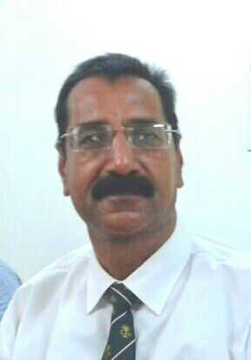

Full Name : Om Prakash Srivastav
Contact Number : +91-9411654394 & +91-8218390313
Session Name /Number :
Category : Poster Presentation

