Thermomechanical properties of low-cost shape memory alloys (Fe-SMA) for civil engineering applications
Dr. Konstantinos Katakalos, Asist. Professor, CE, AUTh, GR
Nikolaos Makris, PhD Candidate, CE, AUTh, GR
Lazaros Melidis, PhD Candidate, CE, AUTh, GR
Sofia Piliafa, Research Assist. CE, AUTh, GR

Abstract
Nowadays much emphasis has been placed on studying smart materials for civil engineering applications because of their ability to change their particular properties in a controlled manner by external stimuli. Shape memory alloys (SMA) belong to the wider category of intelligent materials and exhibit two unique characteristic behaviors, superelasticity and shape memory effect, making them differ from conventional materials. These effects are due to diffusionless transformations between austenitic and martensitic phases. The SME occurs because a temperature-induced phase transformation reverses deformation and the pseudoelasticty achieves large, recoverable strains with little to no permanent deformation, as well, but it relies on more complex mechanisms. More recently, Innovative, low cost iron-based shape memory alloys (Fe-Mn-Si SMAs) with good workability, machinability, and weldability have been drawing much attention during the last two decades regarding to their potential application in civil engineering such as prestressing of concrete or coupling devices. In the present work we carried out an experimental campaign on monotonic mechanical loading, low-cycle fatigue and thermal loading in the laboratory of Experimental Strength for Materials and Structures of Aristotle University of Thessaloniki, so as to investigate in practice their thermomechanical behavior and all their special characteristics in comparison to the results that already exist in the current literature. Our investigation showed that the studied Fe-SMA change positively their mechanical properties when we increased the temperature thus revealing their potential use towards the industry of strengthening existing and new structures.

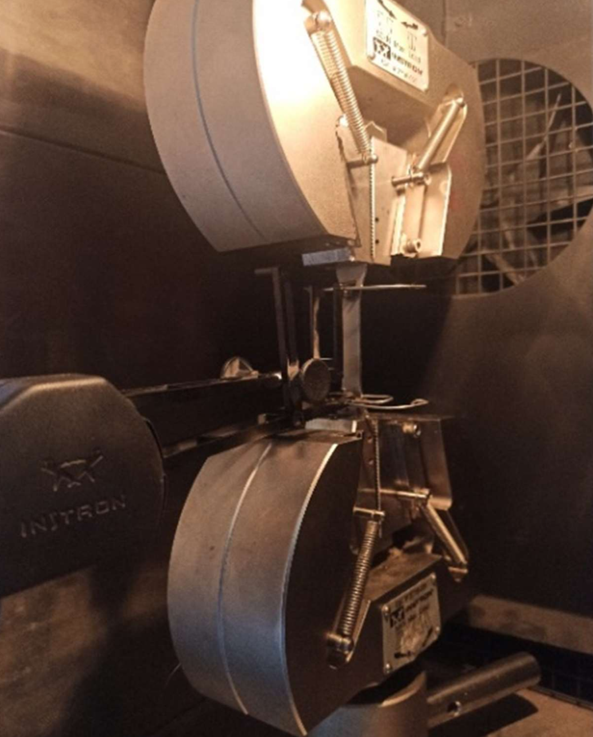
Figure. 1. The Fe-SMA specimen under elevated temperatures
Recent Publications
- G. Songa, N. Maa, H.-N. Li, Applications of shape memory alloys in civil structures, April 2006
- W.J. Lee, B. Weber, G. Feltrin, C. Czaderski, M. Motavalli and C. Leinenbachn, Phase transformation behavior under uniaxial deformationof an Fe–Mn–Si–Cr–Ni–VC shape memory alloy, 2013
- Marcin Górski, Agnieszka Jędrzejewska, Marcin Kozłowski, Active monitoring with use of smart structures based on high-strength fibre composites as a method of structural elements optimization, 1th International Conference on New Trends in Statics and Dynamics of Buildings, Bratislava, October 2013
- Zhizhong Dong ,Ulrich E. Klotz ,Christian Leinenbach ,Andrea Bergamini ,Christoph Czaderski ,Masoud Motavalli, A Novel Fe-Mn-Si Shape Memory Alloy with improved Shape Recovery properties by VC precipitation, 2009
- W.J.Lee,B. Weber, G. Feltrin, C. Czaderski, M. Motavalli and C. Leinenbach, Stress recovery behaviour of an Fe–Mn–Si–Cr–Ni–VC shape memory alloy used for prestressing, 2013

 Biography
Dr. K. Katakalos has been teaching as teaching assistant since 2007 and from 2018 he holds the position of Assistant Professor and Academic Responsible for the Laboratory for Strength of Materials and Structures of Aristotle University of Thessaloniki. He has participated in more than 35 research programs among of which he was the PI for 6 National and European Projects. He has 2 International Patents in the field of civil engineering. He was invited as speaker at four international conferences. He is a reviewer for 12 international journals. He has an H-Index equal to 12 and more than 360 references. He serves as board member for many technical advisory boards. He has been a professional civil engineer since 2005. Email: kkatakal@civil.auth.com

