Abstract
Redox Gated Polymer Memristive Processing Memory Unit
Bin Zhang, Fei Fan, and Yu Chen*
Key Laboratory for Advanced Materials, Institute of Applied Chemistry, School of Chemistry and Molecular Engineering, East China University of Science and Technology, Shanghai 200237, China. Email: chentangyu@yahoo.com

Memristor devices with enormous storage capacity and superior processing efficiency are of critical importance to overcome the Moore’s Law limitation and von Neumann bottleneck problems in the big data and artificial intelligence era. In this contribution, we report the first proof-of-concept polymer memristor based processing-memory unit that demonstrates programmable information storage and processing capability. By introducing redox active moieties of triphenylamine (TPA) and ferrocene (Fc) onto the pendants of fluorene skeletons, the conjugated polymer of PFTPA-Fc exhibits triple oxidation behavior and interesting memristive switching characteristics. Associated with the unique electrochemical and electrical behavior, the ITO/PFTPA-Fc/Pt device is capable of executing multilevel memory and four basic decimal arithmetic operations of addition, subtraction, multiplication and division. Redox gating of the device also endows it with simple binary Boolean logic operations. The integration of multilevel memory and computing capability into a single memristor device through molecular design and electronic properties tuning of polymer promises an essential strategy of obtaining high-performance electronic device that satisfies the increasing demands of data storage and processing nowadays.
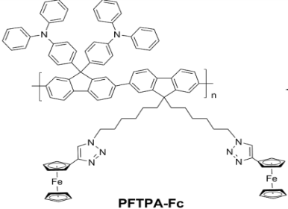
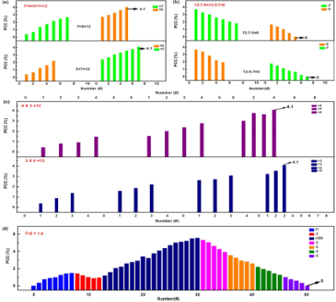

Figure 1. (Left) Structure of PFTPA-Fc and (Right) Demonstration of arithmetic computing with the PFTPA-Fc memristor: (a) Commutative addition, (b) subtraction and (c) multiplication, as well as (d) fractional division conducted with the ITO/PFTPA-Fc/Pt device

References

- Y. Chen, G. Liu, C. Wang, W. Zhang, R.-W. Li, L.Wang, Mater. Horizons 2014, 1(5): 489-506.
- B. Zhang, F. Fan, W. Xue, G. Liu, Y. Fu, X. Zhuang, X.-H. Xu, J. Gu, R.-W. Li, Y. Chen, Nature Commun., 2019, 10:736/1-736/11.

