Graphene Thermal Conductivity Dependence on Using Non-Equilibrium Molecular Dynamics Simulations
Zhongwei Q1, Zhilin F1, Shunlong L1, Shunlong L1, Xianqi W1, 2
1School of Science, Jiangsu Ocean University, Lianyungang, Jiangsu, China, 222005
2Research Institute of Xi'an Jiaotong University, No. 328 Wenming Road, Xiaoshan District, Hangzhou City, Zhejiang Province, 311215
Abstract Body (up to 300 words):
Due to the increasing thermal management has become a serious problems in electric devices, especially in nanodevices. Graphene has been considered as a potential heat transfer material. However, the thermal conductivity in graphene demonstrates the discrepancy between the simulated value and the experimental results. We computed the thermal conductivity of graphene (from length of 21.84 nm to 43.78 nm) on nanoscacle size using NEMD method. The results demonstrate obvious edge type (zigzag edge and armchair edge) and nanostructure size dependence of thermal conductivity. With graphene length << MFP (Phonon mean free path), thermal conductivity increase with the length increasing and is strongly limited by the sample size owing to a dominant boundary scattering. Besides, the thermal conductivity of graphene with zigzag edge is larger than the armchair edge, which is because of the higher phonon group velocities.
Biography:
Correspondence author: Xianqi Wei is a lecturer of Jiangsu Ocean University. She has completed his PhD from Xi’an Jiaotong University in 2016 and Postdoctoral had studied from School of electronics and information engineering, Xi’an Jiaotong University from 2016-2019. She is reviewer for “Nanotechnology”, “Journal of nanomaterials” etc. Her research interest is focused on carbon based electronics and their application.

Presenting author details:
Full Name: Xianqi Wei
Contact number: (0)86-18509242422
Email Id: wei.wxq@163.com
Category: Oral presentation
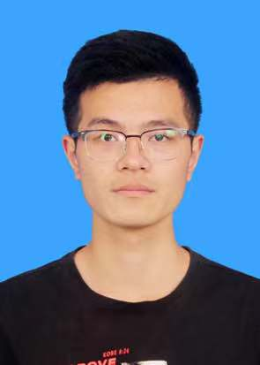
Co-author 1: Zhongwei Qian is a sophomore from Jiangsu Ocean University and his undergraduate major is Photoelectric information science and engineering. Besides, he is a number of laboratory in science collage of Jiangsu ocean University.
Full Name: Zhongwei Qian
Contact number:15261060320
Email Id:1399986732@qq.com

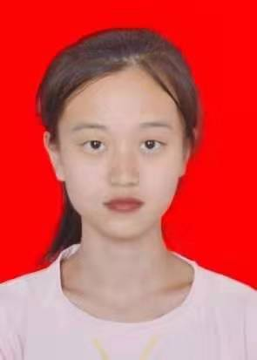
Co-author 2: Zhilin Feng is now studying in the school of science of jiangsu ocean university, majoring in photoelectric information science and engineering. Her grades were among the best in the major.
Full Name: Zhilin Feng
Contact number:18936620631
Email Id:2950331744@qq.com

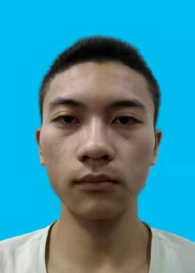
Co-author 3: Shunlong Xu is a sophomore from Jiangsu Ocean University and his undergraduate major is Photoelectric information science and engineering. Besides,He is a number of laboratory in science collage of Jiangsu ocean University.
Full Name: Shunlong Xu
Contact number:15152549760
Email Id:2764803357@qq.com

