Title: Development of Fluorescence Sensor for Determination of Ni (II) Ions
SONER ÇUBUK, TUTKU YILMAZ
Marmara University, Faculty of Arts and Sciences, Chemistry Department, Istanbul, TURKEY
Abstract
Industrial operations such as metallurgical processes, as well as the burning of fossil fuels, result in human-induced nickel emissions, especially in the air and water systems in particular. Nickel-bearing particles in the air can settle into surface waters and soil and thus, nickel can be taken by plants and animals. Therefore, the level of nickel in various matrices, such as food and water, especially in drinking water sources, must be constantly monitored and analyzed. The determination of nickel, which have such great effects on human health and environment, has become very important nowadays. For this reason, many methods have been developed. These methods can provide wide linear range values and good detection limits, but they need to very expensive devices for use in the laboratory and a qualified staff for the application.
In this study, a polymeric fluorescence sensor for the analysis of nickel ions in different matrix has been developed. Parameters required for determination such as pH, measurement range, selectivity, precision, response time, reproducibility were also systematically conducted. Once the characterization of the sensor has been made, optimal conditions were determined so that the analysis could be performed. The fluorescent sensor has been successfully applied to real samples for determination of Ni(II) ions. The results strongly show that the novel sensor can be used for Ni(II) ions determination in various matrices.
This work was supported by Marmara University, Commission of Scientific Research Project (M.Ü.BAPKO) under grant FEN-C-YLP-230119-0007.
Biography:
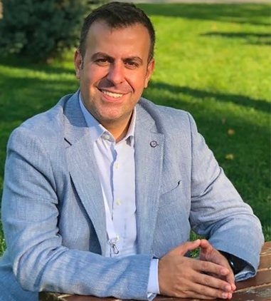
Soner Çubuk has B.Sc. degree in chemistry, and M.Sc. and Ph.D. degrees in analytical chemistry from Marmara University, Istanbul, Turkey. His current research interests include developing instrumental and analytical method, fluorescence spectroscopy, and optical sensors. He is currently associated professor of analytical chemistry at Marmara University.
Presenting author details:
Full Name: Soner ÇUBUK
Contact number: +90 533 273 1993
Email Id: sonercubuk@marmara.edu.tr
(Poster presentation)

