Application of acoustic emission at the analysis of contact interaction
Alexey Moshkovich, PhD, Holon Institute of Technology, Israel
Lev Rapoport, PhD, Holon Institute of Technology, Israel

Abstract

Contact interactions under indentation, scratching and friction in different lubricated conditions were studied by application of acoustic emission (AE) signals, hardness measurement and the analysis of deformed structure. To compare the AE parameters during contact interaction, the indentation and scratching of ductile copper (Cu) and brittle silicon (Si) were evaluated. The effect of different phase of indentation as loading, dwell and unloading on the AE signals were studied. The AE frequencies under indentation and scratching of Cu and Si were compared. Scratching of Si is characterized by scrubbing in nanoscale, accumulation of the shear stress waves and damage development.

Friction of four fcc metals (Ag, Cu, Ni and Al) rubbed in different lubricated conditions was accompanied by the analysis of the AE parameters. The transitions from the elasto-hydrodynamic lubrication (EHL) to boundary lubrication (BL) regions were studied using Stribeck curves. The similar EHL-BL transitions were observed in the curves of AE frequency variations with load increasing. The AE frequency values characterize friction behavior both in macro scale (interaction between contact spots) and microscale (contact interactions in the single spot). The models of friction in different lubricated conditions based on the analysis of AE waveforms are proposed. Shear bands are responsible for formation and development of cracks and microchips under scratching of Si. The AE waveforms during friction in lubricated conditions were analyzed. It was shown that the waveforms characterize the friction both in the macro scale (contact spot interaction) and microscale (single contact interactions in the spot).
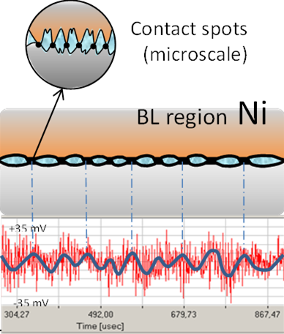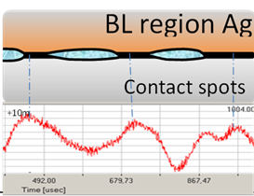

The AE models of contact interaction during friction in lubricated conditions based on the tests of Ni and Ag
Recent Publications
- Perfilyev, V. Moshkovich, A. Lapsker, I. Rapoport, L. (2017) Deformation and fracture of copper and silicon during indentation acoustic emission measurements. Tribol. Lett., 65: 41-48.
- Moshkovich A., Perfilyev V, Lapsker I., Feldman Y., Rapoport L., (2017) Study of the transition from EHL to BL regions under friction of Ag and Ni. I. Analysis of acoustic emission. Tribol. Int., 113: 189–196.

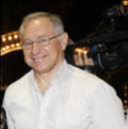Biography
Professor Rapoport is the Head of the Center for Materials Engineering and the Laboratory of Tribology at the Holon Institute of Technology. Friction and wear properties of fullerene-like nanoparticles were studied at first in the laboratory of Prof. Rapoport. Last some years he studied the interaction between structure friction and wear. Prof. Rapoport is a principal investigator in several research grants sponsored by the Israel Ministry of Science, the Bi-national Israel-USA and Germany-Israel Funds. Prof. Rapoport is the author more than 100 publications. He is Vice-President of the Tribology Council in Israel.
Email: rapoport.lev0@gmail.com

Notes/Comments:

