

Our Mission
- Our global mission is to "Light Up the Night Sky," while accelerating affordable worldwide availability of our unique patented solar solutions.
- To provide an affordable means of and encouraging others to take, invent, and use new, more sustainable solutions.
- To better our way of life through the increased use of efficient solar energy.
- We seek to use our concepts, designs, and innovative solutions to help accelerate solar energy production in all areas across the globe and does so by licensing them.

The global energy landscape is changing rapidly. More countries are relying on renewable energy sources and are attempting to phase out fossil fuels. When one examines the speed with which the transition is occurring, the findings are somewhat staggering. Frost & Sullivan reported that revenues in global solar power market are expected to more than double by 2020, from $60 billion in 2013 to $137 billion.
Solar Interchangeable Panels Inc., SIP for short, is pursuing the transformation of our Research and Development (R&D) operations into a global licensing company. Our unique and innovative US Patented solutions in Agriculture and Advanced Lighting apparatus techniques which attach to the back of energy panels make the energy panel take on the Sun and the SIP.
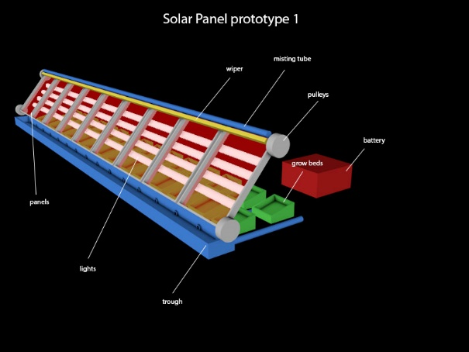
Our proprietary apparatus design uses a natural element product to strengthen it and keep the heat from transferring from the front of the panel into the SIP apparatus. We also add heat reduction material which adds even more value by assisting and blocking any heat from the LED lighting thus preventing overheating and doubling the lumens in the apparatus itself. Finally, we apply an unbreakable product which seals all the components and hardware/ lighting strips. Installing replacement units requires minimal effort with no damage to the unit itself.

As defined by the US Patent office we perform as a grow farm or retro fit to photovoltaic (PV) farms currently installed. The function of the SIP apparatus is trapping and magnifying light energy for agricultural purposes. The same design can also protect precious watering holes from evaporation, where animals can hydrate at night safely as predators will be visible with the lighting
The watering system process consists of misting down the front of the panels keeping them clean and using the water to grow plants. The wiper system can also use the condensation in the night sky to help water the trough at bottom to collect all water which is pumped into the bottom of the grow beds. This design is in the final prototype stage with consistent results from testing since 2014. The entire enclosure of this design uses durable thermal material that has shown improved energy efficiency and controlled temperature which makes possible growing of herbs, vegetables, bushes. trees and flowers. These designs are all environmentally safe and offset heat contributing to climate change warming as we use the thermal material flash back the sun light that does not require charging the energy panels themselves.
In a major disaster situation attaching SIP apparatus to a photovoltaic panel and mounting on relief trucks, adds power and lighting during an evacuation to light roadways and street signs with the ability to light up store fronts to keep looting down. For 911 responders we light up the night sky to help people feel safe and still have the power to help with clean up and back up electrical until they are able to have utility power restored. The same apparatus demonstrates positive results for being a charger for the panels. Laboratory testing has reached as high as 58.2 DC as flip the apparatus back on energy panel themselves and with more test I truly feel and can show were more research definitely needed as with this development can work as generator and work as a chain reaction, which we can demonstrated live and by laboratory testing.
Solar Interchangeable Panels (SIP) brings the power of the Sun to homes and businesses with our proprietary leading-edge lighting designs, where we take low-wattage LEDs and the amazing power of PV and solar to magnify the effect for lighting. At the same time, our advanced design is more than capable of jump-starting PV panels 2/110-volt system lighting low power draw for PV. We can use the same design to close in the PV farm without cooling material which will speed up the growth of your crops.


Solar Interchangeable Panels Inc.
803 Jack Rabbit Rd. Broken Bow, OK 74728
We are an S Corporation and Women owned Company
www.solarinterchangeablepanel.com
Email solarinterchangeable@hughes.net or tamlee@hughes.net
Phone 580-236-2967

