Evaluation of adding carbon tetrachloride as Propulsion to the thermal cracking reactor due to the amount of formed coke in different Coil Outlet Temperatures (COT).
Afshin Davarpanah

Department of petroleum, Science and Research Branch, Islamic Azad University, Tehran, Iran

Abstract
Nowadays, polyvinyl chloride (PVC) was the most usual plastic. Thereby, to make polyvinyl chloride its monomer must be produced firstly that was called vinyl chloride (VCM). It was severely endothermic reaction that was done in an ethylene dichloride ethylene dichloride thermal cracking reactor within temperature range of 680-758 ° K and pressure range of 2500000 Pascal, thus this cracking reaction changed into hydrochloric acid and VCM. In production unit, monomeric chloride had the main and principal role as the core of the process of thermal cracking that occurs in the furnace. Increasing of wall temperature cause to boil gas mixture and causing pyrolysis reactions. Regarding to the simulation results showed that number of pyrolysis produced composition have maximum concentration in the length of reactor that illustrated these compositions participated in secondary reactions. Furthermore, by increasing the amount of coil outlet temperatures, the amount of formed coke will be increased. If Carbon tetrachloride considered as the chlorine radicals, it has an important role as the motivator in the cracking procedures, radicals causing an enhancement in VCM production.
Keywords: Carbon tetrachloride, conversion factor, coke, Coil Outlet Temperatures, thermal cracking.
Image

Recent Publications
Books:
- Evaluation of Permeability by Production Logging Tools(PLT) [Lambert Academic Publishers] ISBN: 978-3-330-03705-2; Published Date Jan-2017
- Variety Types Of Autonomous Underwater Vehicles By Solar Submarines[Lambert Academic Publishers] ISBN: 978-3-659-90945-0; Published Date Feb-2017
Researches:
- Evaluation of Permeability in Fractured Carbonate Reservoirs by Production Logging Tools (PLT)[Journal of Petroleum environmental and biotechnology –Nov2016] ; D0I: 10.4172/2157-7463.1000307
- Assessment of mechanical specific energy aimed at improving drilling inefficiencies and minimize wellbore instability[Journal of Petroleum environmental and biotechnology –Dec2016] ;D0I: 10.4172/2157-7463.1000309
- Analysis of fractured reservoir structure by interpretation of FMI and VSP logs.[Journal of marine science research and development-Dec2016] ;DOI: 10.4172/2155-9910.1000216
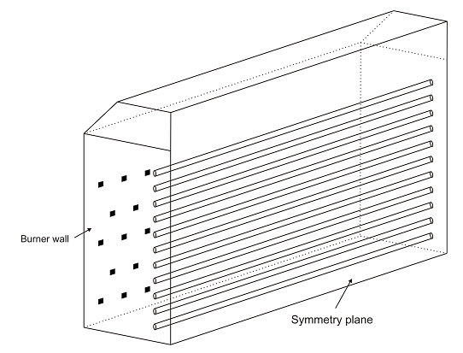
- Evaluation of Thermal stability by comparison of potassium chloride and potassium/sodium formate fluids. [Journal of Environmental & Analytical Toxicology- Jan 2017] ; DOI: 10.4172/2161-0525.1000426
- Evaluation of gas injection in the horizontal wells and optimizing oil recovery factor.[Journal of chromatography and separation techniques- Jan 2017 ] ; DOI: 10.4172/2157-7064.1000344
- Evaluation of adding carbon tetrachloride as a propulsion to the thermal cracking reactor due to the amount of formed coke in different COTs.[Journal of chemical engineering and material sciences – Jan 2017]
- Recommendations for compatibility of different types of polymers with Potassium Sodium formate based fluids for drilling operations An Experimental comparative Analysis [ journal of material science and engineering- Jan 2017] ; DOI: 10.4172/2169-0022.1000311
- An Overview of Wettability Measurements in Fractured Carbonated Reservoirs and investigate the effects of wettability changes in the optimization of enhanced oil recovery techniques [International Journal of Petroleum and Petrochemical Engineering- March2017] ; DOI: http://dx.doi.org/10.20431/2454-7980.0301008
- Implementation analysis of Technical-Economic Solar and wind Energy Potential for small homes [ journal of environmental risk assessment- Jan 2017]

Biography
Afshin Davarpanah, Master degree of Petroleum Engineering at Islamic Azad University, Tehran science and research Branch. My current interests in petroleum engineering sciences include a full-field study of Data Gathering, Reservoir Simulation, History Matching and Prediction. Data gathering stage mainly consisted of Well Logging, Coring, Seismic Survey, Geological Survey and DST (or other well tests). History Matching is an extremely crucial stage in full field study in order to get a more reliable prediction of the reservoir behavior. There are always some data which do not match with the true condition of the reservoir. What I did at this stage as a petroleum engineer was to simulate and find the unmatched data and resolve the discrepancies. Furthermore, experimental evaluation of drilling fluid and its effects on the rheological properties and phase-behavior calculations are another studies which I research about. Theoretical reservoir evaluation is one of the most important activities during my researches.
Email: Afshindpe@gmail.com

Notes/Comments:

