Safety of Human-Robot Interaction Based on Neural Networks and Using Intrinsic Joint Sensors
Abdel-Nasser Sharkawy, PhD, Mechatronics Engineering, Mechanical Engineering Department, Faculty of Engineering, South Valley University, Qena 83523, Egypt

Abstract

Human-robot cooperation (HRC) is the field that aims to perform a complementary combination between the robot abilities and the human skills. The robots can assist humans by increasing their capabilities in precision, speed, and force. The humans could contribute to the cooperation in terms of experience, knowledge of executing a task, easy learning, adaptation, and easy understanding of control strategies. Safety is the most necessary stage during this collaboration between the human and the robot since the proximity of the operator to the robotic manipulator may lead to the possibility of injuries.

In this work, an approach is proposed depending on the neural network (NN) training for detecting the human-robot collisions. The NN is designed taking into consideration the manipulator dynamics and trained, using data with and without collisions, by the algorithm of Levenberg-Marquardt for detecting the collisions that occur between the human and the manipulator. The priori knowledge to the dynamic model is not necessary and required. Three NN types are investigated:

One multilayer feedforward NN (MLFFNN-1) architecture, having one hidden layer, is implemented using the sensors of the joint position and the joint torque of the robot. Therefore, this architecture can be applied with the robots that have the torque sensors. This architecture is investigated experimentally to 1-DOF, 2-DOF, and 3-DOF manipulators.

Other MLFFNN architecture with two-hidden layers (MLFFNN-2), cascaded forward NN (CFNN), and recurrent NN (RNN) are implemented using only the intrinsic joint position sensors of the manipulator. As a result, these architectures could be used with any robot. MLFFNN-2 is investigated experimentally to 1-DOF and 2-DOF manipulators, whereas CFNN and RNN are investigated experimentally to 1-DOF manipulator.

However, all these architectures can be applied with all robot joints. ISO standards are considered for confirming that the detection of the collisions using the introduced method are in the safe region of the human-robot collaboration. The results show that the developed system can detect the collisions effectively.


Image
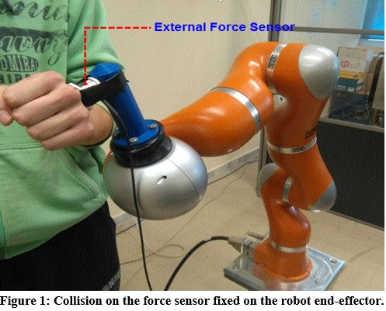
Recent Publications
- Abdel-Nasser Sharkawy, Ahmed A. Mostfa, “Neural Networks’ Design and Training for Safe Human-Robot Cooperation”, Journal of King Saud University - Engineering Sciences, Published online: February 2021.
- Abdel-Nasser Sharkawy, Panagiotis N. Koustoumpardis, Nikos Aspragathos, “Human-Robot Collisions Detection for Safe Human-Robot Interaction Using One Multi Input-Output Neural Network”, Soft Computing, Vol. 24, pp. 6687–6719, 2020.
- Abdel-Nasser Sharkawy, Panagiotis N. Koustoumpardis, Nikos Aspragathos, “Neural Network Design for Manipulator Collision Detection Based Only on the Joint Position Sensors”, ROBOTICA, Vol. 38, Special Issue 10: Human–Robot Interaction (HRI), pp. 1737 – 1755, Published online: June 2019.
- Abdel-Nasser Sharkawy, Panagiotis N. Koustoumpardis, Nikos Aspragathos, “Manipulator Collision Detection and Collided Link Identification based on Neural Networks”, In: Aspragathos N., Koustoumpardis P., Moulianitis V. (eds) Advances in Service and Industrial Robotics. RAAD 2018. Mechanisms and Machine Science, vol 67. Springer, Cham.
- Abdel-Nasser Sharkawy and Nikos Aspragathos, "Human-Robot Collision Detection Based on Neural Networks," International Journal of Mechanical Engineering and Robotics Research, Vol. 7, No. 2, pp. 150- 157, March 2018. DOI: 10.18178/ijmerr.7.2.150-157.

Biography
Abdel-Nasser Sharkawy was graduated with a first-class honors degree (B.Sc.) in May 2013 from Mechatronics Engineering, Mechanical Engineering Department, South Valley University (SVU) and followed this nomination as a demonstrator (teaching assistant) at the same university. Sharkawy received his M.Sc. degree in Mechatronics Engineering in April 2016 and followed this nomination as an assistant lecturer at the same university (SVU). In March 2020, Sharkawy received his Ph.D. degree from Robotics Group, Department of Mechanical Engineering and Aeronautics, University of Patras, Patras, Greece. Dr. Sharkawy is a lecturer (Assistant Professor) at Mechatronics Engineering, Mechanical Engineering Department, SVU, Egypt from June 2020 to present as a permanent Job. From (15 April to 30 November), 2021, Sharkawy is a Postdoctoral Researcher at Humanoid and Cognitive Robotics Group, Department of Cybernetics, Faculty of Electrical Engineering, Czech Technical University in Prague, Prague, Czech Republic. Sharkawy has published more than 21 papers in international scientific journals, book chapters and international scientific conferences. His research areas of interest include mechatronic systems, neural networks, Robotics, human - robot interaction, and robot control.
Email:
eng.abdelnassersharkawy@gmail.com

Notes/Comments:

