Modified optical fiber sensor for dangerous chemical detection
Ahmed Lateef Khalaf, PhD, Al-Ma’moon University College, Iraq.
Mohd. Hanif Yaacob, PhD, Universiti Putra Malaysia, Malaysia.

Abstract (300 word limit)

Gaseous pollutants such as Ammonia are ubiquitous in daily human activities and widely used in many applications. It is extremely toxic, explosive, flammable and corrosive in certain conditions. The inhalation of ammonia is deadly. Many fatal accidents are reported annually due to the ammonia leakages. Liquid pollutants like Ethanol (C2H5OH), is a volatile organic compound (VOC) that is commonly used in the food, beverage, fuel and pharmaceutical industries. Ethanol is extremely flammable and may explode upon mixtures with air or in a fire. Exposure to high concentrations of ethanol may cause intoxication, irritation to the skin and inflammation of the nasal mucous membrane. Common gas and liquid detectors are electrical based. Although these sensors attain high sensitivity, localized electrical sensors suffer from drawbacks that include prone to EMI, poor selectivity, high operating temperature (100 - 300°C), and limited environment. Optical fiber sensors present advantages in certain aspects as compared with electrical sensor, such as they are Lightweight, Immune to electromagnetic interference (EMI), Suitable for volatile & flammable environment, suitable for remote monitoring system (approx. 3 km), room temperature operation, energy saving, competitive cost, high sensitivity and selectivity, and fast response and recovery (<one minute). Presently, nanotechnology enabled chemical sensors have been increasingly used to enhance the sensing performance. Modified optical fibers were selected as the transducing platform for the sensor because of its low cost, ease in fabrication, and suitability for remote sensing applications. The sensors fabrication processes were efficient and simple. The modified sensors were integrated with nanomaterials as the sensing layer. The superior sensing performance shown by the developed optical devices via low cost and simple techniques indicate their high potential as compared to the conventional sensor for pollutants detection in various industrial applications at room temperature.
Image
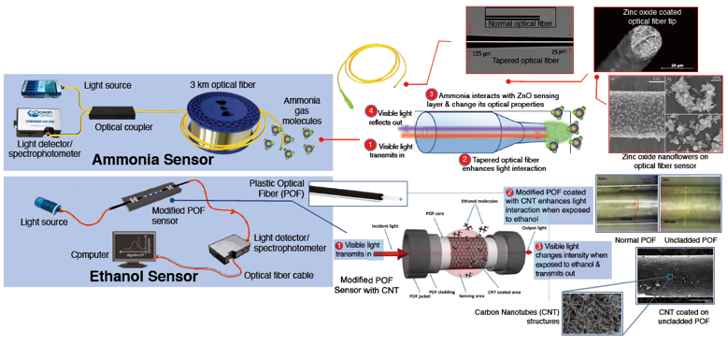
Figure 1: Modified optical fiber sensor for dangerous chemical detection
Recent Publications (minimum 5)
- Ahmed Lateef Khalaf, Taif Sami Hasan, Hayder A Abdulbari, Wafaa A Kadhim, Mohd Hanif Yaacob, "CNT-Based Tapered Optical Fiber for Ethanol Remote Sensing Over 3-kilometer Optical fiber", Journal of Materials Research and Technology, 12(2021) 1738-1746. (Q1)
- Siti Nor Aliffah Mustaffa, Nurul Assikin Ariffin, Ahmed Lateef Khalaf, Mohd Hanif Yaacob, Nizam Tamchek, Suriati Paiman, Suresh Sagadevan, "Sensing mechanism of an optimized room temperature optical hydrogen gas sensor made of zinc oxide thin films," Journal of Materials Research and Technology, 9 (2020) 10624-10634. (Q1)
- A. L. khalaf, A. A. Shabaneh, and M. H. Yaacob "Carbon Nanotubes and Graphene Oxide Applications in Optochemical Sensors," Synthesis, Technology and Applications of Carbon Nanomaterials, 2019, pages 223-246.
- A. L. Khalaf, F. S. Mohamad, N. Abdul Rahman, H. N. Lim, S. Paiman, N. A. Yusof, M. A. Mahdi and M. H. Yaacob, “Room temperature ammonia sensor using side-polished optical fiber coated with graphene/polyaniline nanocomposite,” Optical Materials Express, 6 (2017), 1858–1870. (Q1).
5. A. L. Khalaf, P. T. Arasu, H. N. Lim, S. Paiman, N. A. Yusof, M. A. Mahdi and M. H. Yaacob, “Modified plastic optical fiber with CNT and graphene oxide nanostructured coatings for ethanol liquid sensing,” Optics Express, 25 (2017), 5509–5520. (Q1).

Biography (150 word limit)
Ahmed Lateef khalaf received his B.Sc Eng. degree (Control and Systems Engineering) from University of Technology, Iraq (2001) and M.Sc. Eng, degree (Computer Engineering) from Middle Technical University, Iraq (2008). He did his PhD research at Universiti Putra Malaysia, Malaysia, (2018) in the area of optical sensor based on nanomaterials for chemical sensing applications. Currently, he is a senior lecturer at the Department of Computer Engineering Techniques and Director of Scientific Division, Al-Ma’moon University College. His main research interests are fiber optics sensors, optical chemical sensors, nanomaterials, and computer engineering.
Email: ahmed.l.khalaf@almamonuc.edu.iq

Notes/Comments:

