Design and development of an electrochemical sensing device for heavy metals detection
Antonio Fotia ⁽¹⁾, Angela Malara ⁽²⁾, Patrizia Frontera ⁽²⁾, Lucio Bonaccorsi ⁽²⁾, Emilia Paone ⁽³⁾ Giulia Serrano ^{(3,4)} Andrea Caneschi ^{(3,4)}
- Department Information Engineering, Infrastructure and Sustainable Energy, University of Reggio Calabria, Italy
- Department Civil, Energy, Environmental and Material Engineering, University of Reggio Calabria, Italy
- Consorzio Interuniversitario per la Scienza e la Tecnologia dei Materiali (INSTM), Firenze, Italy
- Department of Industrial Engineering - DIEF, University of Florence, Firenze, Italy

Abstract
Heavy metals are among the main causes of water pollution. They can enter water supply mostly by industrial liquid waste, determining high risk for both the human and the environmental health. Indeed, heavy metals are dangerous since their bioaccumulation can cause important diseases, such as dysfunction of the central nervous system and damage to the blood composition.
Several methods for the detection of heavy metals in water have been developed and many of them are expensive and generally require long time analysis. In these regards, electrochemical impedance spectroscopy (EIS) could be an alternative measurement technique. Moreover, it could be easily incorporated in low-cost sensors for trace metal analysis.
The present work is focused on the development of a portable electrochemical sensing device for the detection of heavy metals in water, able to capture in a highly efficient, selective and not reversible way metallic ions. Therefore, electrochemical techniques combined with electrospun nanofibers has been envisaged as a valid solution. As known, nanofibers are characterized by outstanding properties, such as high porosity, low density and large surface area to volume ratio, making them a suitable substrate for sensing applications.
In addition, they can be functionalized and doped in order to tailor their properties. In particular, conducting nanofibers were obtain by the electrospinning process through a mixture of polyaniline (PANI) blended with polyvinylacethate (PVAc).
EIS measurement were carried out by AMEL 7050 galvanostatic/potentiostatic coupled with AMEL 7200 frequency response analyzer, with three electrodes configurations.
Different solution containing lead, thallium, cadmium or chromium, have been tested by EIS measurement.
Preliminary experiments showed promising results regarding the electrochemical sensitivity and the selectivity of electrospun nanofibers for heavy metals detection. The implementation of a portable device based on STM32board with a specific frequency range of operation was also considered.

Image
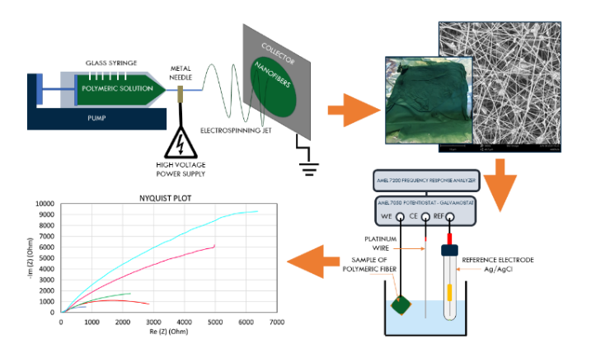

Recent Publications
- Buledi, J.A.; Amin, S.; Haider, S.I.; Bhanger, M.I.; Solangi, A.R. A review on detection of heavy metals from aqueous media using nanomaterial-based sensors. Environ. Sci. Pollut. Res. 2020;
- Li, Y.; Chen, Y.; Yu, H.; Tian, L.; Wang, Z. Portable and smart devices for monitoring heavy metal ions integrated with nanomaterials. TrAC Trends Anal. Chem. 2018, 98, 190–200;
- Zhang, N.; Qiao, R.; Su, J.; Yan, J.; Xie, Z.; Qiao, Y.; Wang, X.; Zhong, J. Recent Advances of Electrospun Nanofibrous Membranes in the Development of Chemosensors for Heavy Metal Detection. Small 2017, 13, 1604293;
- Promphet, N.; Rattanarat, P.; Rangkupan, R.; Chailapakul, O.; Rodthongkum, N. An electrochemical sensor based on graphene/polyaniline/polystyrene nanoporous fibers modified electrode for simultaneous determination of lead and cadmium. Sensors Actuators B Chem. 2015, 207, 526–534;
- Frontera, P.; Busacca, C.; Trocino, S.; Antonucci, P.; Faro, M. Lo; Falletta, E.; Pina, C. Della; Rossi, M. (2013). Electrospinning of Polyaniline: Effect of Different Raw Sources, Journal of Nanoscience and Nanotechnology, Vol. 13, No. 7, pp. 4744-4751(8).

 Biography
Antonio Fotia was born in Reggio Calabria, Italy in 1993. He received the M.S. degree in Environmental and Territorial Engineering from University of Reggio Calabria. Actually, he is Ph.D. student at the University of Reggio Calabria, and his research interests include the development, the synthesis and the characterization of nanostructured materials for energy and sensing applications and the development of portable instrument for test sensing.
Email: antonio.fotia@unirc.it
Notes/Comments:

