On the existing and new potential methods for Partial Discharge source detection
Denis Stanescu, M.S., University of Grenoble Alpes, GIPSA-lab and Military Technical Academy “Ferdinand I”, Romania
Angela Digulescu, PhD, University of Grenoble Alpes, GIPSA-lab and Military Technical Academy “Ferdinand I”, Romania
Cornel Ioana, PhD, University of Grenoble Alpes, GIPSA-lab and
Alexandru Serbanescu, PhD, Military Technical Academy “Ferdinand I”, Romania

Abstract
Energy transmission and distribution networks face an increase in the number of electrical cables used. In such networks the occurrence of defaults given by the type of used cable, the structure and network capacity, voltage levels, and related environmental conditions is inevitable. The difficulties of predictive maintenance of power grids are related to the large spread of electrical infrastructures and the definition of early warning indicators. Such indicator is the partial discharge activities very informative about the rising insulation problems of electrical materials. The monitoring of such phenomena is nowadays important field in the power transmission and distribution [1]. The purpose of this paper is to study different techniques for the detection transient signals in the context of monitoring partial discharges in electrical networks. Among the various techniques developed and used for the detection of partial discharges, we will focus here on four classes of methods, encountered in existing products, for two of them [2], [3], and two new techniques that are based on recent concepts: compressive sensing [4], [5] and phase-diagram-based analysis [6]. The comparative study concerns the evaluation of the probability of detection versus false alarm ratio for real signals generated in a reduced scale experimental facility described in the next figure. That is, thanks to this experimental facility typical for real life configurations, we are able to add to the partial discharge signals perturbations such as load signals, reflexions but also the effect of propagation effects in a real electrical cable.

Image
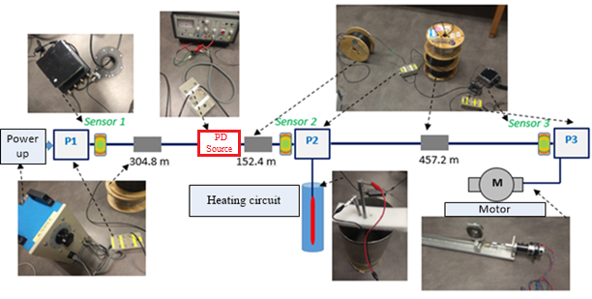

Figure 1: Experimental facility: 914 meters length grid, three reduced scale substations (P1-P3), two loads (motor and heating circuit), one partial discharge source, three local sensing units.
Recent Publications
[1]. G. C. Stone, “Partial Discharge Diagnostics and Electrical Equipment Insulation Condition Assessment”, IEEE Transactions on Dielectrics Electrical and Insulation, Vol. 12, pp. 891-903 (2005).
[2]. Bertrand Gottin, Cornel Ioana, Jocelyn Chanussot, Guy d'Urso, Thierry Espilit. Detection and Localization of Transient Sources: Comparative Study of Complex-Lag Distribution Concept Versus Wavelets and Spectrogram-Based Methods. EURASIP Journal on Advances in Signal Processing, SpringerOpen, 2009, pp.Article ID 864185
[3]. Peter VAN DER WIELEN Fred STEENNIS, “First Field Experience of On-line Partial Discharge Monitoring of MV Cable Systems with location”, CIRED 2009, Prague, 2009.
[4]. I Stanković, C Ioana, M Daković , On the reconstruction of nonsparse time-frequency signals with sparsity constraint from a reduced set of samples, Signal Processing 142, 480-484
[5]. Isidora Stankovic, Angela Digulescu, Cornel Ioana, Kevin Dayet, “Electric arc detection using compressive sensing”, GRETSI 2019, 2019, Lille
[6]. Digulescu A, Ioana C, Serbanescu A, “Phase Diagram-Based Sensing with Adaptive Waveform Design and Recurrent States Quantification for the Instantaneous Frequency Law Tracking”, Sensors (Basel), 2019 May 28

 Biography
Cornel Ioana received the Dipl.-Eng. degree in electrical engineering from the Romanian Military Technical Academy of Bucharest, Romania, in 1999 and the M.S. degree in telecommunication science and the Ph.D. degree in the electrical engineering field, both from University of Brest-France, in 2001 and 2003, respectively. Between 2003 and 2006, he worked as Researcher in ENSTA-Bretagne, Brest, France. Since 2006, he has been an Associate Professor-Researcher with the Grenoble Institute of Technology/GIPSA-lab. His current research activity deals with the signal processing methods adapted to the natural phenomena. His scientific interests are nonstationary signal processing, natural process characterization, underwater systems, distributed sensing and artificial intelligences approaches applied to the surveillance of power systems and natural environments.
Email:
cornel.ioana@gipsa-lab.grenoble-inp.fr

