Deformable Structures for Flexible Smart Materials and actuators
Zunfeng Liu, Professor of Chemistry, College of chemistry, Nankai University, Tianjin Province, China
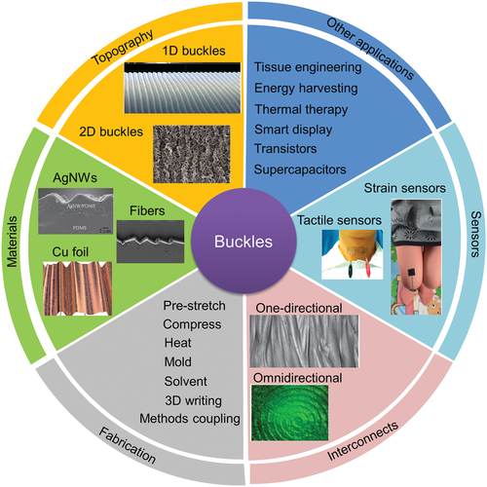

Abstract
Superelastic conducting composites with improved properties and new functionalities are needed for applications ranging from electronic interconnects to sensors and electrically driven artificial muscles. In this talk, I will present our work using hierarchically buckled sheath-core structures based on carbon nanotube sheets and rubber fiber. Various applications such as superelastic conducting fibers, resistive and capacitive strain sensors, stretchable antennas and artificial muscles will be demonstrated. I will further show their applications in wearable healthcare devices such as stretchable electrodes for glucose detection, body temperature sensor, artificial muscle, and inflatable electrocauterization devices. In addition, by introducing twisting technology into the fiber, the stretching stroke of the artificial muscle fiber is greatly increased, and a moisture-sensitive smart fabric is constructed. The smart fabric is woven by the stretching muscle of silk to realize the stretching of the length of the smart fabric when the environmental humidity changes. Besides, the double mechanism of thermal expansion and infrared absorption is also used to achieve the overspeed movement of artificial muscle. The water-sensitive textile can realize the management function of water and heat by changing the shape and structure, which is expected to bring new opportunities to the intelligent textile field.

Image

Figure1. Schematic illustration of buckled structures for wearable electronics.
Recent Publications
- Zunfeng Liu, Shaoli Fang*, Francisco A. Moura, et al. Science, 2015, 349, 400.
- Hongyan Wang#, Zunfeng Liu# (equal contribution), Jianning Ding, et al. Adv. Mater. 2016, 28, 4998.
- Xiaoyu Hu; Yuanyuan Dou; Jingjing Li, Small. 2019, DOI: 10.1002/smll.201804805.
- Run Wang, Shaoli Fang, Yicheng Xiao et al. Science, 2019, 366, 216.
- Tianjiao Jia, Yang Wang, Yuanyuan Dou et al., Adv. Fun. Mater. 2019, DOI: 10.1002/adfm.201808241.


Zunfeng Liu has published 68 peer reviewed SCI papers and cited for 6379 times by other researchers. Among them, there are 30 papers which were published by first-author or corresponding-author on Science, Adv. Mater., Adv. Funct. Mater., etc. Zunfeng’s current research interests are elastic and flexible devices, artificial muscles, wearable electronics and sensors. He has given 40 plenary or invited talks in national and international conferences about the wearable electronics. To date, He has 2 issued Chinese patents and 15 pending Chinese patents. Liu has obtained honors including “National special support program for high-level personnel recruitment”, “the introduction plan of high-level creation and innovation talent of Jiangsu province”, “the distinguished professor of Jiangsu province” and “the 12th outstanding scientist of Jiangsu province”
Email:liuzunfeng@nankai.edu.cn

This work was supported by the National Natural Science Foundation of China (Grants U1533122 and 51773094), the Natural Science Foundation of Tianjin Province, China (Grant No. 18JCZDJC36800)

