The use of Artificial Intelligence (AI) in Clinical Laboratory for Population Based Cervical Cancer Screening and Diagnosis

Bojana Turic, Wuhan Landing Intelligence Medical Co., Ltd Wuhan, China
Xiaorong Sun, Wuhan Landing Intelligence Medical Co., Ltd Wuhan, China
Boachun Pang, Wuhan Landing Intelligence Medical Co., Ltd Wuhan, China
Dr Wang Jian, Wuhan Landing Intelligence Medical Co., Ltd Wuhan, China

Abstract (300 word limit)
Background In the last few years internet technology has played a very important role in reinventing various medical procedures and allowing quick access to medical services, particularly in the remote areas of China. Use of (AI) and cloud computing in clinical laboratories for slide analysis has potential to compensate for a country-wide lack of pathologists. We used an automated scanner as well as mobile devices for screening and pathology diagnosis in a cervical cancer screening for rural women in Hubei province in China. Design In 2017 we launched a prospective cohort study where 703 103 women were enrolled in cervical cancer screening program using a validated AI-assisted cytology system. Each woman with slides classified as abnormal by either AI-assisted or manual reading and 10% negative randomly selected (AI selected) was referred for colposcopy and subsequent biopsy. We compared cytologists’ reports with AI reports for subsets of all slides. The outcomes were histologically confirmed cervical intraepithelial neoplasia grade 2 or worse (CIN2+). We measured economic value of this approach and compared it with the current standard of practice. In addition, we used mobile device to scan biopsy slides and applied a different algorithm to generate diagnosis. Those were compared with manual reading. Results AI-assisted cytology was 5.8% (3.0%-8.6%) more sensitive for detection of CIN2+ than manual reading with a slight reduction in specificity. We concluded that combining AI and cloud computing is the ideal approach for cervical cancer screening programs, providing the best service delivery and standardization across the entire program while maintaining high standards of quality control. Conclusion Our data showed that AI, cloud computing combined with mobile phone units can assist pathologists at every step of their work, bringing important laboratory services across geographic regions where pathology expertise is not available or there is a lack of it.

Image
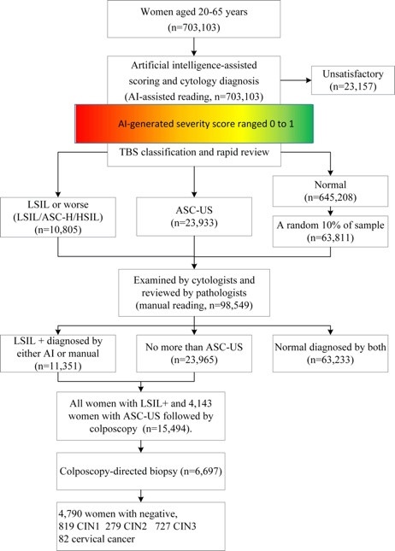
Recent Publications (minimum 5)
- Mell P., Grance T., The NIST Definition of Cloud Computing, NIST Special Publication 2011: 800-145,
- Li J., Kang L., Qiao Y.: Review of the Cervical Cancer Disease Burden in Mainland China, Asian Pacific J Cancer Prev, 12, 1149-1153
- Di J. Rutherford S., Chu C.: Review of the Cervical Cancer Burden and Population-Based Cervical Cancer Screening in China, Asian Pac J Cancer Prev., 2015 16 (17), 7401-7407
- Cohen PA. Cervical Cancer, Lancet, 2019, 393： 169-182.
5. Wang Y.,, Wei L., Liu J.,, Li S., Wang Q.,Comparison of Cancer Incidence between China and the USACancer Biol Med 2012; 9: 128-132 doi: 10.3969/j

 Biography
. Dr. Bojana Turic was a part of the executive team at PMI labs, a Vancouver-based private spin off company from BC Cancer Agency that focused on early cancer detection. She led the company through all steps from a concept through significant clinical and regulatory milestones including positioning the company as a leader in early cancer diagnostic technologies, the development of strategic commercialization alliances, and execution of the company’s first commercial agreements. She was also instrumental for expanding private pathology services in BC. At present she is a part of Landing Medical High Tech Co. team where she supports the use of AI application for cervical cancer screening. Dr. Turic completed her MD at the University of Sarajevo, Bosnia and Herzegovina where she held the position of Assistant Professor of Medical Microbiology. She finished her fellowship in Medical microbiology at the University of Zagreb, Croatia.

Email: Bojana.turic@gmail.com

