Theory of gyroscopic effects for rotating objects
Ryspek Usubamatov, Dr.Tech.Sc, Kyrgyz State Technical University, Kyrgyzstan

Abstract

Gyroscopic effects started to study at the beginning of the eighteenth century, which analytical models did not match with practices. The famous scientists of those times could not solve gyroscopic effects in principle, because the physical terms of the kinetic and potential energy were developed one century later. The recent research demonstrated the physics of the gyroscopic effects are many times harder than represented in known theories. This problem has solved by a new analytical approach constituted on the principle of the kinetic energy conservation law for rotating objects. The gyroscopic effects are the result of the action of the system of eight interrelated inertial torques and the dependency of the angular velocities of the spinning objects around axes of rotation. The inertial torques generated by the centrifugal, common inertial, Coriolis forces, as well as the change in the angular momentum of the rotating mass. All types of inertia torque of rotating objects depend on their geometry that can be presented by the sphere, cone, paraboloid, ellipsoid, propeller, etc. This system represents the fundamental principles of the gyroscope theory. All gyroscopic effects are described by mathematical models, explained their physics, and validated by practical tests. A new analytical approach to gyroscopic effects demonstrates the new phenomena of the deactivation of inertial forces acting on the rotating objects that is the result of their interrelations at the specific condition. The new solutions for gyroscopic effects are represented the breakthrough gyroscope theory that scientists tried to find for a long time. The new approach to the dynamics of rotating objects opens a new chapter in classical mechanics.

Image
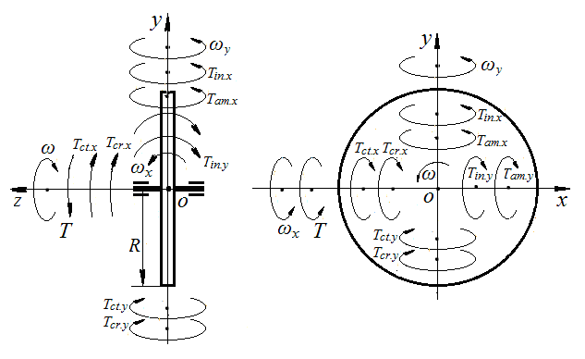
Figure 1. Load and inertial torques and motions acting around axes on the spinning disc
Recent Publications
- R. Usubamatov, Mathematical model for motions of gyroscope suspended from flexible cord, Cogent Engineering, 2016, 3; 1245901.
- R. Usubamatov, Inertial Forces Acting on Gyroscope, Journal of Mechanical Science and Technology, 32 (1), 2018, pp. 101-108

R. Usubamatov, Physics of gyroscope nutation, AIP Advances 9, 105101 2019; https://doi.org/10.1063/1.5099647.
- R. Usubamatov, Physics of gyroscope’s “anti-gravity effect”, Mathematical Problems in Engineering, 2019, Vol. 2019, Article ID 4197863.
- R. Usubamatov and A. Arzybaev, Inertial Torques Acting on a
Spinning Paraboloid, AIP Advances 10, 055124 (2020); https://doi.org/10.1063/1.5145389

 Biography (150 word limit)
Dr. Ryspek Usubamatov studied Mechanical and Manufacturing Engineering at Bauman Moscow State Technical University that graduated as a professional engineer in 1966 and received his Ph.D. in 1972 at the same university. After several years of postdoctoral research, he obtained the degree of Dr. Tech. Sc at the Kyrgyzstan Academy of Sciences. He has published as author and co-author more than 400 research manuscripts and half of them in reputed international journal and conferences in English, 8 books, 30 brochures, and 60 patents of inventions. His research interests are Productivity Theory for Industrial Engineering and Theory of Gyroscopic Effects. Currently, he is a Professor of Kyrgyz State Technical University after I. Razzakov, Kyrgyzstan. He is also member of several editorial board of international journals and member of organizing committees of several international conferences.

Email: ryspek0701@yahoo.com

Notes/Comments:

