Deep Learning for Intrusion Detection
Jemili Farah, PhD Eng, University of Sousse, TUNISIA

Abstract
In recent years, the world has seen a significant evolution in the different areas of connected technologies such as smart grids, the Internet of vehicles, long-term evolution, and 5G communication. By 2023, it is expected that the number of IP-connected devices will be three times larger than the global population, and the total number of DDoS attacks will double from 7.9 million in 2018 to 15.4 million by 2023 as reported by Cisco.
As of 2020, the amount of data generated each day is exceeding petabytes and this includes the traces that internet users make when they access a website, mobile application or a network. This growth gave more space to hackers to launch their malicious attacks and use development techniques and tools for intrusion. Intrusion detection systems (IDSs) are one of the most important systems used in cyber security. Intrusion detection systems are the hardware or software that monitors and analyzes data flowing through computers and networks to detect security breaches that threaten confidentiality, integrity and availability of a system’s resources. According to IBM, the costs of data breaches have increased from $3.86 million to $4.24 million in 2021. This is a loss that no business would be able to sustain. That's why, as Forbes reports, 83% of enterprise workloads will move to the cloud by 2020, making it necessary to develop new and efficient IDS.
Deep learning for intrusion detection is one of the hot topics in recent academic research. With the improvement of computing power and the rapid growth of the volume of data, the development of deep learning have attracted people’s attention again, so that the practicality and popularity of deep learning have greatly improved. Deep learning is an advanced branch of machine learning that uses multi layer networks. The layers are connected by neurons, which represent the mathematical computation of the learning processes.
Intrusion detection has been widely studied in both industry and academia, but cybersecurity analysts always want more accuracy and global threat analysis to secure their systems in cyberspace. Big data represents the great challenge of intrusion detection systems, making it hard to monitor and analyze this large volume of data using traditional techniques. Recently, deep learning has been emerged as a new approach which enables the use of Big Data with a low training time and high accuracy rate.
This contribution proposes an approach of an IDS based on cloud computing and the integration of big data and deep learning techniques to detect different attacks as early as possible. To demonstrate the efficacy of this system, the proposed system is implemented within Microsoft Azure Cloud, as it provides both processing power and storage capabilities, using a convolutional neural network (CNN–IDS) with the distributed computing environment Apache Spark, integrated with Keras Deep Learning Library.
The proposed approach includes the pre-processing of data and deep learning. The experimental results show effectiveness of the approach in terms of accuracy and detection rate due to the integration of deep learning technique and Apache Spark engine.

Image
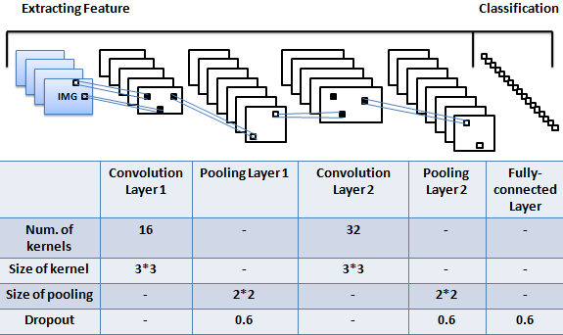
Fig1. CNN Model and Parameters

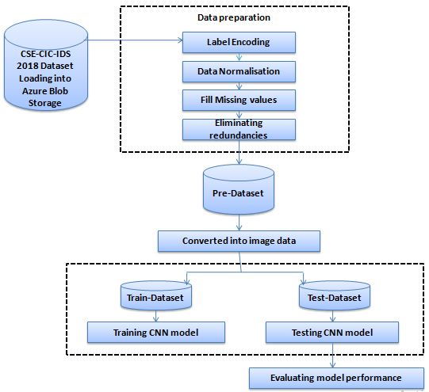
Fig2. Proposed Approach

Recent Publications
- M. Essid, F. Jemili, O. Korbaa (2021) Distributed Architecture of Snort IDS in Cloud Environment. Intelligent Systems Design and Applications, ISBN: 978-3-030-49341-7 100-111.
- M. Elayni, F. Jemili, O. Korbaa, B. Solaiman (2021) Big Data Processing for Intrusion Detection System Context: A Review. Intelligent Systems Design and Applications, ISBN 978-3-030-49341-7 122-131.
- A. Abid, F. Jemili (2020) Intrusion Detection based on Graph oriented Big Data Analytics. Procedia Computer Science (1877-0509) 572-581.
- R. Ben Fekih, F. Jemili (2020) Distributed Architecture of an Intrusion Detection System Based on Cloud Computing and Big Data Techniques. Proceedings of the 8th International Conference on Sciences of Electronics, Technologies of Information and Telecommunications (SETIT’18), Vol.1 192-201.
- R. Meddeb, F. Jemili, B. Triki, O. Korbaa (2019) Anomaly-based Behavioral Detection in Mobile Ad-Hoc Networks. Procedia Computer Science (1877-0509) 77-86.


Biography
Farah JEMILI had the Engineer degree in Computer Science in 2002 and the Ph.D degree in 2010. She is currently Assistant Professor at Higher Institute of Computer Science and Telecom of Hammam Sousse (ISITCOM), University of Sousse, Tunisia. She is a senior Researcher at MARS Laboratory (ISITCOM –Tunisia). Her research interests include Artificial Intelligence, Cyber Security, Big Data Analysis, Cloud Computing and Distributed Systems. She served as reviewer for many international conferences and journals. She has many publications; 6 book chapters, 6 journal publications and more than 20 conference papers.

Email:jmili_farah@yahoo.fr

