Biography

Nadine Hachach Haram, BEM

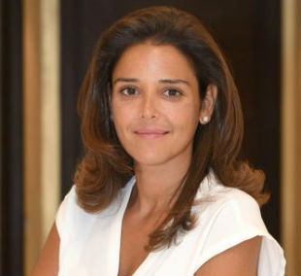

Dr. Nadine Hachach-Haram, BEM, the recipient of the British Empire Medal in the Queen’s Birthday Honours for 2018, is an NHS surgeon, lecturer and clinical entrepreneur. Nadine drew on her passion for innovation, education and global surgery to found Proximie, an augmented reality platform aiming to improve access to expert care and to scale clinical expertise. Through its patented platform doctors can virtually transport themselves in to any clinical setting to visually and practically interact and collaborate. From marking up a patient to providing real-time virtual presence overlaid with content and a rich palate of augmented reality they aim to provide safe, accessible and high-quality care to every patient around the world. Proximie has enjoyed significant success with early adoption by major medical institutions and device companies and has been covered by news agencies around the world. Dubbed by CNN the "Future of Surgery," Proximie has gone from strength to strength and won multiple awards including Foreign Press Association Science Story of the Year.
Nadine has been selected as an Endeavor entrepreneur, is a member of the Royal College of Surgeons’ Commission on the Future of Surgery, consisting of some of the country’s leading doctors, engineers, data experts, managers, and patient representatives with the objective to investigate the advances that will transform surgery over the next 20 years, and Faculty at Singularity & Exponential Medicine. She is also the Clinical lead for Innovation at Guys & St Thomas’ Hospital
When she isn’t working, Nadine spends her time with her husband and 3 children in London.

