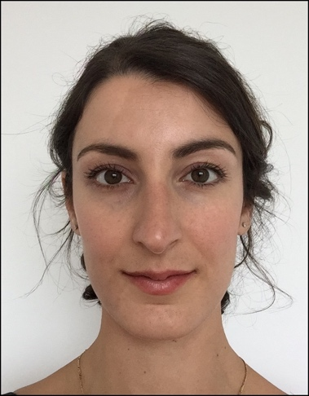

Title: Robotic right hemicolectomy with complete mesocolic excision - A video vignette.
DOI: 10.1111/codi.15233

Name: Dr Jessica Rahme

University of Melbourne, Australia
Austin Hospital, Victoria, Australia

Rahme J , Rajkomar A, Larach JT, Smart P, Warrier S

In this Video, our method for performing a robotic right hemicolectomy with central mesocolic excision is described. We present the case of a 42-year-old woman with a hepatic flexure proficient mismatch repair adenocarcinoma with no significant medical or family history. A superior mesenteric vein first technique was used for the central mesocolic excision. Once complete, the ileum and transverse colon were divided to remove the tumour and an isoperistaltic side-to-side anastomosis was made. The pathology revealed a poorly differentiated adenocarcinoma 65 mm in maximum dimension with clear margins. There was no evidence of malignancy in 62 harvested lymph nodes. The patient was discharged on day 2 postoperatively and there were no short- or long-term complications.

https://www.youtube.com/watch?v=F9pgdx3vHWc&feature=youtu.be

Biography

Dr Jessica Rahme has completed her BMBS at Deakin University as is currently working as a General Surgery Registrar at Austin Hospital in Australia. She is completing a thesis on Robotic Surgery Education at University of Melbourne in Australia. She has published more than 10 papers in reputed journals and has been serving as an editorial board member of repute.

Research Interest: Colorectal Robotic Surgery

Presenting author details:
Full name: Dr Jessica Rahme
Contact number/ WhatsApp No: 0415655990
Twitter account: @RahmeJessica
Category (Oral presentation/ Poster presentation): Oral Presentation

