THE DESIGN OF AN UNMANNED AERIAL VEHICLE

BALAJI THIRU, ELANGOVAN MUNIYANDY, S.SANKAR RAM
Veltech Rangarajan Dr Sagunthala R&D Institute of science and technology,
Anna University,
Tamil nadu, India

Abstract
This paper revolves around the game-plan, appearing, usage and testing of a programmed automated airborne vehicle. The regulator depends on a got together with mechanical assembly to switch control between the RC control and the autopilot control (that is the multiplexer/shield, for the most part called MUX).This control course (following GPS waypoints) and height by controlling the rudder and choke. The structure utilizes flight adjustment structure (co-pilot), a sensor pack, Global Positioning System(GPS) and a RF handset to screen and report tremendous boundaries, for example, rise, speed ,pitch, roll, and position. A shown programming assessment has been made to pull in the aeronautical vehicle achieve the necessary self-affiliation and keep up commendable flight activity.
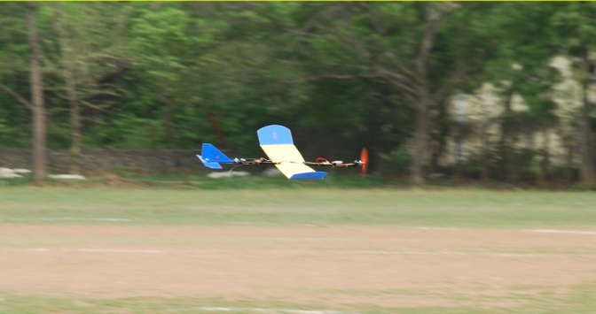
Recent Publications (minimum 5)
- Introduction to UAV Systems, Paul G. Fahlstrom, Thomas J. Gleason.
- T. Chang and H. Yu, “Improving Electric Powered UAVs' Endurance by Incorporating Battery Dumping Concept,” Procedia Engineering, vol. 99, pp. 168–179, 2015.
- D. L. Gabriel, J. Meyer, and F. Plessis, “Brushless DC motor characterisation and selection for a fixed wing UAV,” in IEEE Africon '11, pp. 13–15, Livingstone, Zambia, 2011.
- S. G. Kontogiannis and J. A. Ekaterinaris, “Design, performance evaluation and optimization of a UAV,” Aerospace Science and Technology, vol. 29, no. 1, pp. 339–350, 2013.
- B. Wainfan, Airfoil Selection: Understanding and Choosing Airfoils for Light Aircraft, B. Wainfan, 2005.


Balaji Thirunauvkkarasu, born in Tamil Nadu, India on 13th May 1989, obtained his B.E degree in Mechanical Engineering in 2011 from the Anna University, Chennai and he has completed his M.Tech in Robotics at SRM University, Chennai. He is presently serving as Assistant Professor at Vel Tech University, Chennai, with his thirst for research in Robotics. He has successfully completed a Government Project on Solar Aircraft of Unmanned Aerial Vehicle Design funded by the Tamilnadu State Council for Science and Technology, during 2011.
This budding researcher has also received Best Project Awards and the Young Scientist Award for his innovative projects on Robotics /Aircraft Design in various forums from different organizations. He has also published more than 12 papers in leading national and international conferences and reputed journals. He has developed many products for educational based robot and has delivered several lectures for schools and colleges. He published book for technical –How to Make Robot,Mr.Balaji has visited many countries, including like USA, JAPAN and given interviews in local TV Channels, Magazines and some Daily news media. Media have given enough coverage to his models on Robotics to foster his quest for innovation.

Email: tbalaji@veltech.edu.in

