MUTLIFUNCTIONAL ROBOT VECHICLE

BALAJI THIRU, RAVICHANDRAN. A.T, ELANGOVAN MUNIYANDY
Veltech Rangarajan Dr Sagunthala R&D Institute of science and technology,
Tamil nadu, India

Abstract
The multifunctional controller vehicle comprises of three primary capacities. Initial one is bomb distinguishing. Second one is putting out fires and last one is sun powered grass shaper. These capacities are very utilize full in numerous applications. For example, armed force, homegrown, mechanical, timberland insurance and etc.,the bomb identifying give an additional line safeguard to the military warriors and the bomb crew. The putting out fires framework go about as a fire douser during fire mishap and the sunlight based grass shaper is utilized to cut the grass with the assistance of sun based force and straightforward instrument. In this sun based grass shaper framework the sun based vitality utilized as source vitality so contamination is decreased and fuel isn't too used to even consider running the vehicle.
The principle point of the Multifunctional Remote Control Vehicle (MFRCV) is to decrease the expense and development space and increment the work proficiency. In this task the three capacities are included. The bomb identifying framework is utilized to distinguish the bomb in the war place and some other spot. These bomb recognizing frameworks comprise of electromagnetic sensor. This sensor is worked by the guideline of electromagnetic enlistment. At the point when the current conveying Material to be set close to it, it will deliver attractive acceptance.
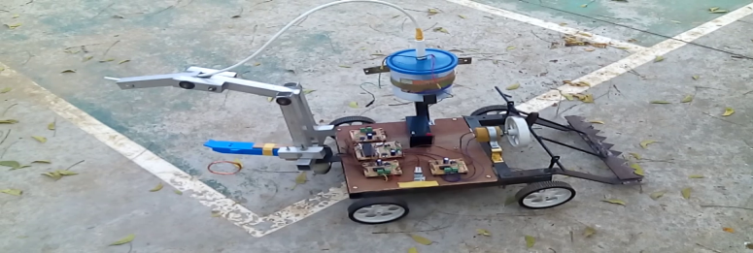
Recent Publications (minimum 5)
- Steve Rapp, classification of robots, A. Linwood Holton Governor's School. C (2009).
- S.Salmi, and S.Yl¨onen. Hybrid locomotion of a wheel-legged machine. In Proceeding CLAWAR’s of the International Conference on Climbing and Walking Machine, Madrid, 2000. M, Egli M (2006).
- M. Das. Advanced Soil Mechanics. Taylor and Francis, ISBN 0-89116-980-6 1983.
- C. Grand, F. Ben Amar, P. Bidaud, and G. Andrade. A simulation system for behaviour evaluation of oﬀ-rooad mobile robots. In Proceedings CLAWAR’s of the International Conference on Climbing and Walking Robots, pages 307–314, Germany, 2001.
5. Purdy M. E., Presentation slide “Ground robotics technology”, Joint Ground Robotics Enterprise, Department of Defense, June 2007


Balaji Thirunauvkkarasu, born in Tamil Nadu, India on 13th May 1989, obtained his B.E degree in Mechanical Engineering in 2011 from the Anna University, Chennai and he has completed his M.Tech in Robotics at SRM University, Chennai. He is presently serving as Assistant Professor at Vel Tech University, Chennai, with his thirst for research in Robotics. He has successfully completed a Government Project on Solar Aircraft of Unmanned Aerial Vehicle Design funded by the Tamilnadu State Council for Science and Technology, during 2011.
This budding researcher has also received Best Project Awards and the Young Scientist Award for his innovative projects on Robotics /Aircraft Design in various forums from different organizations. He has also published more than 12 papers in leading national and international conferences and reputed journals. He has developed many products for educational based robot and has delivered several lectures for schools and colleges. He published book for technical –How to Make Robot,Mr.Balaji has visited many countries, including like USA, JAPAN and given interviews in local TV Channels, Magazines and some Daily news media. Media have given enough coverage to his models on Robotics to foster his quest for innovation.

Email: tbalaji@veltech.edu.in

