

Abstract Template

Title: LARGE SPONTANEOUS RIGHT CATAMENIAL PNEUMOTHORAX WITH DIAPHRAGMATIC DEFECT AND LIVER HERNIATION
Mukku VK¹, Cassidy E², Negulescu C¹, Jagneaux T³ , Godke J³

- Department of Internal Medicine, Baton Rouge General Internal Medicine Residency Program
- Cardiovascular Thoracic Surgery, CVT Surgical Center, Baton Rouge
- Pulmonary Critical Care, Louisiana State University Health Sciences Center, Baton Rouge Campus

Keywords: Catamenial pneumothorax, diaphragmatic defect, liver herniation, video-assisted thoracoscopic surgery, mechanical pleurodesis

- Abstract Body (up to 250 words)
Catamenial pneumothorax (CP) is a spontaneous pneumothorax that occurs predominantly in women of child bearing age (1). In the literature, only few cases of CP with diaphragmatic defect and liver herniation are reported (2). We present a case of 40 year old nulliparous woman with medical history significant only for endometriosis presented with severe chest tightness of 1 day duration. Chest radiography (CXR) showed a large right spontaneous pneumothorax with what was thought to be, a 5.6 cm pleural mass at the right lung base (image 1). Following the pneumothorax diagnosis, the patient underwent emergent right thoracostomy with pigtail catheter placement. A repeat CXR revealed marked reexpansion of the lung but persistence of the right pleural mass. A follow up computed tomography scan of chest showed 33mm diaphragmatic defect with a 5.8 x 4.6 x 3.9 cm area of herniated liver corresponding to presumed pleural mass (image 2). Following complete thoracic imaging the patient underwent video-assisted thoracoscopic surgery (VATS), mechanical pleurodesis, and open repair of the right diaphragmatic defect (images 4, 5 & 6). Intraoperatively, an endometrial implant was noted on chest wall (image 3). On post-operative day-3, she began her menstrual cycle and was evaluated by a gynecologist who recommended hormonal therapy to reduce the risk of recurrent pneumothorax. Due to persistent air leak, chest tube was transitioned to Heimlich valve to facilitate home discharge. The patient was discharged on postoperative day 8 and seen as an outpatient with resolution of air leak and removal of chest tube.

Images:

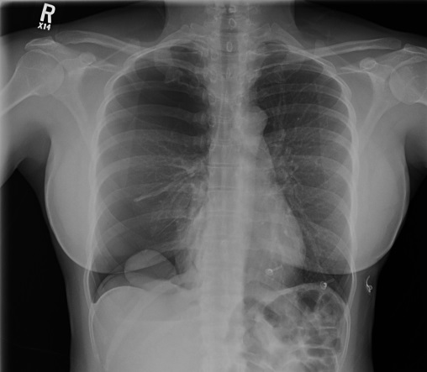
image 1. Blue arrows showing pneumothorax, diaphragmatic air and orange arrow showing large 56mm mass at base of lung confirmed as liver on CT scan
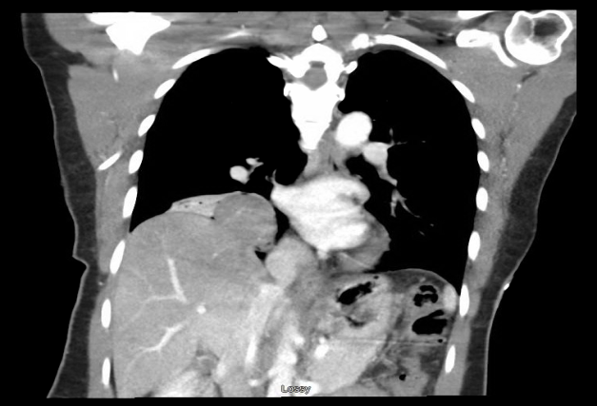
image 2: Coronal view of CT showing 33mm diaphragmatic defect with liver herniation, 5.8 x 4.6 x 3.9cm
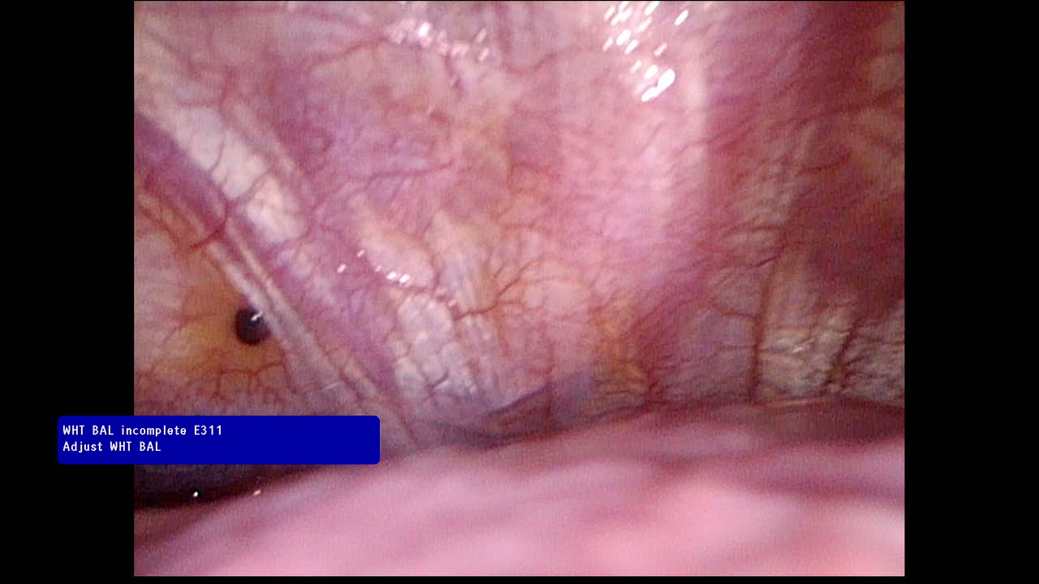 image 3. Endometrial implant on Chest wall
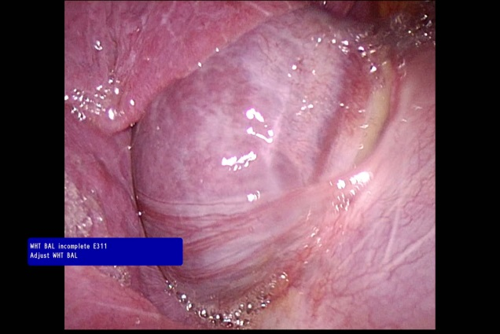image 4 – Diaphragmatic defect with herniation of liver

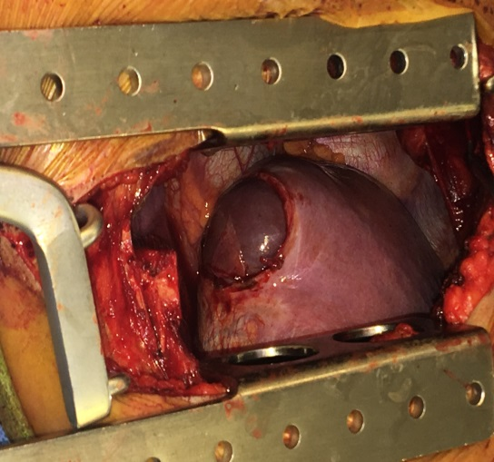
image 5: Diaphragmatic defect with herniation of liver before repair

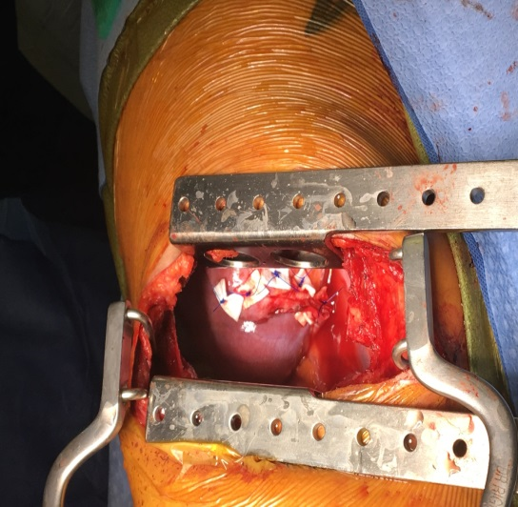
image 6: Repair of diaphragmatic defect

Reference:

1 1. A.N. Visouli, K. Darwiche, A. Mpakas, et al., Catamenial pneumothorax: a rare entity? Report of 5 cases and review of the literature, J. Thorac. Dis. 4 (S1) (2012) 17–31.
2. Visouli AN1, Zarogoulidis K et al., Catamenial pneumothorax. J Thorac Dis. 2014 Oct;6(Suppl 4):S448-60.

Biography:
Dr. Venkata Kishore Mukku is an internal medicine resident at Baton Rouge General Interanal Medicine Residency Program affiliated to Tulane Univeristy School of Medicine. Currently, he is doing 2nd year of internal medicine. He has 9 peer reviewed published articles and 10 abstracts.

Presenting author details

Full Name: Venkata Kishore Mukku, MD Contact number: 409-543-2001
Session name/ number:
Category: Oral presentation/ Poster presentation Passport Number:
USA 477314273

Copyright © 2016-2018 Meetings Int PTE Ltd, All Rights Reserved.
Meetings Int.Pte Ltd

Company Registration No: 201524282R,28 MAXWELL ROAD, #03-05 RED DOT TRAFFIC, SINGAPORE (069120)
Tel: 65-310-80483 Toll Free: +800-852-6126
Web: https://www.meetingsint.com/conferences/pulmonarymedicine | E-mail respiratorydisease@meetingseries.org

