

Abstract Template

Title: An evaluation of compliance, knowledge and attitudes related to the new 100% smoke-free law in bars and restaurants in Kampala, Uganda.
1Advocacy Officer Framework Convention Alliance for Tobacco Control, Yaounde, Cameroon
2Department of Education, Community Action and Intervention, University of Yaounde I, Cameroon

Keywords: Compliance, Knowledge, attitudes, 100% smoke-free law, bars, restaurants, PM2.5

- Abstract Body (up to 250 words)
The present study was focused on evaluating the Ugandan new smoke-free law in high-risk venues. People who work in bars and restaurants, in countries without a smoke-free policy, are the occupational group at highest risk of SHS exposure. We used an established observational checklist (developed by John Hopkins School of Public Health) and we also measured PM2.5 – which is particulate matter in the air which gives us information on the level of second hand smoke in the air. Findings: Our team employed Gabriel Okello, an expert in the measurement of PM2.5. For 24 venues roughly one fifth – the PM2.5 levels were so low that there was no evidence of second hand smoke. But for most of venues there was second hand smoke. Looking at table below, there was second hand smoke at outdoor areas of 17 venues, which resulted in an Unhealthy level (as deemed by the US Environmental Protection Agency), and for the 67 venues where there was second hand smoke indoors, this was found to be at a level classified as hazardous. Our data collection team visited a subsample of venues, 108 venues. They spent two hours at each venue with a sidepak device that measures air quality. I believe they made repeated visits to each venue at different times of day, to give an average PM2.5 reading. This shows a pretty concerning situation where despite the new smoke-free law, people attending these venues and working in these venues are being exposed to high levels of second hand smoke. PM2.5 particles, being air pollutants with a diameter of 2.5 micrometers or less, small enough to invade even the smallest airways and scientifically known to cause respiratory and cardiovascular illness.

Image:
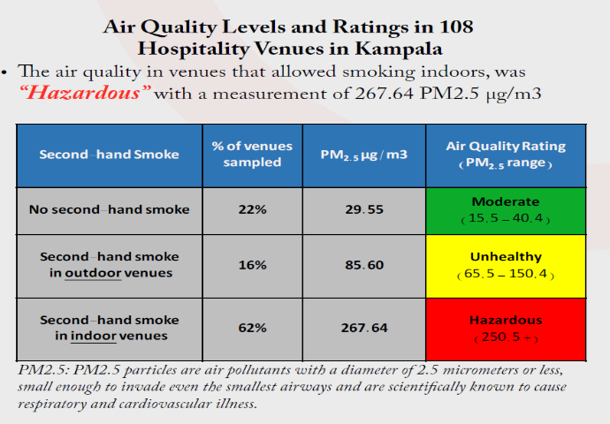
- Reference:

- Gravely S (2017) Knowledge, opinions and compliance related to the 100% smoke-free law in hospitality venues in Kampala, Uganda: Cross-sectional results from the KOMPLY Project. BMJ Open. 2017-017601
- 17th World Conference on Tobacco or Health (WCTOH 2018). Monitoring Compliance of a Smoke-free Law and Overcoming Obstacles in Compliance with Smoke-free law in Hospitality Venues, KOMPLY Project, World Heart Federation.

Biography:
Elvis Ndikum has his expertise in clean air advocacy collaboration and passion in improving the health and wellbeing. He is currently working with the Framework Convention Alliance (FCA) for Tobacco Control as Advocacy Officer for Afro Region. He is a World Heart Federation (WHF) Emerging Leader 2016 cohort with focus on tobacco to reduce premature CVD death globally by at least 25% by 2025. He participated during the 16th and 17th World Conferences on Tobacco or Health (WCTOH 2015/2018) respectively. Elvis is member of The Union since 2015, and Principal Investigator for Yaounde, Cameroon with the Global Asthma Network. He is also National President with the Association for the Promotion of Youth Leadership, Advocacy and Volunteerism (APYLAV Cameroon). A graduate student in Community Action and Intervention from the University of Yaounde I.

Presenting author details


Elvis Ndikum Contact number: +237 675956499 : Linked In account: https://www.linkedin.com/in/achiri-ndikum-aaaa95101
Session name/ number:
Category: (Oral presentation/ Poster)
Passport N°:0680437

Copyright © 2016-2018 Meetings Int PTE Ltd, All Rights Reserved.
Meetings Int.Pte Ltd

Company Registration No: 201524282R,28 MAXWELL ROAD, #03-05 RED DOT TRAFFIC, SINGAPORE (069120)
Tel: +1-302-231-6756 ; +6531080483| Toll Free no. +800-852-6126
Web: http://www.meetingsint.com/conferences/foodtechnology | E-mail foodtechnology@meetingseries.org

