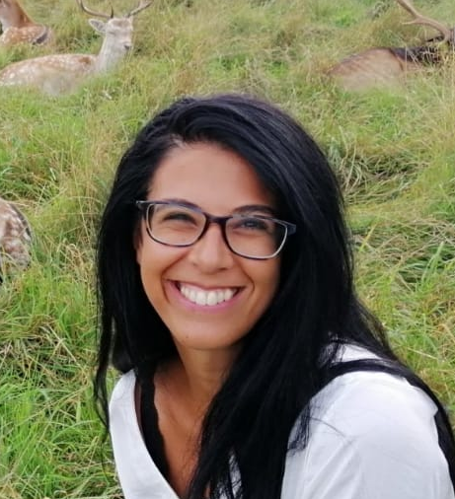
Black Carbon as an Additional Indicator of the adverse health effects at urban scale
Ornella Salimbene¹, L. Boniardi², A.M. Lingua¹, M. Ravina¹, M. Zanetti¹, D. Panepinto¹, M.B. Romero³, F. Pilla⁴
¹Politecnico of Torino (Italy)
²Università Statale of Milano (Italy)
³University of Castilla La Mancha (Spain)
⁴University college of Dublin (Ireland)

Abstract:
Problem statement: Continuous personal monitoring is a benchmark for assessing exposure to air pollution. European air-quality standards for particulate matter (PM) use mass concentration of PM (PM with aerodynamic diameters ≤ 10 μm (PM10) or ≤2.5 μm (PM2.5)) as the metric. It would be desirable to use if black carbon (BC) can be as a better and newer indicator than PM10 and PM2.5. For these objectives it is necessary to implement social, environmental and clinical data by developing real-time laboratories on an urban scale. This research discusses the integrated approach of three pilot studies developed in the city of Turin (Italy) which involved the resident population and some volunteers with Chronic obstructive pulmonary disease (COPD) respiratory disease. Methodology and Theoretical Orientation: The Living Lab developed in Turin was organized in three pilot studies (LL). LL#1 involved 15 volunteer citizens residing in Turin who were observed and monitored for a week in November 2021. The aim was to collect information on the exposure of citizens at the neighborhood scale to superimpose the information in real-time to those collected by the regional monitoring network. LL#2 monitored (October 2020-October 2021) the respiratory parameters of 50 male volunteers suffering from mild COPD and residing in areas with different traffic densities. More precisely, 25 volunteers resided in high-traffic areas and 25 in low-traffic areas. LL#2 allowed us to investigate the associations between PM, BC and forced expiratory volume in the 1st second (FEV1). Finally, LL#3 developed a social survey on over 300 Turin citizens who participated in a semi-structured questionnaire on urban air quality and their behaviors adopted in favor of urban air quality. Each seemingly different LL is interconnected by a common denominator: data collected by users, such as active human sensors, provide information to be integrated into the management of air quality regulatory policies at the local level. Results: A total of 8640 eBC measurements were obtained during LL#1 with an average daily personal exposure of 3.1 µg/m³ (±SD 1.3). The change in movement patterns and the variability of microenvironments were decisive determinants of exposure. LL#2 showed that high traffic density is significantly associated with lower forced expiratory volume in 1 s (FEV1) and forced vital capacity (FVC). The results from LL#2 highlight that people with persistent respiratory symptoms and residing in busier areas appear to be more vulnerable to BC exposure and have greater nocturnal dyspnea. Conclusion and Meaning: Preliminary results highlight the potential utility of Living Labs for innovative approaches to design an urban-scale air quality management plan that also includes BC as a new indicator to protect human health.
Biography
Ornella Salimbene is Environmental Engineer, PhD researcher in Urban and Regional Development at the Department of Environmental and Infrastructure Engineering (DIATI) of the Polytechnic of Turin (Italy). She collaborates with the Environmental and Sanitary Engineering group (Wearve) and with Geomatics Lab of Politecnico of Torino. Her research activities focus on the study of air pollution, its impact on human health and on new possible indicators for air quality management at urban level. O. Salimbene research approach is interdisciplinary and integrates clinical, environmental, and social data into real-time living laboratories on an urban scale. Currently O. Salimbene collaborates with several Italian hospitals, with the School of Architecture, Planning and Environmental Policies of the University College of Dublin (Ireland) and with the Department of Chemistry-Physics of Industrial and Aerospace Engineering of Toledo of the University of Castilla La Mancha (Spain).

About Research Topic
Carbon black emission is known to cause severe environmental problems. Black carbon particles contribute to global warming, carry carcinogenic compounds and cause serious health risks. At the state of the art it is not yet included among the air quality indicators and there is no standardized measurement network of BC on an urban scale.
About Institution:
The Politecnico di Torino, located in Piedmont, Italy, is a highly specialized technical university in engineering and related disciplines. DIATI is the Research Department of the Environment of the Territory and Infrastructures, it is the reference structure of the University in the cultural areas that study technologies that aim to safeguard, protect and manage the environment and the territory, sustainable use of resources and the optimized and eco-compatible development of infrastructures and transport systems. DIATI promotes, coordinates and manages fundamental and applied research, training, technology transfer and services to the territory with reference to areas relating to engineering applications of earth sciences, natural sciences and economic and management sciences. With around 340 researchers, university professors, engineers, technicians, doctoral students and external collaborators, it is one of the key players in environmental research in Italy and in Europe.
References:
- WHO. Review of Evidence on Health Aspects of Air Pollution—REVIHAAP Project. 2013. Available online: http://www.euro.who.int/__data/assets/pdf_file/0004/193108/REVIHAAP-Final-technical-report-final-version.pdf?ua=1 (accessed on 1 January 2022).
- Invernizzi, G.; Ruprecht, A.; Mazza, R.; de Marco, C.; Močnik, G.; Sioutas, C.; Westerdahl, D. Measurement of Black Carbon concentration as an indicator of air quality benefits of restriction policies within the ecopass zone in Milan, Italy. Atmos. Environ. 2011, 45, 3522–3527. [Google Scholar] [CrossRef]
- Tunno, B.J. Spatial patterns in rush-hour vs. Work-week diesel-related pollution across a downtown Core. Int. J. Environ. Res. Public Health 2018, 15, 1968. [Google Scholar] [CrossRef]
- Janssen, N.A.H.; Hoek, G.; Simic-Lawson, M.; Fischer, P.; Van Bree, L.; ten Brink, H.; Keuken, M.; Atkinson, R.W.; Anderson, H.R.; Brunekreef, B.; et al. Black carbon as an additional indicator of the adverse health effects of Airborne particles compared with PM10 and PM2.5. Environ. Health Perspect. 2011, 119, 1691–1699. [Google Scholar] [CrossRef]
- Da Schio, N. Self-portraits of personal exposure to air pollution: On where and when people are exposed, and on why it is difficult to avoid. Hum. Ecol. 2020, 48, 465–479. [Google Scholar] [CrossRef]
- Boniardi, L.; Dons, E.; Campo, L.; Van Poppel, M.; Int Panis, L.; Fustinoni, S. Is a Land use regression model capable of predicting the cleanest route to school? Environments 2019, 6, 90. [Google Scholar] [CrossRef]

