Effects of Furan Exposure on Endocrine Disruption and Reproduction of Sprague Dawley Rats - An F1 Extended One Generation Reproductive Toxicity Study
Sarwat jahan PhD, Quaid I azam University, PAKISTAN
Humaira Rehman PhD, Quaid I azam University, PAKISTAN
Imdad Ullah PhD, Quaid I azam University, PAKISTAN
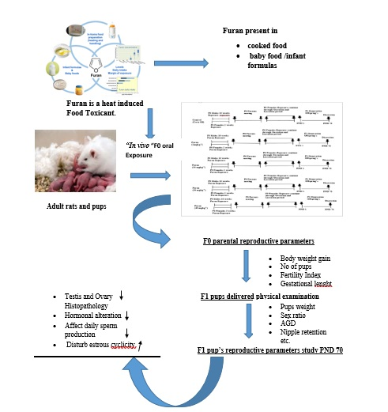

Abstract (300-word limit)

Sprague Dawley F0 weaning rats (30/sex/group) were exposed to furan orally at 0, 5,10, 20 and 40 mg/kg/day for ten weeks (males), two weeks (females) and then mated. F0 females were continuously exposed through gestation and lactation of F1 litters. Different parameters in F0 and F1 generation were studied. Results of F0 indicated that the body weight gain decreased during prebreed and gestational period while increased during lactation periods. F0 animals prebreeding exposure resulted in head tilt and foot splay at higher doses. Reproductive indices and gestational length of F0 animals were remained unchanged. Number of live pups at birth were decreased at 20 & 40 mgkg⁻¹. Weaning pups were distributed into study groups by sex. Survival of F l pups was reduced at 20 & 40 mgkg⁻¹ only for PND 0 through PND 4. At PND 70, hormonal concentration and histological changes were determined in ovaries and testis. In males, Testosterone and LH levels were decreased while increase in estrogen level of females was seen in 20 or 40 mgkg⁻¹ groups. Testicular and ovarian weight was reduced in F1 offspring with decreased DSP and disturbed estrous cyclicity in higher doses groups. No histopathological changes were observed in testis and ovaries but in higher doses groups, number of cystic follicles were increased in ovaries. On the basis of above results, it is suggested that furan exposure at 20 or 40 mgkg⁻¹ exhibit marked changes in extended one generation reproductive toxicity study in F0 (parental stage) and F1 (offspring and pubertal stage) animals.

Recent Publications
- Akram, Z., Riaz, S., Kayani, M. A., Jahan, S., Ahmad, M. W., Ullah, M. A., ... & Mahjabeen, I. (2018). Lead induces DNA damage and alteration of ALAD and antioxidant genes mRNA expression in construction site workers. Archives of environmental & occupational health, 1-8.
- Razak, S., Afsar, T., Ullah, A., Almajwal, A., Alkholief, M., Alshamsan, A., & Jahan, S. (2018). Taxifolin, a natural flavonoid interacts with cell cycle regulators causes cell cycle arrest and causes tumor regression by activating Wnt/β-catenin signaling pathway. BMC cancer, 18(1), 1043.
- Ain, Q. U., David, M., Shah, Q., Ahmad, M., & Jahan, S. (2018). Antifertility effect of methanolic leaf extract of Chenopodium ambrosioides Hook. in male Sprague Dawley rats. Andrologia, 50(10), e13129.
4. Jahan, S., Fatima, A., Alam, I., Ullah, A., Rehman, H., Afsar, T., ... & Razak, S. (2018). Effects of dietary supplements on selected hematological and biochemical parameters of Pakistani athletes. BMC Nutrition, 4(1), 41
.5. Ullah, A., Pirzada, M., Jahan, S., Ullah, H., Shaheen, G., Rehman, H., ... & Butt, M. A. (2018). Bisphenol A and its analogs bisphenol B, bisphenol F, and bisphenol S: Comparative in vitro and in vivo studies on the sperms and testicular tissues of rats. Chemosphere.


Sarwat Jahan has her expertise in reproduction and passion in improving the health. Her open and related assessment model based on heat induced food reproductive toxicants that disturb the reproductive healthcare. She has constructed this study after years of experience in research, evaluation, teaching and administration both in hospital and education institutions. The current finding is based on F1 Extended one generation reproductive toxicity. The aim of this lab is to provide opportunity for students to specialize in human reproductive biology considering both basic science and clinical aspects of the subject. She has practical experience in major laboratory techniques including histological studies, hormone assays, bio chemical assays, assessment of sperm and the application of molecular biology to reproductive medicines are part of the studies conducted. The lab has active collaboration with Salma and Kafeel Infertility Clinic, Islamabad, Centre of Excellence for bovine genetics Renala Khurd, Okara under control of Pakistan army and Cleveland clinic in America.

Email: sjahan@qau.edu.pk

