Transition from Electromechanical Dynamics to Quasi-Electromechanical Dynamics Caused by Participation of Full Converter-Based Wind Power Generation
Jianqiang Luo, Department of Electrical Engineering, The Hong Kong Polytechnic University, Kowloon, Hong Kong
Siqi Bu, Department of Electrical Engineering, The Hong Kong Polytechnic University, Kowloon, Hong Kong
Jiebei Zhu, School of Electrical Automation and Information Engineering, Tianjin University, Tianjin, China

Abstract (300 word limit)
Previous studies generally consider that the full converter-based wind power generation (FCWG) is a “decoupled” power source from the grid, which hardly participates in electromechanical oscillations. However, it was found recently that strong interaction could be induced which might incur severe resonance incidents in the electromechanical dynamic timescale. In this paper, the participation of FCWG in electromechanical dynamics is extensively investigated, and particularly, an unusual transition of the electromechanical oscillation mode (EOM) is uncovered for the first time. The detailed mathematical models of the open-loop and closed-loop power systems are firstly established, and modal analysis is employed to quantify the FCWG participation in electromechanical dynamics, with two new mode identification criteria, i.e., FCWG dynamics correlation ratio (FDCR) and quasi-electromechanical loop correlation ratio (QELCR). On this basis, the impact of different wind penetration levels and controller parameter settings on the participation of FCWG is investigated. It is revealed that if an FCWG oscillation mode (FOM) has a similar oscillation frequency to the system EOMs, there is a high possibility to induce strong interactions between FCWG dynamics and system electromechanical dynamics of the external power systems. In this circumstance, an interesting phenomenon may occur that an EOM may be dominated by FCWG dynamics, and hence is transformed into a quasi-EOM, which actively involves the participation of FCWG quasi-electromechanical state variables.

Image
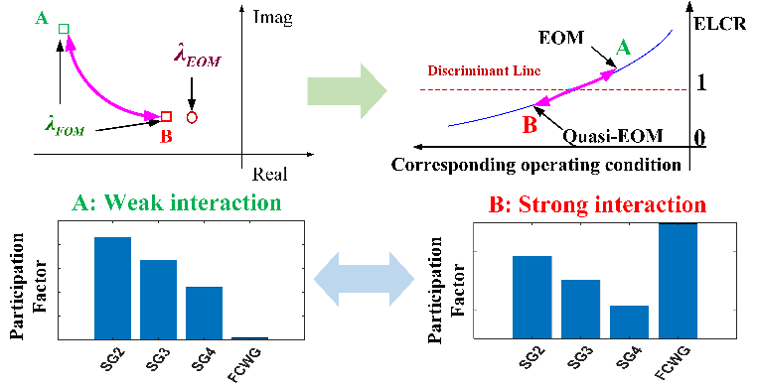
Recent Publications (minimum 5)
- Luo, J.; Bu, S.; Zhu, J.; Chung, C.Y. Modal Shift Evaluation and Optimization for Resonance Mechanism Investigation and Mitigation of Power Systems Integrated with FCWG. IEEE Trans. Power Syst. 2020, 35, 4046–4055, doi:10.1109/TPWRS.2020.2975631.
- Luo, J.; Bu, S.; Teng, F. An Optimal Modal Coordination Strategy based on Modal Superposition Theory to Mitigate Low Frequency Oscillation in FCWG Penetrated Power Systems. Int. J. Electr. Power Energy Syst. 2020, 120, 105975, doi:10.1016/j.ijepes.2020.105975.
- Luo, J.; Bu, S.; Zhu, J. A Novel PMU-based Adaptive Coordination Strategy to Mitigate Modal Resonance between Full Converter-based Wind Generation and Grids. IEEE J. Emerg. Sel. Top. Power Electron. 2020, doi:10.1109/JESTPE.2020.3024759.
- Du, W.; Bi, J.; Wang, H. Damping Degradation of Power System Low-Frequency Electromechanical Oscillations Caused by Open-Loop Modal Resonance. IEEE Trans. Power Syst. 2018, 33, 5072–5081, doi:10.1109/tpwrs.2018.2805187.
- Garmroodi, M.; Hill, D.J.; Verbic, G.; Ma, J. Impact of Tie-Line Power on Inter-Area Modes with Increased Penetration of Wind Power. IEEE Trans. Power Syst. 2016, 31, 3051–3059, doi:10.1109/tpwrs.2015.2477536.



Biography (150 word limit)
Jianqiang Luo received the B.Eng. and M.Eng. degrees in electrical engineering from Huazhong University of Science and Technology, Wuhan, China, in 2010 and 2015, respectively. He is currently working toward the Ph.D. degree with the Department of Electrical Engineering, Hong Kong Polytechnic University, Kowloon, Hong Kong. He is a National Registered Electrical Engineer and Intermediate Economist in China. He is also a Visiting Student with the Control & Power Research Group, Imperial College London, U.K. His research interests include power system stability analysis and control integrated with renewable energy.
Email: hustljq@gmail.com

Notes/Comments:

