Anemia of Chronic Kidney disease: An Overview
Ali AlSahow. MD, FRCP(C), FASN
Head of Nephrology Division, Jahra Hospital

Abstract
Anemia of CKD is One of the most common and significant complications of CKD with complex pathophysiology. Management has evolved significantly, with improved understanding of the pathophysiology. There has been progress in the use of iron therapy (oral and intravenous) and erythropoiesis stimulating agents for the treatment of anemia in both dialysis independent and dialysis dependent CKD, and we will review these . There also has been some exciting new developments in terms of availability of oral hypoxia inducible factor stabilizers that has been approved in some countries, and in terms of progress in the management of anemia of inflammation, which is a major contributory factor in the development of anemia of CKD, and its resistance to therap. We will also review these developments.

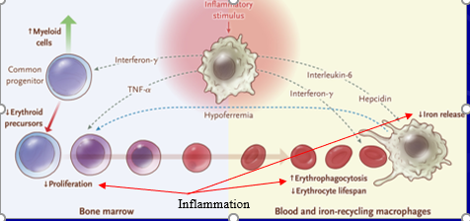
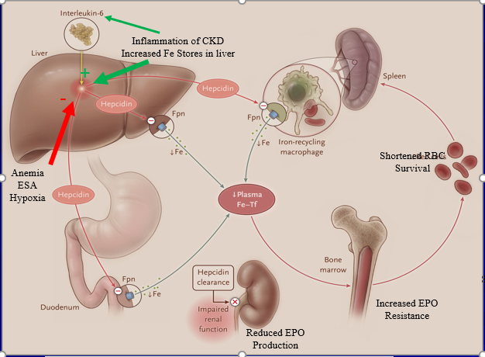
Image
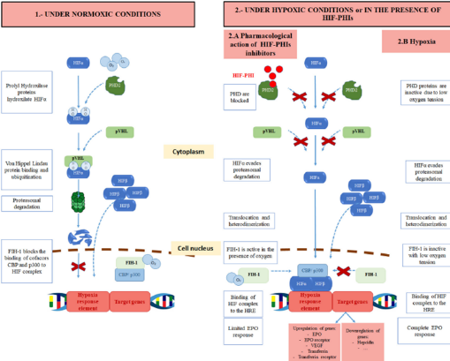
Recommended Reading:
Portoles J, Martin L, Broseta J, Cases A. Anemia in Chronic Kidney Disease: From Pathophysiology and Current Treatments to Future Agents. Fron Med. (2021) 8:642296
Santos EJF, Dias RSC, Lima JFB, Salgado Filho N, Miranda Dos Santos A. Erythropoietin Resistance in Patients with Chronic Kidney Disease: Current Perspectives. Int J Nephrol Renovasc Dis. 2020 Oct 8;13:231-237.
Gluba-Brzózka A, Franczyk B, Olszewski R, Rysz J. The Influence of Inflammation on Anemia in CKD Patients. Int J Mol Sci. 2020 Jan 22;21(3):725.
Ganz T. Anemia of Inflammation. N Engl J Med 2019; 381:1148-1157
Babitt JL, Eisenga MF, Haase VH, Kshirsagar AV, Levin A, Locatelli F, Małyszko J, Swinkels DW, Tarng DC, Cheung M, Jadoul M, Winkelmayer WC, Drüeke TB; Conference Participants. Controversies in optimal anemia management: conclusions from a Kidney Disease: Improving Global Outcomes (KDIGO) Conference. Kidney Int. 2021 Jun;99(6):1280-1295.
Hanna R, Steja E, Kalantar Zadeh K. Burden of Anemia in Chronic Kidney Disease: Beyond Erythropoietin. Adv Ther. 2021:38(1):52-75
Batchelor EK, Kapitsinou P, Pergola PE, Kovesdy CP, Jalal DI. Iron Deficiency in Chronic Kidney Disease: Updates on Pathophysiology, Diagnosis, and Treatment. J Am Soc Nephrol. 2020 Mar;31(3):456-468.
Wish JB. Treatment of Anemia in Kidney Disease: Beyond Erythropoietin. Kidney Int Rep. 2021. https://doi.org/10.1016/j.ekir.2021.05.028.

 Dr Ali AlSahow
Graduated from University College Cork medical school, Ireland in 1994, then completed residency in Internal Medicine & fellowship in nephrology in the University of British Columbia (UBC), Canada. Obtained the American Board & the Canadian Fellowship in Internal Medicine in 2000 & the American Board & the Canadian Fellowship in Nephrology in 2002. Won the Prize for Best Fellow in Teaching from UBC in 2003. Former Head of Department of Medicine in Jahra Hospital, Past President of Kuwait Nephrology Association, Former country representative for Kuwait in GCC DOPPS SAC & in ISN Middle East Regional Board. Currently Head of Nephrology Division in Jahra hospital.
Email: alsahow@hotmail.com

