Is there improvement in renal function in patients undergoing bariatric surgery?
Juliana Amaro Borborema Bezerra. Nephrologist. Federal University of Campina Grande(UFCG). Campina Grande, Paraíba, Brazil.
Carlos Teixeira Brandt. Scientiﬁc Director, UNIFACISA, Campina Grande, Paraíba, Brazil.

Abstract
Introduction: Obesity may cause progressive chronic kidney disease. Weight loss in the postoperative follow-up of bariatric surgery may improve renal function in these patients. Thus, the purpose of this study was to give insight on the subject using a sensible biomarker.
Methods: This cross sectional study was performed in the Obesity Department from Campina Grande – Paraiba, Brazil. It was randomly enrolled 23 postoperative patients (7 bypass and 16 sleeve), with at least two years of follow-up, from the outpatient Department and 29 (18 bypass and 11 sleeve) in the preoperative period for bariatric surgery. They were homogeneously from both genders with ages ranging from 25 to 57 years. Serum levels of creatinine and cystatin C were measured, and the glomerular filtration rate (GFR) was estimated using the CKD Epi (chronic kidney disease epidemiology collaboration) cystatin-creatinine equation. The investigation was approved by the Ethics Committee.
Results: The mean body mass index (BMI) of the preoperative group was significantly greater than the postoperative group (p ≤ 0.0001). The mean serum levels of C cystatin was significantly greater in the postoperative group as compared to preoperative (p= 0.0197). However, there was no mean difference between creatinine serum concentrations comparing the two groups (p = 0.3252). The mean glomerular renal function rates of the groups were similar (p = 0.1240).
Conclusion: There is no definitive evidence for supporting the hypothesis that there is improvement in the kidney renal function after bariatric surgery in obese patients. Prospective cohorts are necessary to enlighten the answer for this important question.

Image
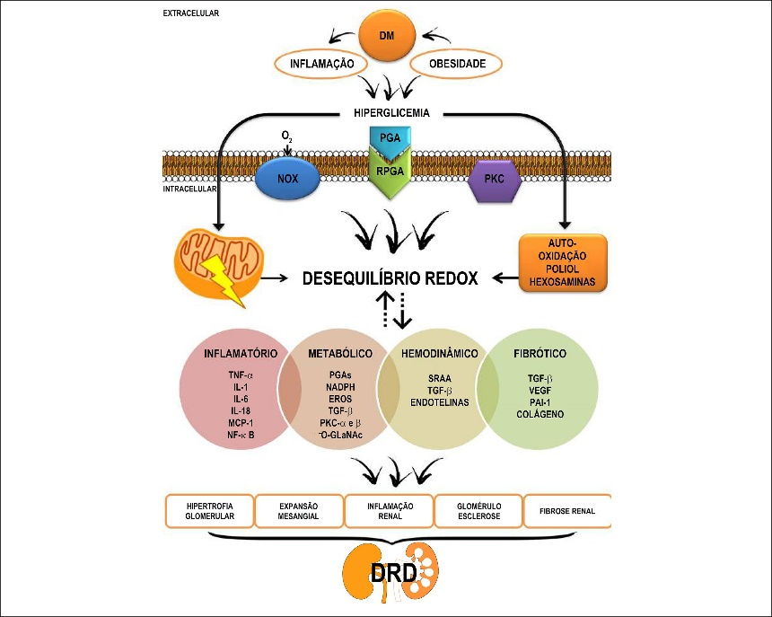
Fig. 1 Mechanisms of renal injury in obesity
Recent Publications
- Favre G, Schiavo L, Lemoine S, Esnault VLM, Iannelli A. Longitudinal assessment of renal function in native kidney after bariatric surgery. Surg Obes Relat Dis. 2018; 14: 1411-1418. PubMed: https://www. ncbi.nlm.nih.gov/pubmed/30077663
- Choi JI, Cho YH, Lee SY, Jeong DW, Lee JG, et al. The Association between obesity phenotypes and early renal function decline in adults without hypertension, dyslipidemia, and diabetes. Korean J Fam Med. 2019; 40: 176-181. PubMed: https://www.ncbi.nlm.nih.gov/pmc/ articles/PMC6536908/
- Holcomb CN, Goss LE, Almehmi A, Grams JM, Corey BL. Bariatric surgery is associated with renal function improvement. Surg Endosc. 2018: 32: 276-281. PubMed: https://www.ncbi.nlm.nih.gov/ pubmed/28664440
- Chuah LL, Miras AD, Perry LM, Frankel AH, Towey DJ, et al. Measurement of glomerular filtration rate in patients undergoing obesity surgery. BMC Nephrology. 2018; 19: 383.
- Park JY, HeoY, Kim YJ, Park JM, Kim SM. Long-term effect of bariatric surgery versus conventional therapy in obese Korean patients: a multicenter retrospective cohort study. Ann Surg Treat Res. 2019; 96: 283-289. PubMed: https://www.ncbi.nlm.nih.gov/pubmed/31183332

 Biography - Juliana Amaro Borborema Bezerra
Graduated in MEDICINE from the Federal University of Paraíba (UFPB), 1999. Residency in Clinical Medicine at (UFPB), 2001, and specialization in Nephrology at the Federal University of Pernambuco (UFPE), 2004. Title of specialist in Nephrology, awarded by the Society Brasileira de Nephrologia, 2004. Master in Public Health from the State University of Paraíba (UEPB), 2011. PhD student in surgery at UFPE, 2018. Has professional experience based on a diversity of experience in medical clinic, nephrology, and public health, especially with dialysis and kidney transplantation.
Email: julianaamaroborborema@gmail.com

