Sustainable management of olive tree pruning residues and olive mill byproducts

KAVVADIAS V ¹, PAPADOPOULOU M ¹, VAVOULIDOU E ¹, THEOCHAROPOULOS S ¹, KOUBOURIS G ²
¹ Department of Soil Science of Athens, Institute of Soil and Water resources, Athens, Greece.
²Institute for Olive Tree, Subtropical Crops & Viticulture, Agrokipion, Chania, Greece.

Keywords: Pruning residues, olive trees, soil management

- Abstract
Olive trees are a major source of agricultural residues. The present study investigated the effect of sustainable organic matter input practices (recycling of shredded pruning residue, returning of olive mill wastes to the field via compost) on soil properties in irrigated and rain fed olive groves. The study took place in 120 olive groves in the regions of Peza and Merambelo, island of Crete and in the region of Chora, South West Peloponnese, Greece, during a five year period (2012-2017). Reduced tillage or no tillage practices were also applied. The results showed that recycling of tree residues and olive mill wastes helps in improving soil organic matter. On the other hand most of the soil chemical and microbial properties were reduced. The relatively low amount of organic materials applied to soil and the insufficient inorganic nutrients of pruning residues caused a decrease of soil microbial carbon use efficiency which consequently affects decomposition of organic materials. With the exception of available nitrogen and microbial properties, soil properties in irrigated fields were favored compared to rain-fed soil parcels due a more favorable environment for soil processes. Sustainable management of olive trees can play an important role in soil nutrient conservation under semi-arid conditions in the Mediterranean basin.

- References:
- Kavvadias V., M. Papadopoulou, E. Vavoulidou, S. Theocharopoulos, S. Malliaraki, K. Agelaki, G. Koubouris and G. Psarras 2018. Chapter 10 - Effects of carbon inputs on chemical and microbial properties of soil in irrigated and rainfed olive groves. In: Soil Management and Climate Change, María Ángeles Muñoz and Raúl Zornoza (eds), Academic Press Inc, San Diego, United States pp. 137-150.

- Koubouris, G.C., N.N. Kourgialas, V. Kavvadias, N. Digalaki and G. Psarras 2017. Sustainable agricultural practices for improving soil carbon and nitrogen content in relation to water availability – an adapted approach to Mediterranean olive groves. Comm. Soil Sci. Plant Anal., 48: 2687-2700.

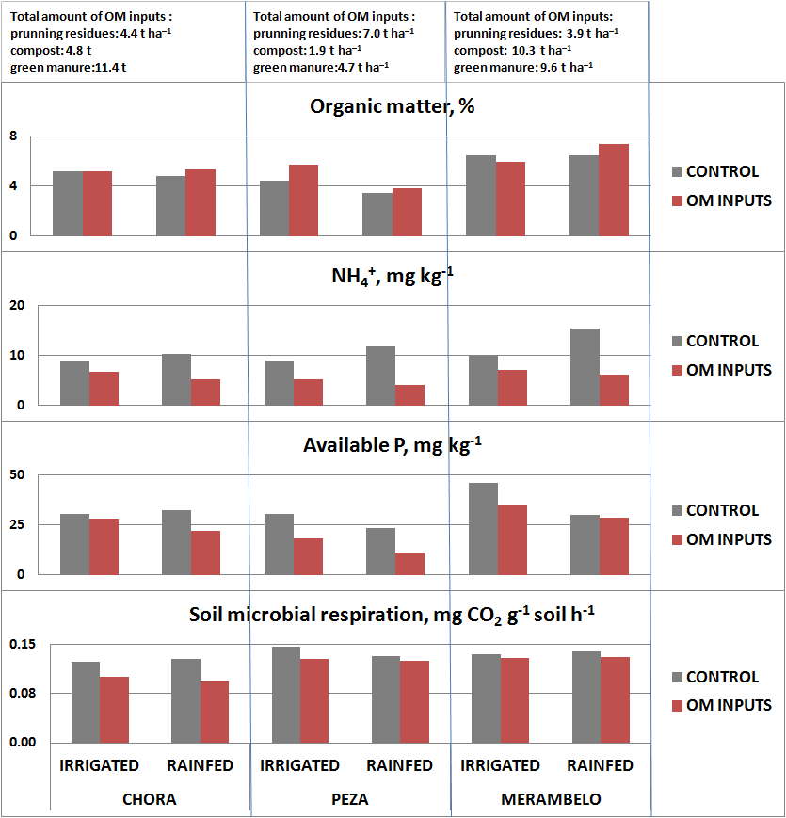
- Biography:
KAVVADIAS V. has completed his PhD from Agricultural University of Aberdeen, Great Britain. He is senior researcher in the Dept. of Soil Science of Athens, Hellenic Agricultural organization DEMETER. His research work is related to sustainable practices of soil management and crop fertilization, soil pollution and remediation. He has published more than 60 papers in peer-reviewed journals.
- Presenting author details


Full Name: Victor Kavvadias
Contact number: 00302102816974, 00306946430052
Twitter account:
Linked In account:
Session name/ number:
Category: (e-Poster presentation)
Passport Number:

