Abstract Template

Title: An overview of the current solid waste management in Bangladesh

Narayan Saha

Department of Forestry and Environmental Science, Shahjalal University of Science and Technology, Sylhet-3114, Bangladesh

Keywords: Solid waste management, waste collection, incineration, land filling, Bangladesh

I. Abstract
Population growth and rapid urbanization are the key drivers of the solid waste generation in Bangladesh. It is a big threat to the environment, particularly to the public health. Inappropriate disposal of waste and inadequacy of other management initiatives are major challenges of the urban solid waste management sector of the country. Considering these view points, this review article provides an overview of the current solid waste management situation in urban areas of Bangladesh. The aim of this article is to provide a guideline for developing an appropriate solid waste management system in Bangladesh. About 41.9 million people (28% of the total population) live in 506 urban city areas of Bangladesh. The urban city population is increasing at the rate of 3.5% per annum and is expected to reach 60 million in 2051. About 16,380 tons per day solid waste generate in the country from domestic, commercial, industrial, street sweeping and health care facilities Of which, approximately 74.4% organic matter originated waste and rests are paper, plastic, textile and wood, leather and rubber, metal, glass and other matters originated. Dhaka, Chattogram, Khulna, Rajshahi, Barishal and Sylhet cities are generating about 8,000 tons of solid waste each day, of which only Dhaka city is contributing about 70%. Of the total waste generation 40%-60% are not properly stored, collected or disposed in the designated places for ultimate disposal. Much of the inorganic waste is partially recycled by mainly informal sectors. Non-governmental Organizations (NGOs) are compositing a limited quantity of organic portion, the rest remains a major problem. The solid waste management situation is now alarming in Bangladesh seeks an immediate action for its sustainable solutions. Lacks of awareness, economic condition, and life style, etc. are the major problems of waste management. This article suggests for improving the systems of waste collection, transportation, recycle, incineration and land filling to make the waste as a form of wealth.

II. Images

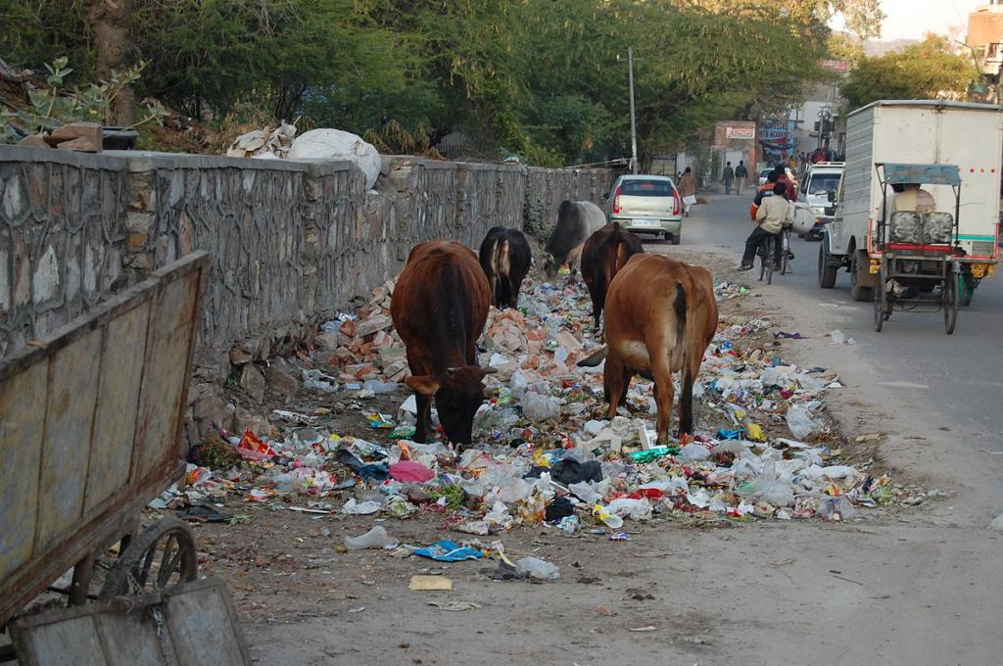
a) Inappropriate disposal of waste (Photo: Google)

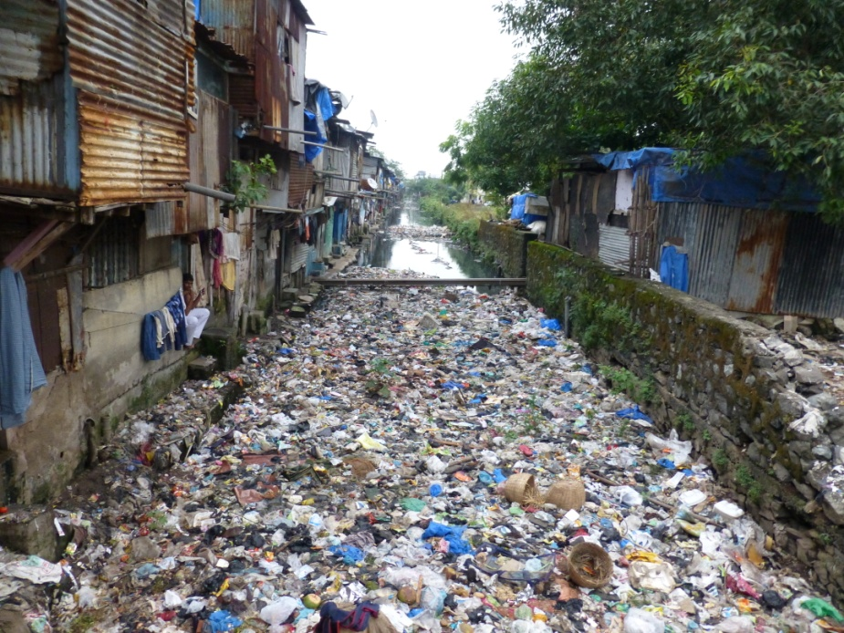
b) Inappropriate disposal of waste (Photo: Google)

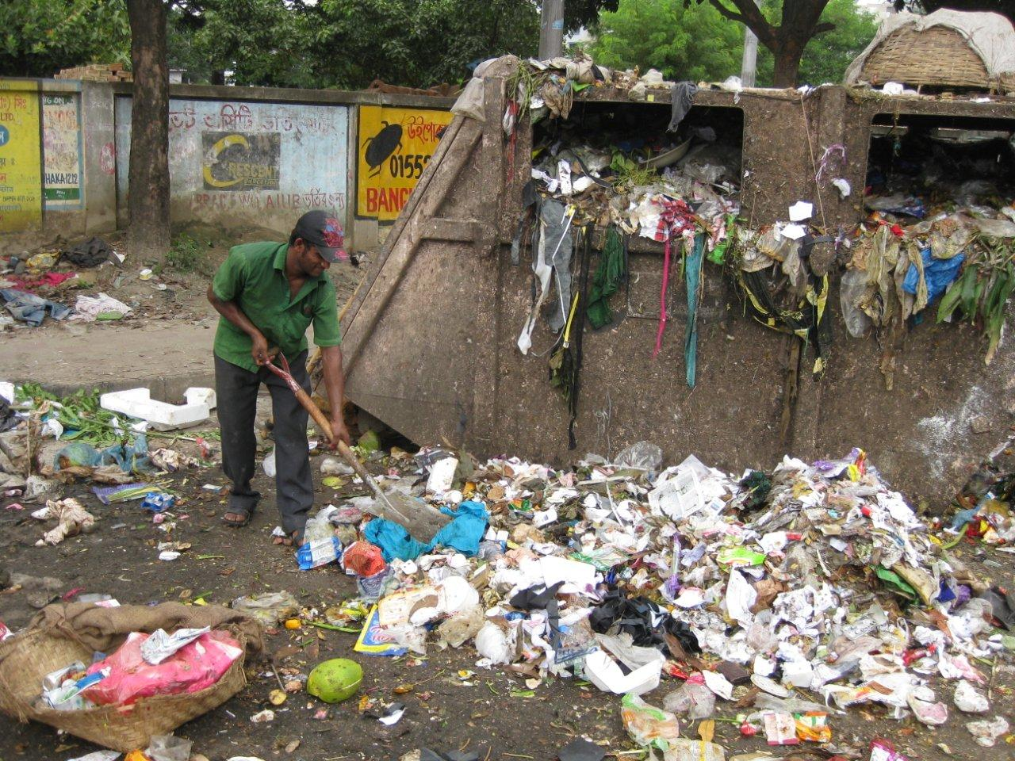
c) Waste management (Photo: Google)

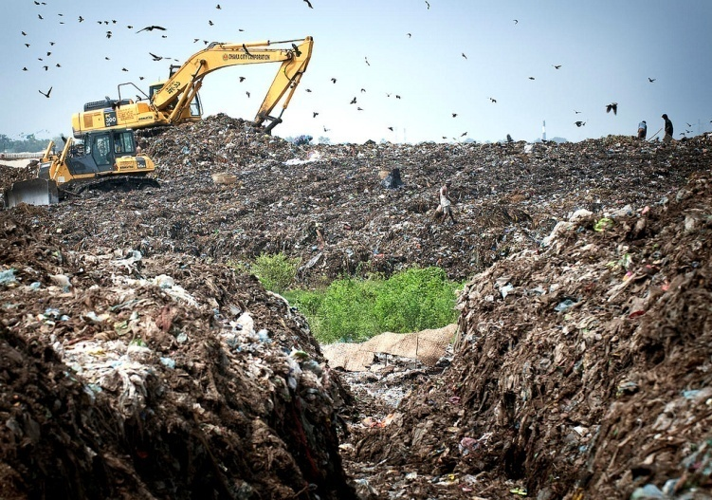
d) Land filling (Photo: Google)

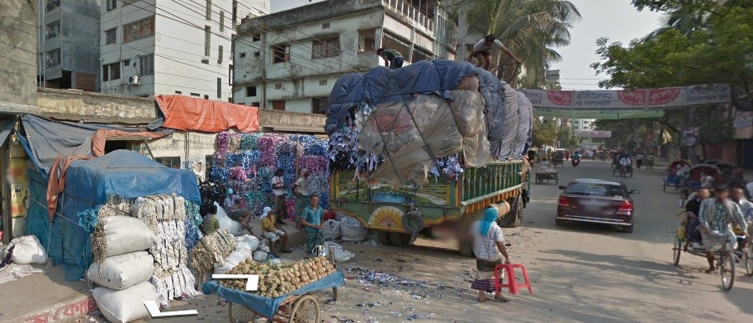
e) Sustainable waste collection and transportation (Photo: Google)
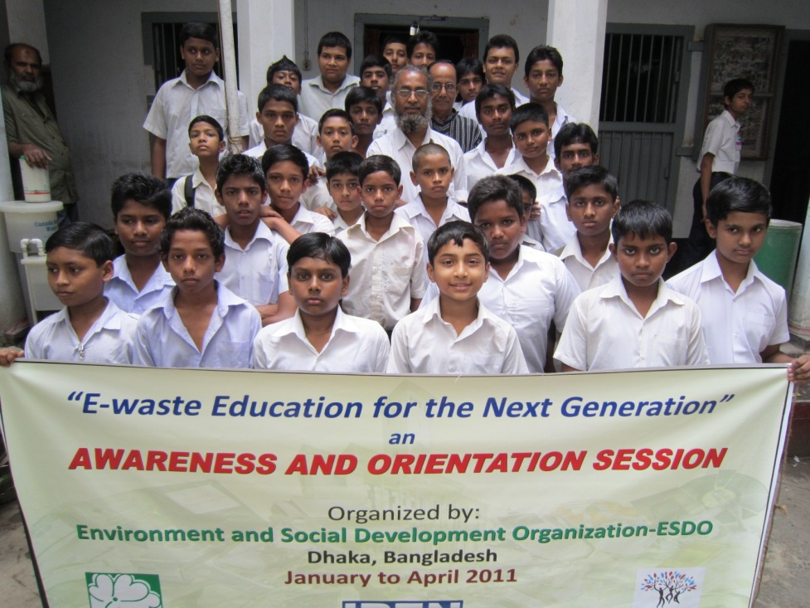
f) Awareness Campaign (Photo: Google)

III. References

1. Abedin, M. A. and Jahiruddin, M., 2015. Waste generation and management in Bangladesh:
an overview. Asian Journal of Medical and Biological Research. 1(1), 114-120

2. ADB, 2011. Toward sustainable municipal organic waste management in South Asia. A
guidebook for policy makers and practitioners. Asian Development Bank (ADB), Philippines.
76pp

3. GED, 2015. Millennium development goals-Bangladesh progress report 2015. General
Economics Division (GED), Bangladesh Planning Commission, Government of the
People’s Republic of Bangladesh. 126pp

4. Nasrin, F., 2016. Waste management in Bangladesh: current situation and suggestions for
action. International Research Journal of Social Sciences. 5(10), 36-42

5. UNEP, 2009. Developing integrated solid waste based management plan. Training manual
volume 2. Assessment of current waste management system and gap therein. Complied by
United Nations Environment Programme (UNEP), Division of Technology, Industry and
Economics, International Environmental Technology Centre, Osaka/Shiga, Japan. 23pp

IV. Biography

Narayan Saha has completed his Ph. D. at the age of 32 years from Ehime University of Japan and Post-doctoral Studies from Department of Forest Science, Kochi University of Japan. He is the Professor of the Department of Forestry and Environmental Science, Shahjalal University of Science and Technology of Bangladesh. He was head of the same department and dean of the School of Agriculture and Mineral Sciences of the same university. Before joining this university, he was a Research Officer of two renowned research institutions of Bangladesh. He has published more than 25 papers in reputed journals and has been serving as a reviewer of some reputed journals.

V. Presenting author details

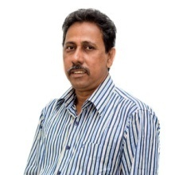

Full Name: Narayan Saha
Contact Number: +880-1716-072440
Twitter Account: Not available
Linked In Account: https://www.linkedin.com/in/narayan-saha-43096951/
Session name/number: Waste management techniques
Category (Oral presentation/Poster Presentation): Oral presentation
Passport Number: AF 4490303 (Date of Expiry 01 June, 2018)

