Production of Microalgae Biomass (MAB): A cost-efficient, profitable, sustainable and quality upscaling of five commercial microalgae strains in greenhouse at northern latitudes

Bedoya HT¹, Sahu AK², Gislerød HR¹, Rusten B³,

¹Biosciences faculty, Plant sciences institute, The Norwegian University of Life Sciences, Ås, Norway
²Product and Technology Applications Manager, Salsnes Filter AS, Namsos, Norway
³Senior Consultant, Aquateam-COWI, Oslo, Norway

Keywords: microalgae biomass, commercial strains, indoors production, upscaling, harvesting, TSS

Abstract
Feasibility, sustainability, profitability and quality of a low-cost upscaling of microalgae biomass production (MABP) at Norwegian latitudes in greenhouse as an energy source.
Two marine(m) and three freshwater(f) algae were cultivated in duplicate, from inoculum batch to upscale in polypropylene open Tray PhotoBioReactor (TPBR, 25 L). Chlorella vulgaris(f), Dunaliella salina(m), Nannochloropsis oculata(m), cultivated for 63 days (20.06.12-23.08.12), and Scenedesmus sp(f), Chlorella wild mix Årungen(f), cultivated for 42 days (20.07.12-23.08.12), at semi-continuous operation system, enriched CO₂ air (3%) and prepared in situ, trifold nitrogen nutrition bold media (3N-BBM+Vit) and tap water, with volumes replenished when need. Effects investigated: 1- 23°C Scenedesmus sp grew at 1,2d⁻¹ and fivefold when doubling the irradiation energy input, Dunaliella salina, reported 0,576d⁻¹ and 71,4% growth increase. 2- Cloudy days generated 31% more DO with 2,64 times less PAR irradiation than sunny days. 3- Optimized Dilution(D) and Mixing(M) regimes on biomass productivity(P) of marine algae increased by 60%. 4- Marine strains, 61% lower irradiance gave 4 times higher Photosynthetic Efficiency(PE), and for freshwater strains, a four times lower irradiance gave 4,6 times higher PE. 5- Mean CO₂ fixation rate was 55,44gCO₂m⁻²d⁻¹, which is 2,6 times higher values than found by Hulatt (2011). 6- Outdoors weather conditions on TPBRs energetic efficiency found the overall Irradiation Utilization Efficiency(IUE) provided by the TPBR. Nannochloropsis oculata, performed best with 1,37gMJ⁻¹, and optical pathway 9cm.
A cost-efficient greenhouse MABP at northern latitudes shows great potential if axenic cultures as source for food, feed and medicine otherwise bioremediation, biofertilizer, biodiesel and wastewater treatment

References:
- Sahu AK, Bedoya H, Wesche T, Gislerød HR, Rusten B. (2015 unpublished) Commercial primary Wastewater Treatment Fine Mesh Sieve Technology for Microalgae Harvesting. Aquateam-COWI AS, Oslo and NMBU Ås Norway.
- Sahu AK, Bedoya H, Rusten B. (2012) Report on algae size analysis, supplement to Deliverable 1.2. Operation SWAT. Aquateam report, 12-034
- Salsnes Filter (2014) Salsnes Filter brochure. www.salsnes-filter.no
- Sahu AK, Bedoya H, Rusten B. (2013, Conference Paper) Recovering Microalgae Using a Salsnes Filter, Aquateam-COWI AS, Oslo and NMBU Ås Norway.
- Sahu AK, Bedoya H, (2013, Conference Poster) Sahu&Bedoya_microalgae_harvesting_technology_2012-2013.pdf

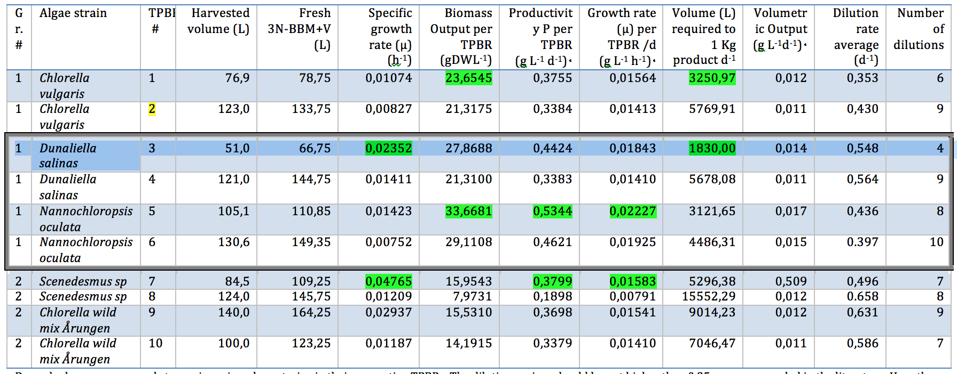
Figure 1: Registered MAB production summer period 2012 - Volume of algae culture need to produce 1kg DW algae: 3251ls culture of Chlorella vulgaris and 1830ls culture of Dunaliella salina

Biography:

Bedoya Has background in biological, botanical and microbiological studies with degrees from Kharkov´s National State University, Ukraine; University of Oslo, and The Norwegian University of Life Sciences. Technical and applied research and development of low-cost photobioreactor and bioprocesses in microalgae biomass (MAB) production at greenhouse conditions at northern latitudes. B. delivered the microalgae for the EU Research project n: 286840, for SME program title: “Operation SWAT” , in cooperation with R&D institutions from Czech Republic, Germany, Poland, Spain UK and Norway. Bedoya´s work generated the core data for a universal MAB harvester for Salsnes Filter Technology

Author details

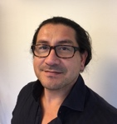

Full Name: Henry Trujillo Bedoya
Contact number: +47 93036973
Twitter account: none
Linked In account: https://www.linkedin.com/in/henry-bedoya-5154a46b/
Session name/ number: Recycling market
Category: Oral presentation
Passport Number: 27006072
Email: henry.brujillo@gmail.com

