Waste Derived Solar Evaporator for Clean Water Production Utilizing Interfacial Solar Steam Generation Technique
Md. Nahian Al Subri Ivan¹, Ahmed Mortuza Saleque¹, Safayet Ahmed¹ and Yuen Hong Tsang^{1*}
¹Department of Applied Physics, The Hong Kong Polytechnic University, Hong Kong,

Abstract (300 word limit)
Growing waste and water shortages are two of the world's most pressing challenges. Landfilling is one of the most common ways of disposing municipal solid waste in which paper and cardboard contribute a significant portion. Except landfilling, wastepaper can also be used for making other recycled products like egg trays. However, after transporting eggs most of the time these egg trays are disposed by the end users. On the other hand, waste like photocopier toner (categorized as e-waste) cannot be disposed normally as the toner particles can remain suspended in air due to their size (>10µm) which may cause damage to the respiratory system if inhaled. To solve these issues, an affordable and efficient solar evaporator is fabricated by recycling waste photocopier toner, egg trays and polyurethane that can purify water using interfacial solar steam generation (ISSG) technique. Instead of heating bulk water ISSG technique concentrate heat at the site of evaporation which increases the solar evaporation efficiency. Due to the presence of carbon black and magnetite in the toner, the fabricated evaporator shows broadband light absorbing capability and photothermal conversion capability. On the other hand, the presence of cellulose and -OH bond in the egg tray makes the surface of the evaporator hydrophilic. Porous and three-dimensional structure of the evaporator has sufficient microchannel for transporting water at the top surface of the evaporator. Under 1 sun illumination the solar evaporator shows the evaporation rate and efficiency of 1.3 kg.m⁻².h⁻¹ and 78.5% respectively. The evaporator can also generate usable water by desalinating sea water and purifying dye contaminated water at 1.118 kg.m⁻².h⁻¹ and 1.253 kg.m⁻².h⁻¹ evaporation rate. The facile fabrication process, use of waste material and electricity independent nature of producing usable water makes the proposed system environment friendly and lucrative for the underdeveloped region of the world.
Biography
Md. Nahian Al Subri Ivan is currently pursuing his Ph.D. in Applied Physics from the Hong Kong Polytechnic University under the Hong Kong Ph.D. Fellowship Scheme (HKPFS). He has worked as an Assistant Professor in the Dept. of Electrical and Electronic Engineering (EEE), Faculty of Engineering,


Image
American International University – Bangladesh (AIUB). He has completed his M.Sc. in Electrical Power Engineering from RWTH Aachen University, Germany, and B.Sc. in EEE from AIUB. His main research focuses are Interfacial Solar Steam Generation, 2D materials, Waste Materials, Energy Storage Devices, Renewable Energy Technologies, Reliability Analysis and Electric Vehicles.
Email: nahian.ivan@gmail.com
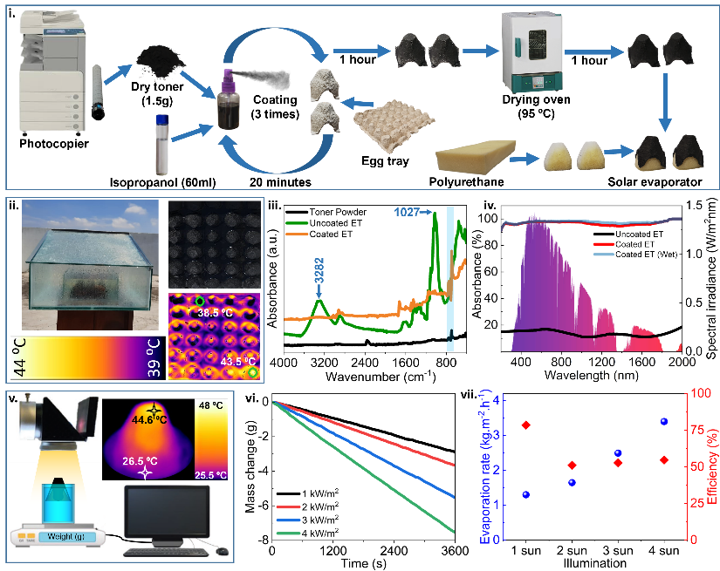
Fig.1. Fabrication and observations. i. Illustration of the fabrication process. ii. Temperature distribution of the evaporator during outdoor experiment. iii. FTIR-ATR spectra of toner and the surfaces of egg tray with and without coating. iv. Absorbance spectra of egg trays with and without coating. v. graphical illustration of experimental set-up (indoor) and temperature distribution (inset). vi. Mass change rate of water under different illumination. vii. Evaporation rate and efficiency of the evaporator

References:
[1] M. N. A. S. Ivan et al., “Waste Egg Tray and Toner-Derived Highly Efficient 3D Solar Evaporator for Freshwater Generation,” ACS Appl. Mater. Interfaces, 2022, doi: 10.1021/acsami.1c22215.
[2] A. M. Saleque, N. Nowshin, M. N. A. S. Ivan, S. Ahmed, and Y. H. Tsang, “Natural Porous Materials for Interfacial Solar Steam Generation toward Clean Water Production,” Sol. RRL, vol. 2100986, p. 2100986, 2022, doi: 10.1002/solr.202100986.
[3] A. M. Saleque et al., “High-temperature solar steam generation by MWCNT-HfTe2 van der Waals heterostructure for low-cost sterilization,” Nano Energy, vol. 94, no. December 2021, p. 106916, 2022, doi: 10.1016/j.nanoen.2022.106916.
[4] A. M. Saleque, S. Ma, S. Ahmed, M. I. Hossain, W. Qarony, and Y. H. Tsang, “Solar Driven Interfacial Steam Generation Derived from Biodegradable Luffa Sponge,” Adv. Sustain. Syst., vol. 2000291, pp. 1–12, 2021, doi: 10.1002/adsu.202000291.
[5] S. Ma et al., “Recycled waste black polyurethane sponges for solar vapor generation and distillation,” Appl. Energy, vol. 206, no. March, pp. 63–69, 2017, doi: 10.1016/j.apenergy.2017.08.169.
[6] B. Yuan et al., “A Low-Cost 3D Spherical Evaporator with Unique Surface Topology and Inner Structure for Solar Water Evaporation-Assisted Dye Wastewater Treatment,” Adv. Sustain. Syst., vol. 5, no. 3, p. 2000245, Mar. 2021, doi: https://doi.org/10.1002/adsu.202000245.

Recent Publications:
(1) Ivan, M. N. A. S.; Saleque, A. M.; Ahmed, S.; Cheng, P. K.; Qiao, J.; Alam, T. I.; Tsang, Y. H. Waste Egg Tray and Toner-Derived Highly Efficient 3D Solar Evaporator for Freshwater Generation. ACS Appl. Mater. Interfaces 2022. https://doi.org/10.1021/acsami.1c22215.
(2) Saleque, A. M.; Nowshin, N.; Ivan, M. N. A. S.; Ahmed, S.; Tsang, Y. H. Natural Porous Materials for Interfacial Solar Steam Generation toward Clean Water Production. Sol. RRL 2022, 2100986, 2100986. https://doi.org/10.1002/solr.202100986.
(3) Saleque, A. M.; Ahmed, S.; Ivan, M. N. A. S.; Hossain, M. I.; Qarony, W.; Cheng, P. K.; Qiao, J.; Guo, Z. L.; Zeng, L.; Tsang, Y. H. High-Temperature Solar Steam Generation by MWCNT-HfTe2 van Der Waals Heterostructure for Low-Cost Sterilization. Nano Energy 2022, 94 (December 2021), 106916. https://doi.org/10.1016/j.nanoen.2022.106916.
(4) Cheng, P. K.; Ahmed, S.; Qiao, J.; Wong, L. W.; Yuen, C. F.; Saleque, A. M.; Ivan, M. N. A. S.; Hani, S. U.; Hossain, M. I.; Zhao, J.; Wen, Q.; Tsang, Y. H. Nonlinear Optical Properties of Two-Dimensional Palladium Ditelluride (PdTe2) and Its Application as Aerosol Jet Printed Saturable Absorbers for Broadband Ultrafast Photonics. Appl. Mater. Today 2022, 26. https://doi.org/10.1016/j.apmt.2021.101296.
(5) Ahmed, S.; Qiao, J.; Cheng, P. K.; Saleque, A. M.; Ivan, M. N. A. S.; Alam, T. I.; Tsang, Y. H. Two-Dimensional Gallium Sulfide as a Novel Saturable Absorber for Broadband Ultrafast Photonics Applications. ACS Appl. Mater. Interfaces 2021, 13 (51), 61518–61527. https://doi.org/10.1021/acsami.1c18155.

