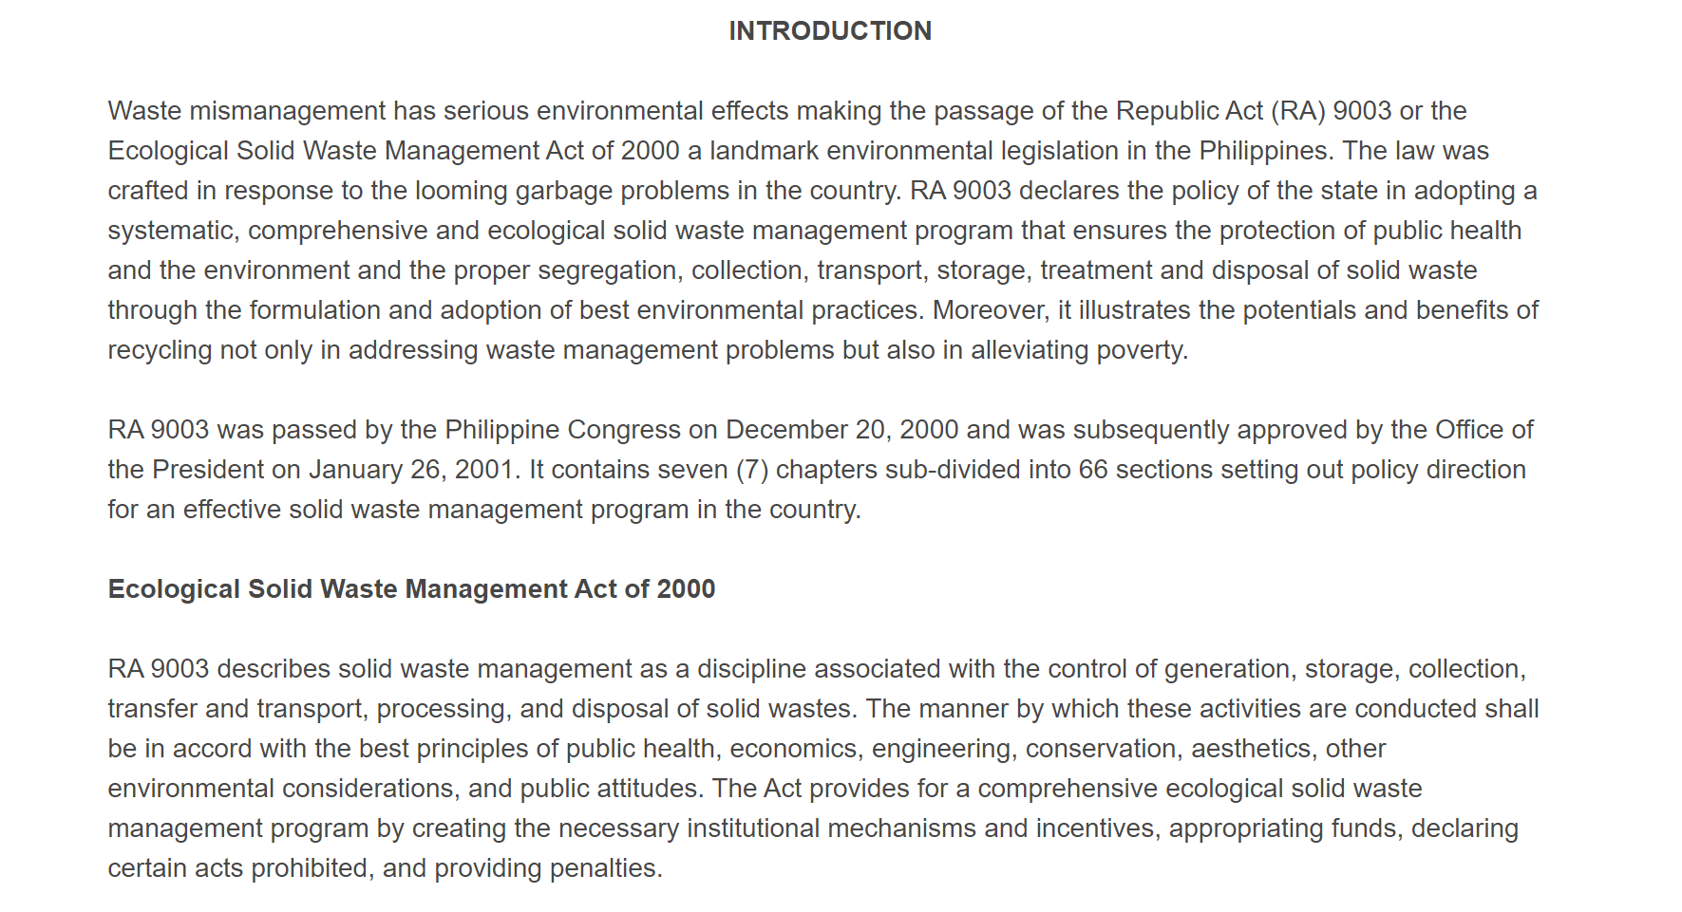
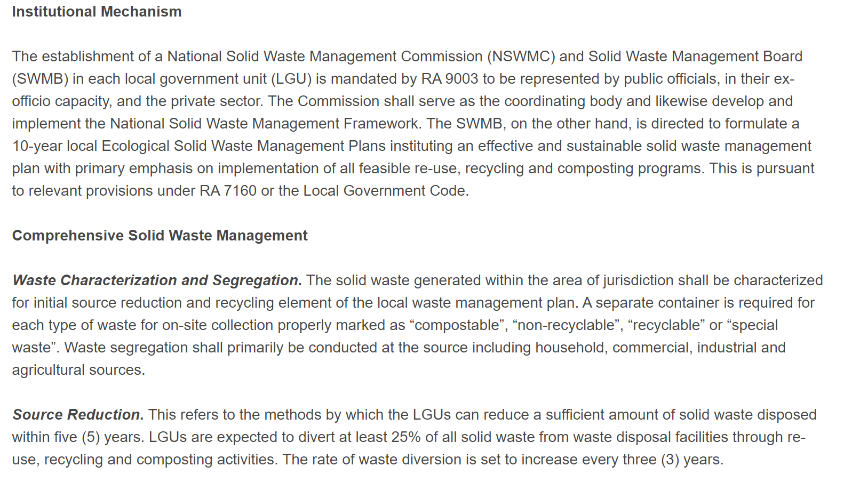
ECOLOGICAL SOLID WASTE MANAGEMENT ACT OF 2000
Abstract:

