Coal fly ash as a perspective filler in polyurethane materials
Monika Kuźnia, PhD, Faculty of Metals Engineering and Industrial Computer Science, AGH University of Science and Technology in Cracow, Poland
Beata Zygmunt-Kowalska, PhD Student, Faculty of Metals Engineering and Industrial Computer Science, AGH University of Science and Technology in Cracow, Poland

Abstract
Statement of the Problem: Despite the dynamic development of renewable energy sources, fossil fuels (hard coal) are the main and stable source of heat and electricity in developing countries around the world. Due to the growing trend of replacing traditional pulverized coal combustion with fluidized bed combustion (FBC), the amount of fly ash produced from FBC has increased. These wastes are more difficult to utilize than the classic fly ash which has found many industrial applications, for example in concrete materials. It should be noted that the FBC fly ash is processed to a very narrow extent. This waste is usually stored in a landfill, which has negative environmental effects and is very costly. This paper contains the basic analyzes of FBC fly ash, which allowed to assess the potential of its application in polyurethane materials (PU). Methodology & Theoretical Orientation: In the assessment of the use of fly ash as a filler for polyurethane materials, it was necessary to conduct basic waste analyzes, such as: density, elemental analysis, oxide and SEM. In addition, its density was also measured. The next step was to make rigid polyurethane foams containing the filler, i.e. fly ash. The samples contained different concentrations of the ash additive. Additionally, basic functional parameters of the resulting composites were tested and compared with the unmodified product. Moreover, basic functional parameters of the resulting composites were tested and compared with the unmodified product. Conclusion & Significance: Conducted activities allowed to assess the possibilities of using fly ash from coal combustion as fillers in PU materials. Areas in which polyurethanes parameters were improved or deteriorate were identified.
Acknowledgement
This work was supported by the Ministry of Science and Higher Education, Poland [grant AGH no 16.16.110.663].

Image

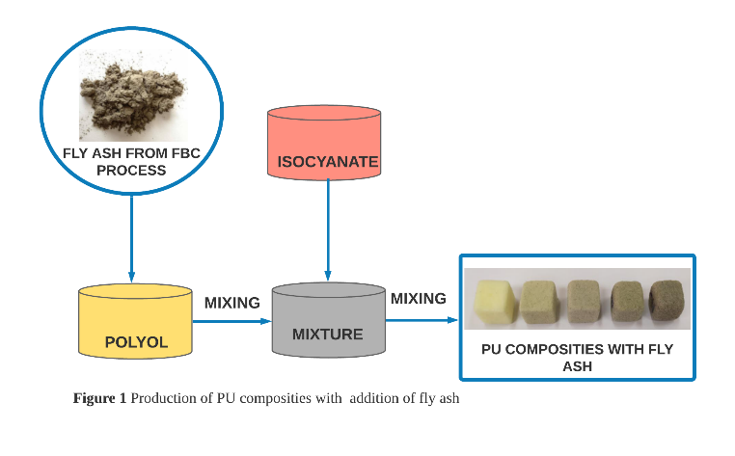
Recent Publications
- Kuźnia M, Magiera A, Pielichowska K, Ziąbka M, Benko A, Szatkowski P, Jerzak W (2019) Fluidized bed combustion fly ash as filler in composite polyurethane materials. Waste management 92:115-123.
- Rawat K, Yadav A. K (2020) Characterization of coal and fly ash (generated) at coal based thermal power plant. Materials Today: Proceedings 26:1406-1411.
- Zahedi M, Jafari K, Rajabipour F (2020) Properties and durability of concrete containing fluidized bed combustion (FBC) fly ash. Construction and Building Materials 258:119663.
- Strigáč J, Števulová N, Mikušinec J, Sobolev K (2018) The fungistatic properties and potential application of by-product fly ash from fluidized bed combustion. Construction and Building Materials 159:351-360.
- Ohenoja K, Körkkö M, Wigren V, Österbacka J, Illikainen M (2018) Increasing the utilization potential of fly ashes from fluidized bed combustion by mechanical treatments. International Journal of Environmental Science and Technology 16:1839-1846.

Biography
 | 
Monika Kuźnia is working as Assistant Professor. Her research area includes the use of fly ash from coal combustion as filler in composite polyurethane materials. Thermal analysis, flammability, mechanical properties and cell structure of polyurethane materials are carried out.  Email: kuznia@agh.edu.pl | Beata Zygmunt-Kowalska is a participant in doctoral studies. Her main interests are the use of waste in plastics technology, and in particular the use of fillers in polyurethane materials. In her research, she focuses on the assessment of the influence of fillers on the functional parameters of PU composites.  Email: zygmunt@agh.edu.pl

