Abstract

Title: Lead (Pb) recycling from old baterries in Dong Mai village in Vietnam and its effect on local human health

Chu T. T. Ha1, Vu V. Tu2, Nguyen T. H. Ha, 3,
1Institute of Ecology and Biological Resources, Vietnam Academy of Science and Technology (VAST), Ha Noi, Vietnam
2Institute of Environmental Technology, VAST, Ha Noi, Vietnam
³VNU University of Science, Vietnam National University, Ha Noi, Vietnam

Keywords: E-waste recycling, Heavy metal, Health risk, Waste management

- Abstract Body
The present study investigated the status of lead (Pb) recycling from old baterries in the Dong Mai Village, Chi Dao Commune, Van Lam District, Hung Yen Province, northern Vietnam. This traditional village has been recycling Pb since 1970s. A total of 200 questionnaires collected from local people about the situation of recycling Pb from old batteries showed that the average amount of old battery collected is 30-50 tons / month, the largest is 300 tons / month. The average amount of Pb produced per evening is 9 tons, the average amount of Pb prodcued per household is 10-20 tons / month. It also showed that 100% workers working at Pb recycling factories got Pb poisoning. More than 80 % workers said that their family members had diseases related to respiration and digestion. In addition, we found some seriously cases, for example, a worker that has been working for 20 years at the Pb recylcing was detected heavily poisoned, and he had two children that also had high Pb level in their blood. In case of other workers, they got trouble about nervous system and brain disease. Analysis of 32 soil samples collected at seven sites in Pb recycling area in Dong Mai village indicated the contents of Al, Fe, As, Cr, Cu, Zn, Cd, and Pb were 6200–32,600, 11,300–55,500, 5.4–26.8, 24.9–290, 66.0–252, 143–455, 0.71–1.67, and 370–47,400 mg/kg, respectively. The values of As, Cr, Cu, Zn, Cd, and Pb in soil samples exceeded the allowable limits at three, one, five, six, one, and seven of the seven sites tested, respectively. Contents of Pb and Cd in 5 of 6 samples of irrigation ditch and waste water exceeded the allowable limits from 9 - 50 times and from 2 – 15 times, respectively.

Image:
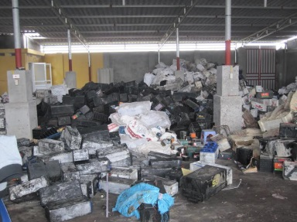 | 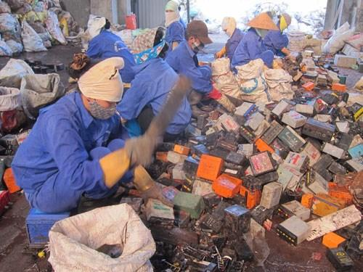

- Reference:

- Ha T.T. Chu, Tu V. Vu, Tam K.B. Nguyen and Ha T.H. Nguyen (2019) Accumulation of Arsenic and Heavy Metals in Native and Cultivated Plant Species in a Lead Recycling Area in Vietnam. Minerals, 9, 132; doi:10.3390/min9020132.

- Phan, T.P.; Pham, T.T.T.; Nguyen, K.L.; Nguyen, T.K.O.; Ha, T.T.T.; Nguyen, K.B.T.; Chu, T.T.H. (2016) The impacts of lead recycling activities to human health and environment in Dong Mai craft village, Hung Yen, Vietnam. J. Viet. Environ., 8: 266–270.

Biography:
Chu T. T. Ha has completed her PhD at the age of 36 from Dresden University of Technology, Germany. She is the senior researcher, deputy Head department at the Institute of Ecology and Biological Resources, Vietnam Academy of Science and Technology. She has published more than 20 papers in reputed journals and has been serving as deputy Editor in-chief of Journal of Vietnamese Environment.

Presenting author details
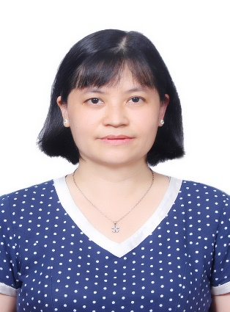
Full Name: CHU Thi Thu Ha
Contact number: +84 912 513 505
Linked In account: https://www.linkedin.com/in/ha-chu-3453984a/
Session name/ number: E-Wastes Recycling and Management/5
Category: Oral presentation
Passport Number: S1173506

