Abstract Template

Title: Comparison of varying sizes and depths of sand and aggregates as filter media for treatment of grey water

Prof. Renu Hujare1, Priyanka Kadam1, Karishma Madav¹, Sayali Bhojane¹, Tejaswini Patil¹
1Department of Civil Engineering, Gharda Institute of Technology, Maharashtra, India

Keywords: Grey Water, Slow sand filter, aggregates, sand, reuse.

- Abstract Body (up to 300words)
Water scarcity is one of the most challenging problems faced by today’s world. Grey water treatment and reuse can be an easy and economical solution when applied at household level. Grey water forms almost 60 to 80% of the entire waste water generated in a household. If this quantity of grey water is treated and reused, considerable savings in water consumption could be achieved.
In the current study we have compared grey water treatment efficiencies using 6 types of filter media combinations. The filter media combination for all the models (starting from top) are as: very fine sand, fine sand, coarse sand, fine aggregates and coarse aggregates. The sizes of these aggregates and the filter media depths have been varied. The grey water generated in the canteen of Gharda Institute of Technology and the treated samples were analyzed for various parameters like BOD, COD, TDS and turbidity.
A working slow sand filter will be designed and constructed for Gharda Institute of Technology’s canteen grey water waste based on the results of our analysis.
.

Image:

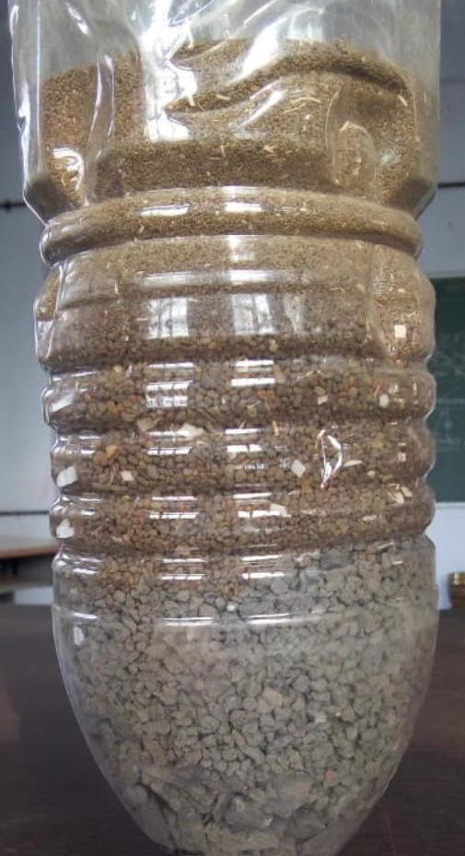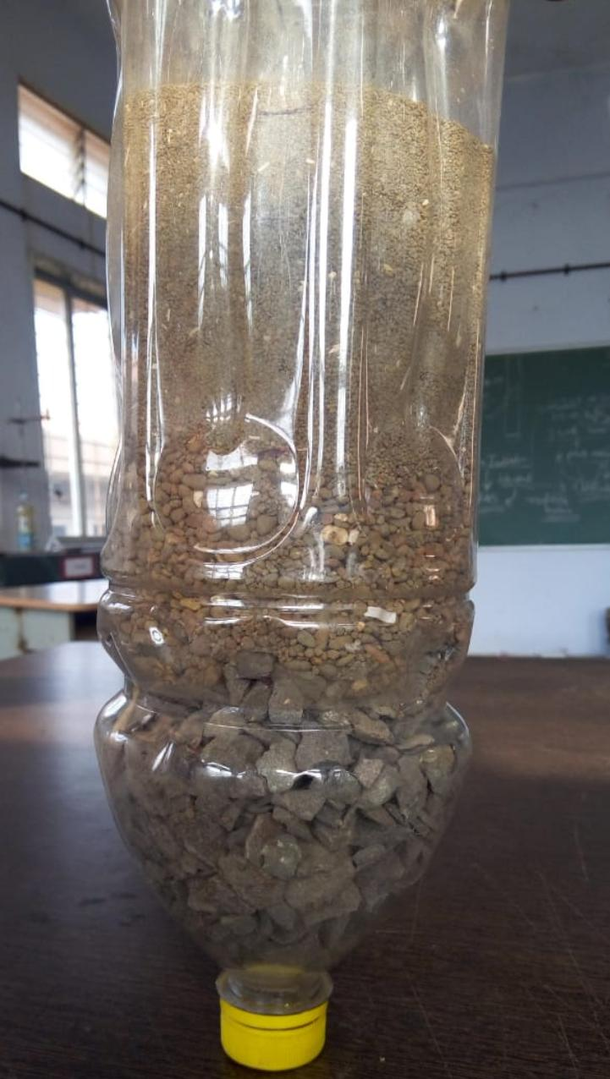

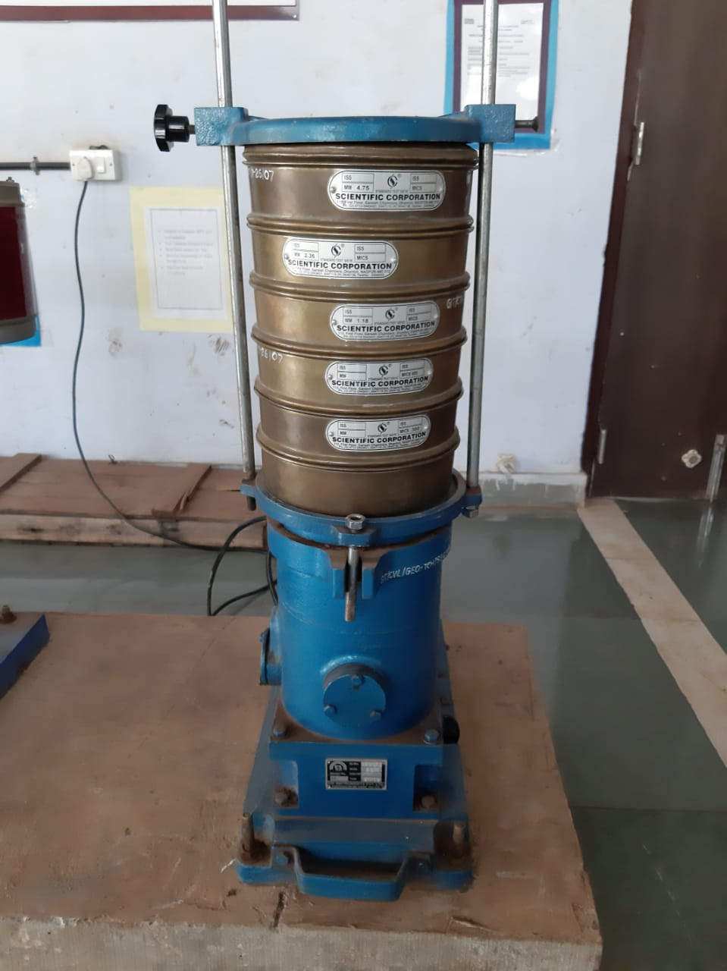
- Reference:

- Juvekar, P.R., 2015. Design of small scale waste water (grey water) treatment plant. Thesis, 1-136

- Pachkor, R. T., Parbat, D. K., 2017. A Literature Review on Integrated Approach for Grey Water Treatment. International Journal for Research in Applied Science & Engineering Technology, 5: 1601-1607

- Ankidawa, B. A. and Tope, A. A., 2017. Design of Slow Sand Filter Technology for Rural Water Treatment. Asian Journal of Environment & Ecology, 3: 1-7

Biography:
Prof. Mrs. Renu Hujare has completed her MTech from IIT Bombay (India). Currently she has received a verbal acceptance for PhD at Michigan State University, USA (waiting for final documents to arrive). She is working as an Assistant Professor for Department of Civil Engineering at Gharda Institute of Technology in the state of Maharashtra (India). In the past, she has worked for a couple of environmental consultancies in India. She has 3.5 years of teaching experience along with 4 years of industrial experience. Her research areas of interest are Grey water treatment and reuse, solid waste management and applications of GIS to solve local environmental problems.

Presenting author details

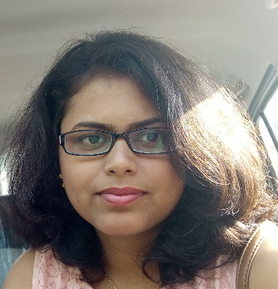
Full Name: Prof. Renu Hujare
Contact number: +91-7218429986
Twitter account: NA
Linked In account: www.linkedin.com/in/renuhujare
Session name/ number:
Category: (Oral presentation/ Poster presentation) Any
Passport Number: K3543752

