Abstract Template

Title: Comparison of locally available filter media for treatment of grey water

Prof. Renu Hujare1, Vaibhav Patil1, Ankita Turate¹, Vrushali Kandalgaonkar¹, Saurabh Sutar¹
1Department of Civil Engineering, Gharda Institute of Technology, Maharashtra, India

Keywords: Grey Water, Slow sand filter, Sand, Activated charcoal, Maize, Mangalore tiles, Marble Chips, Rice Husk, Coconut Shell

- Abstract Body (up to 300words)
Water scarcity is one of the most challenging problems faced by today’s world. Grey water treatment and reuse can be an easy and economical solution when applied at household level. Grey water forms almost 60 to 80% of the entire waste water generated in a household. If this quantity of grey water is treated and reused, considerable savings in water consumption could be achieved.
In our study we have compared grey water treatment efficiencies using 6 types of filter media viz., Rice Husk, Marble Chips, Maize, Coconut Shell, Mangalore Tiles, Jute & Coir in 7 slow sand filter models. The seventh slow sand filter model was the basic model without any use of special filter media as mentioned above. Every slow sand filter contained layers of (starting from top) Very Fine Sand (size - 300 µ, depth - 0.5 cm), Fine Sand (size - 600 µ, depth - 2 cm), Coarse Sand (size – 2.36 mm, depth - 1.5 cm), the selected filter media as mentioned above (depth – 8 cm), Activated charcoal (depth – 3 cm), Fine Aggregate (size – 4.75 mm, depth – 3 cm) and Coarse Aggregate (size – 10 mm, depth - 2 cm).
The grey water generated in the canteen of Gharda Institute of Technology and the treated samples were analyzed for various parameters like BOD, COD, TDS and turbidity. It was found that slow sand filter using marble Chips, Mangalore tiles and rice husk gave better removal efficiencies as compared to the rest of the filter media types. It can be concluded that inorganic material used as a filter media gives more removal efficiency than the organic filter media. A working slow sand filter will be designed and constructed for Gharda Institute of Technology’s canteen grey water waste based on the results of our analysis.
.

Image:

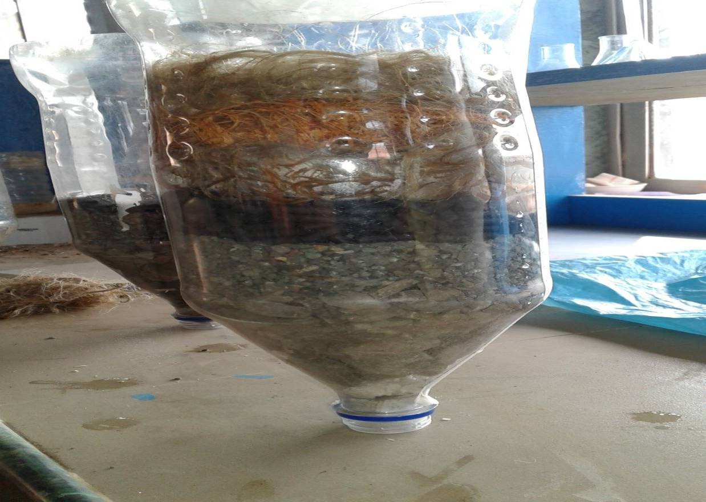
- Reference:

- Singh, R., Kaur, A., Ghawana, T., Gupta, N.C., 2018. Feasibility Study of Treatment Technologies for Greywater to Enhance Water Security. International Journal of Applied Engineering Research, 13: 4042-4048

- Kumar, A. S., Srivastva, M., Rajneesh, N.K., Shukla, S., 2017. Corncobs as Low Cost Bio-Adsorbent For Water And Waste Water Treatment. International Journal Of Innovative Research In Science Engineering And Technology, 10: 20487-20491

- Singh, S., Ojha, N., Pradhan, N., Bose, S., 2016. Grey Water Treatment and its application in cultivation of plants. Asian Journal of Micro-biology, Bio-Technology and Environmental Sciences, 4: 1043-1053

Biography:
Prof. Mrs. Renu Hujare has completed her MTech from IIT Bombay (India). Currently she has received a verbal acceptance for PhD at Michigan State University, USA (waiting for final documents to arrive). She is working as an Assistant Professor for Department of Civil Engineering at Gharda Institute of Technology in the state of Maharashtra (India). In the past, she has worked for a couple of environmental consultancies in India. She has 3.5 years of teaching experience along with 4 years of industrial experience. Her research areas of interest are Grey water treatment and reuse, solid waste management and applications of GIS to solve local environmental problems.

Presenting author details


Full Name: Prof. Renu Hujare
Contact number: +91-7218429986
Twitter account: NA
Linked In account: www.linkedin.com/in/renuhujare
Session name/ number:
Category: (Oral presentation/ Poster presentation) Any
Passport Number: K3543752

