Abstract Template

Title: Plastics and strategies for recycling, waste management and pollution control.

- ACQUILA RECYCLING PLANT UGANDA
- DEPARTMENT OF RESERCH

Keywords: Garbage Islands, Landfills, Blocking streams, waterways, Air Pollution.

- Abstract Body (up to 300 words)

Plastic is a non- biodegradable organic polymer, which is very commonly used in materials, large amounts of discarded plastics accumulating in oceans as Garbage islands and in land as landfills or blocking streams and waterways. Leaching of waste plastics from landfilling and fumes released during incineration resulting major health impacts to living things as well as polluting the air, water, and soil, burning PVC releases cancer causing dioxins and PCB. Addition to recycling waste plastics also used in production of energy or in co-processing. Oxo-degradable plastics end up in fragments which cannot be compostable and also resulting in particles that can cause bioaccumulation. This study analyses plastics, and their path way in the environment, it also figure out the hazardous effects of plastics to living things and to the environment, and ends with practically feasible solutions

Image: Recycling of PET
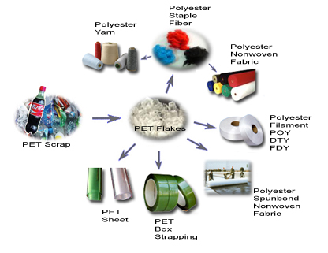
- Reference:

- Mr. Joseph Kakembo
Environmental sciences, Cairo University, Egypt.

- Dr John Walukagga.-
Senior Advisor acqila Recycling Plant.

Biography:
Swaibu kasenke has completed his Diploma in Agriculture and currently pursuing Agriculture and environmental sciences on Degree basis in makerere university .Working as Recycling and Pollution control With Acquila Recycling plant Kampala.

Presenting author details

Full Name: Swaibu Sulaiti Kasenke Contact number: +971528890018
Session name/ number:
Category: (Oral presentation/ Poster presentation) Passport Number B1363874

