Abstract

Cost Benefit Analysis of Biogas Generation from Organic waste: A Case Study Rawalpindi Pakistan

Muhammad Umer Aziz1, Imtiaz Afzal Khan2, Xu linyu1, *,
1School of Environment, Bejing Normal University, China
2Department of Civil and Environmental Engineering, Hanyang University, 222 Wangsimni-ro, Seongdong-gu, Seoul 04763, Republic of Korea

Keywords: Cost benefit analysis (CBA), Food waste (FW), Biogas potential (Methane)

- Abstract Body
The present study based on to evaluate the biogas potential of solid waste from Rawalpindi city, furthermore to perform the cost benefit analysis (CBA) to find out that the use of this bio gas generation is economical for the household use or not. Lack of segregation knowledge was the main reason behind the non-effectiveness of bio methane potential, in our study we find out the 40% waste was related to food waste (kitchen waste, rotten fruits and vegetables, leaves etc.) and none of was separated on source and mixed with inorganic waste. By analysis of 30 days of food waste samples from transfer point, we find the chemical composition ratio that includes 37.10%, 37.60% ,1.40% and 7.39% of oxygen, carbon, nitrogen and hydrogen, respectively. 351 LCH₄/ Kg of VS was produced from the food waste generated from the Rawalpindi, waste with 70 % consumption of volatile ratio. In broader prospect it will help to produce 1.2 MW of energy, which contributed to 9% energy consumption of city, moreover if we add this potential to CNG utilization it will help to manage the 14 % CNG stations consumption of city. The 19% increase in production of biomethane will be observed in combination of animal manure with solid waste. It will save 0.2 Million dollar per year spent on importing LPG for the city.

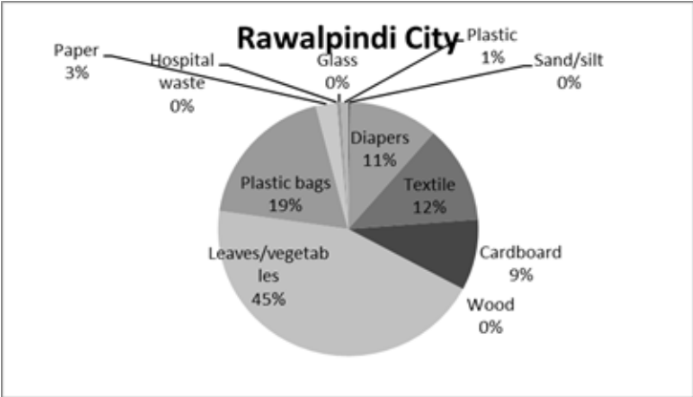
Image:

- Reference:

1 Chan Gutiérrez, E., Wall, D.M., O'Shea, R., Novelo, R.M., Gómez, M.M. and Murphy, J.D. (2018) An economic and carbon analysis of biomethane production from food waste to be used as a transport fuel in Mexico. Journal of Cleaner Production 196, 852-862.

- Yazan, D.M., et al., Cooperation in manure-based biogas production networks: An agent-based modeling approach. Applied Energy, 2018. 212: p. 820-833.

- Achinas, S., V. Achinas, and G.J.W. Euverink, A Technological Overview of Biogas Production from Biowaste. Engineering, 2017. 3(3): p. 299-307.

Biography:
Muhammad Umer Aziz is the MS student in School of Environment, Bejing Normal university, China.

Presenting author details


Full Name: Muhammad Umer Aziz

Contact number: 008613141005356

Twitter account: NA

LinkedIn account: NA

Session name/ number: 2017-2019

Category: Poster presentation

Passport Number: DG1812271

