Title: Home composting systems for organic waste treatment: technologies, greenhouse gas emissions and economic analysis
VR Sankar Cheela^{1,2}, Brajesh Dubey¹, Michele John²
¹Department of Civil Engineering Indian Institute of Technology Kharagpur, West Bengal, India
²Sustainable Engineering Group, Curtin University, Perth, Australia

Keywords: Organic waste, Composting, Household
- Abstract
In developing countries, the biodegradable component of municipal solid waste is typically composed of 40-60% kitchen waste. Composting is a globally accepted technology for clean and sustainable management of organic waste. This study attempts to assess three domestic composting systems, Kamba (clay pots), rotary drum, and bin composting. Technical and economic features of the systems were also discussed and compared. During the composting process greenhouse gases are generated, mechanisms to reduce the greenhouse emissions are noted. Composting and Bokashi systems are compared in terms of process mechanisms, the quality of end products, operation and maintenance process. The domestic composting process reduces the pressure on the collection and transportation components of municipal solid waste management. This review provides an insight into the development of strategies for municipal solid waste management at the household level.

Types of composting under study

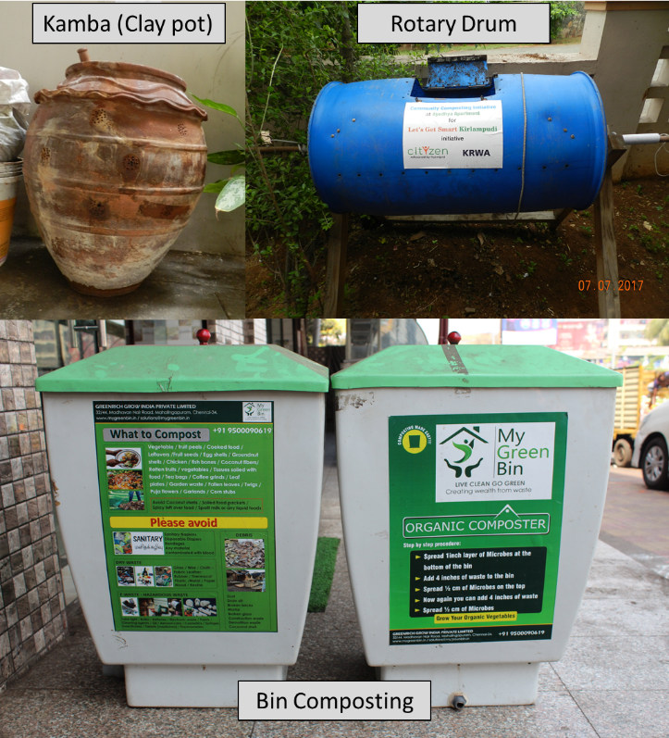
Reference:
- Jouhara, H., Czajczynska, D., Ghazal, H., Krzyzynska, R., Anguilano, L., Reynolds, A. J., Spencer, N. 2017. Municipal waste management systems for domestic use. Energy. 139, 485-506.
- Lim, S. L., Leong, H. L., Ta Yeong, W. 2016. Sustainability of using composting and vermicomposting technologies for organic solid waste biotransformation: recent overview, greenhouse gases emissions and economic analysis. Journal of Cleaner Production. 111, 262-278.
- Lleó, T. T., Albacete, E., Barrena, R., Font, X., Artola, A., Sánchez, A. 2013. Home and vermicomposting as sustainable options for biowaste management. Journal of Cleaner Production. 47, 70-76.

Biography:
VR Sankar Cheela is perusing his PhD from IIT Kharagpur (India) and Curtin University (Australia). His areas of interest include Solid waste management, sustainability engineering and industrial ecology. He worked as a faculty in Civil Engineering department at MVGR College of Engineering, India for a period of 5 years. He is associated with councils in India and done consulting works in the field of solid waste management. He has published 8 Journal articles and book chapters.
Dr Brajesh Dubey is an Associate professor in the Division of Environmental Engineering and management at Indian Institute of Technology (IIT) Kharagpur, India. He has more than a decade of research, teaching, training and industrial outreach experience in the areas of Integrated Solid Waste Management and Sustainable Engineering. He has collaborated with UN agencies, World bank, National Science Foundation, Auckland Regional Council and Guwahati Municipal corporation (India) on various projects. Dr. Dubey has authoured/co-authoured more than 160 publications in his area of expertise.
Professor Michele John is the Director of the Sustainable Engineering Group at Curtin University, Perth Western Australia. Michele is a resource economist with research interests in life cycle assessment, environmental economics and resource efficiency. She currently leads an internationally recognized industrial ecology research group with major projects in industrial symbiosis, sustainability education, waste management, remanufacturing and sustainability design and policy. She has worked internationally with several large multi-national companies in the mining and manufacturing industry in London, Japan and Singapore. Michele is currently Editor-in-Chief of the Recycling Journal.

Presenting author details
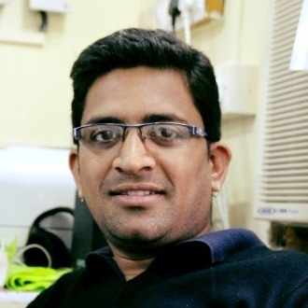
Full Name: VR Sankar Cheela
Contact number: +61478499673
Twitter account: Nil
Linked In account: Nil
Session name: Solid Waste Management
Category: Oral presentation
Passport Number: H9849716

