Abstract Template

Title: Improving recycling by leveraging on governance

Awuor F. O1
1Department of Natural Resource Management, Jaramogi Oginga Odinga University of Science and Technology, Bondo, Kenya

Keywords: Recycling, Governance, Kisumu city, solid waste, food waste,

- Abstract Body (up to 300 words)
A lot of resources go to waste in developing countries which end up clogging drainage infrastructures and neighborhoods. Kenya is no exception. Even though there are many recycling initiatives, their impact remains minimal. Furthermore, certain solid wastes remain almost untouched resulting in their undesired economic, environmental and social effects. This study explores the experience of Kisumu and how the existing governance system has impacted on recycling of such wastes in the City. Additionally, it explores opportunities where governance can be leveraged upon to improve recycling.

Image:
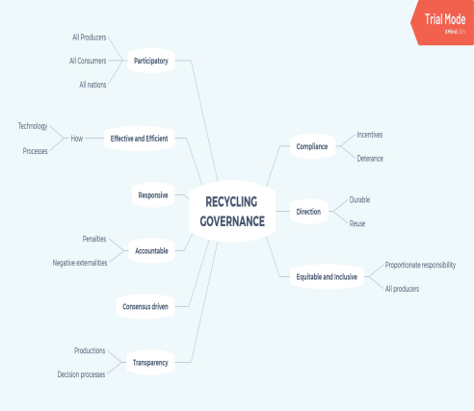

Applying governance to for improved solid waste management
Reference:

1 Awuor, F. O., Nyakinya, B., Oloo, J., Oloko, M., & Agong, S. G. (2018). How did Kachok dumpsite in Kisumu City develop into a crisis? In Urban Forum (pp. 1-17). Springer Netherlands

- National Environmental Management Authority (2015). National solid waste management strategy

- Lougheed, S. C., Metuzals, J., & Hird, M. J. (2018). Modes of governing Canadian waste management: a case study of Metro Vancouver’s energy-from-waste controversy. Journal of Environmental Policy & Planning, 20(2), 170-182.

Biography:
Dr. Awuor completed his PhD in 2016 from Jaramogi Oginga Odinga University of Science and Technology and is currently in his second year of Postdoctoral Studies at Kisumu Local Interactions Platform, a sister platform of MISTRA Urban Futures. He is the Chairman of the Department of Natural Resources Management of the School of Spatial Planning and Natural Resources Management of Jaramogi Oginga Odinga University of Science and Technology. He has published 7 papers in reputed journals.

Presenting author details

Full Name: Frankline Otiende Awuor Contact number: +254720984254 Twitter account: Linked In account:
Session name/ number: Track: 3 Food waste Recycling
Category: (Oral presentation) Passport Number: A17228834

