Abstract Template

Characterization of marine waste from various sources in Istanbul, Turkey

Mehmet Sinan Bilgili1, Elanur Adar2, Senol Yildiz3, Kadir Sezer4
1Department of Environmental Engineering, Yildiz Technical University, Istanbul, Turkey
2Department of Environmental Engineering, Artvin Coruh University, Artvin, Turkey
3Istanbul Applied Gas and Energy Technologies Research Engineering Indsutry Trade Inc. (UGETAM), Istanbul, Turkey
4Istanbul Environmental Managemet Industry and Trade Inc. (ISTAC), Istanbul, Turkey

Keywords: Marine waste, Recyclables, Plastics, Combustible waste, Calorific value

- Abstract Body (up to 300 words)
The marine transportation between the Mediterranean and the Black Sea is realized through the Canakkale Strait and the Bosphorus. The Bosphorus, particularly, has a much more heavy traffic because of its significant location for intercontinental transition and international trade. Continuous and increasing waste input and its accumulation in the marine environment diversely effects marine life, humans and the economy.
This study is the first one realized in Turkey for the detailed characterization of marine waste. The amount and characteristics of solid wastes originating from beaches, coastlines, sea surface cleaning processes and ships (both cargo and cruise ships) were determined. It was observed that the majority of marine wastes are generated from recyclables. Although, it was ascertained that the amount and composition of waste differs according to the collecting sources, majority of wastes are composed of different types of plastics. The average calorific value of marine waste was determined as 2500 kcal/kg, which is higher than that of mixed municipal solid waste. There is a lack of studies on the pathways of disposal alternatives of marine waste after collection. As landfilling is the common pathway for disposal after collecting, it is clear that recycle/reuse and energy recovery options are possible for marine waste.

Image:
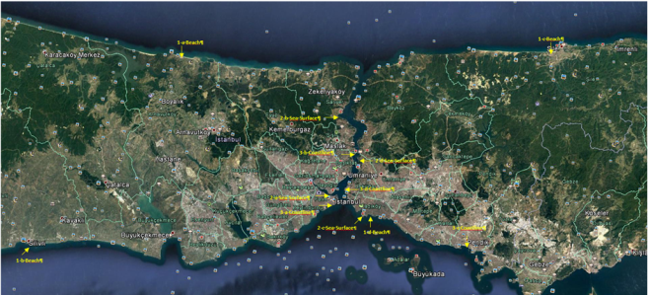
- Reference:

- UNEP (2013). http://www.unep.org/regionalseas/marinelitter.
- Schneider F, Parsons S, Clift S, Stolte A & McManus MC (2018). Review collected marine litter — a growing waste challenge. Marine Pollution Bulletin 128: 162–174.
- Rayon-Viña F, Miralles L, Gómez-Agenjo M, Dopico E & Garcia-Vazquez E (2018). Marine litter in south Bay of Biscay: Local diﬀerences in beach littering are associated with citizen perception and awareness. Marine Pollution Bulletin 131: 727–735.
- Polasek L, Bering J, Kim H, Neitlich P, Pister B, Terwilliger M, Nicolato K, Turner C & Jones T (2017). Marine debris in ﬁve national parks in Alaska. Mar. Pollut. Bull. 117 (1–2): 371–379.
- Pettipas S, Bernier M & Walker TR (2016). A Canadian policy framework to mitigate plastic marine pollution. Marine Policy 68: 117–122.
- Pasternak G, Zviely D, Ribic CA, Ariel A & Spanier E (2016). Sources, composition and spatial distribution of marine debris along the Mediterranean coast of Israel. Marine Pollution Bulletin
- Pasquini G, Ronchi F, Strafella P, Scarcella G & Fortibuoni T. (2016). Seabed litter composition, distribution and sources in the Northern and Central Adriatic Sea (Mediterranean). Waste Management 58: 41–51.

Biography:
Prof. Dr. Mehmet Sinan BİLGİLİ has completed his PhD at 2007 from Yildiz Technical University, Turkey. He has been working as a full professor since 2017. Since 2007, he has supervised more than 30 Bachelor and Master of Science Degree students as well as 5 doctorate students. Prof. Bilgili is the Editor in Chief of an International Journal Environmental Research & Technology. He has authored more than 40 scientific publications. His research interests focus on Sustainable landfill gas studies, waste characterization, municipal waste management, biological treatment of waste, waste minimization, leachate treatment, and water and wastewater treatment

Presenting author details

Full Name: Prof. Dr. Mehmet Sinan Bilgili
Contact number: +90 506 233 0015
Twitter account: https://twitter.com/msinanbilgili
Linked In account: https://www.linkedin.com/in/sinan-bilgili-83789718/

Session name/ number:
Category: (Oral presentation/ Poster presentation) Passport Number

