Title: The precious leftover system: A waste disposal process to improve efficiency of waste management system in Indonesia.

Fatimah Syaura1, Edwina Bernita Sitorus2,
1Department of Environmental Health, Universitas Indonesia, Depok, Indonesia
2Department of Environmental Health, Universitas Indonesia, Depok, Indonesia

Keywords: Waste management, Food wastes, Domestic wastes, Indonesia, Waste disposal system, TPA, TPS, TPST

- Abstract Body
Indonesia is the fourth country with highest population density in the world. This leads to a massive amount of wastes produced each day. Indonesia has not performed any integrated waste separation activities for domestic wastes. The food wastes are dumped together with other kind of domestic wastes. Basically, all domestic wastes will be gathered and processed at Integrated Waste Disposal Sites (TPST). The workers at TPST will eventually separate food wastes from the mixture of all kind of domestic wastes to be composed. Therefore, current domestic waste disposal management is not efficient. The precious left-over system is an alternative waste management system that will encourage society to separate food wastes thenceforth they dump it to temporary disposal site (TPS). This system is an effort to increase the efficiency of domestic waste management system in Indonesia. Besides, this system also educate the society to possess awareness and responsibility toward their own wastes.

The scheme of the precious left-over system
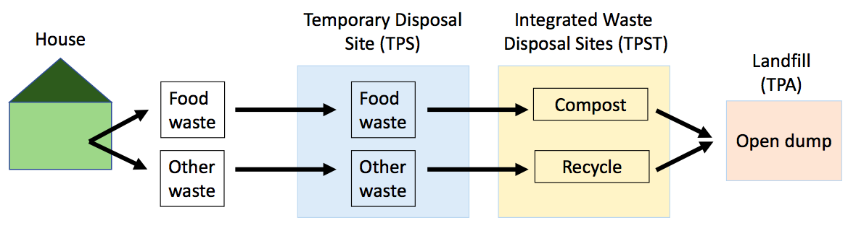
- Reference:

1 A. Aprilia, T. Tezuka, and G. Spaargaren, 2012. Waste management Household Solid Waste Management in Jakarta, Indonesia: A Socio-Economic Evaluation. (London: IntechOpen). Chapter 4, 71–100.

- G. Brigita, B. Rahardyan, 2013. Analisa pengelolahan sampah makanan di kota Bandung. Jurnal Teknik Lingkungan. 19(1): 34–45. Retrieved from https://ftsl.itb.ac.id/wp-content/uploads/sites/8/2018/06/4.-Gladys-Brigita-dan-Benno-Rahardyan.pdf on 25 January 2019.

- Ilham, 2010. Efektivitas sistem pengolahan sampah terpadu (TPST) pada perumahan Graha Asri Kendari. Jurnal Arsitektur. 1(1), 11 – 17. Retrieved from https://media.neliti.com/media/publications/221846-efektivitas-sistem-pengolahan-sampah-ter.pdf on 25 January 2019.

- Kementrian Lingkungan Hidup dan Kehutanan Republik Indonesia. 2018. Sistem Informasi Pengolahan Sampah Nasional. Jakarta. Retrieved from http://sipsn.menlhk.go.id/?q=3a-data-umum on 24 January 2019.

- Peraturan Menteri Dalam Negeri Nomor 33 Tahun 2010 Pedoman Pengelolaan Sampah Pasal 1 Ayat 10.

- Peraturan Menteri Dalam Negeri Nomor 33 Tahun 2010 Pedoman Pengelolaan Sampah Pasal 1 Ayat 11.

- Peraturan Menteri Dalam Negeri Nomor 33 Tahun 2010 Pedoman Pengelolaan Sampah Pasal 1 Ayat 12.

Biography:
Author 1:
Fatimah Syakura is currently taking undergraduate program on environmental health in Universitas Indonesia. She has been Indonesian delegate for International Islamic Cultural Connect at Osaka-Kyoto in October of 2018. She has also achieved second place on a prefectural essay competition regarding mental health and food in the same month of 2018.

Author 2:
Edwina Bernita Sitorus is a student of Environmental Health in Universitas Indonesia. In 2018, she has been a delegate from a Non-Government Organization called “Youcan Indonesia” as a form of social action and expedition in Labengki, Sulawes. Now she is part of a student ambassador called “UTeam Microsoft” that is collaborating with Universitas Indonesia 2019.

Presenting author details
Author 1 :
Full Name: Fatimah Syakura
Contact number: 081314935790
Twitter account: -
Linked In account: Fatimah Syakura

Session name/ number: Food and Agricultural Waste Recycling/9
Category: Oral presentation
Passport Number: X401788

Author 2 :

Full Name: Edwina Bernita Sitorus
Contact number: 085716206461
Twitter account: -
Linked In account: Edwina Bernita Sitorus


Session name/ number: Food and Agricultural Waste Recycling/9
Category: Oral presentation
Passport Number: C0420465

