Abstract Template

Title: Recycling of post- consumer plastic packaging into cementitious composite

RAFENOMANANJARA Tsinjo Nirina, Tomoo SEKITO, Yutaka DOTE,
Department of Civil and Environmental Engineering, Waste management laboratory, Miyazaki, Japan

Keywords: plastic recycling, construction material, polyethylene terephthalate (PET), polyethylene (PE) and polypropylene (PP)

- Abstract Body (up to 300 words)

In African countries, post-consumer plastic packaging has become a challenge in terms of marine pollution by dumping of plastics; global warming gas generation by incineration of plastics technologies sustainability. Some cities with more than one million inhabitants still have only small landfills, while the size of the population involves huge amounts of waste. In case of Madagascar, municipalities collect post-consumer plastic waste composed of different types of dirty polymers with other wastes.
Among the various types of recycling management approaches, the reuse of waste and recycled plastic material in the construction sector is considered an ideal method for disposing plastic waste (Gu & Ozbakkaloglu, 2016).
This present work aims to assess the construction material using plastic packing waste as a replacement of cement in a concrete and evaluate the mechanical and physical properties of the product. Thus, the methodology is easy to implement and appropriate to the local context in Madagascar.
- Image:

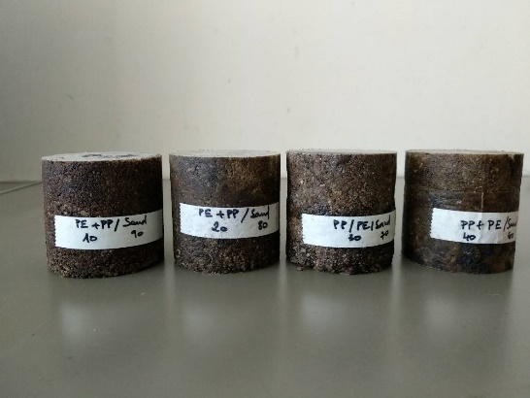
- Reference:

- Azhdarpour, A. M., Nikoudel, M. R., & Taheri, M. (2016). The effect of using polyethylene terephthalate particles on physical and strength-related properties of concrete; A laboratory evaluation. Construction and Building Materials, 109, 55–62.
- Gu, L., & Ozbakkaloglu, T. (2016). Use of recycled plastics in concrete: A critical review. Waste Management, 51, 19–42.
- Mahdi, F., Abbas, H., & Khan, A. A. (2010). Strength characteristics of polymer mortar and concrete using different compositions of resins derived from post-consumer PET bottles. Construction and Building Materials, 24(1), 25–36.

Biography:
RAFENOMANANJARA Tsinjo Nirina has completed his master’s degree in Chemical engineering at the age of 23 years from Polytechnics School - University of Antananarivo, and studies at University of Miyazaki about Civil and Environmental engineering. She worked in an oil company, then construction company as engineer before continuing her study in Japan.

Presenting author details


Full Name: RAFENOMANANJARA Tsinjo Nirina
Contact number: 070 4305 5399
Twitter account:
Linked In account: Tsinjo rafenomananjara
Session name/ number:
Category: Oral presentation
Passport Number: A13Y351393MDG

