Title: Problems and Potentials of Composting from Organic Solid Wastes in Khulna City

T. K. Roy¹, I. F. Easha², T. Mazumder³
¹Assistant Professor, Department of Urban and Regional Planning, Khulna University of Engineering& Technology, Khulna, Bangladesh.
²MURP Student, Department of Urban and Regional Planning, Khulna University of Engineering& Technology, Khulna, Bangladesh.

³Urgraduate Student, Department of Urban and Regional Planning, Khulna University of Engineering& Technology, Khulna, Bangladesh.

Keywords: Organic solid waste, composting, agro-forestry nursery, urban agriculture, Khulna city

Abstract
Khulna, the 3rd largest industrial city of Bangladesh has 1.5 million people in its 45.65 sq. km. area. It produces about 520 tons of solid wastes per day, of which 75% is organic and suitable for compost. Among the 10 NGOs of Khulna City, Prodipan, RUSTIC, Samadhan and SPS were involved in recycling organic wastes into compost during 1998-2010. But, at present only RUSTIC produces about 30 ton compost per month in its small plant on 0.47 acre land. There are 110 agro-forestry nurseries in Khulna city and its outskirts, of which only a few use compost. Applying compost in such nurseries, urban agriculture, green space plantations etc. will potentially reduce the volume of municipal waste, increase agro-forestry-agricultural productivity and create a healthy environment. Non-segregation of organic wastes mostly at household level; complexity of getting permission from government for the production and marketing of compost; lack of assistance from concerned departments; lack of space for the NGOs to establish compost plant; lack of fund to run and extend composting initiatives both for KCC (Khulna City Corporation) and NGOs etc. are the problems of composting initiatives in Khulna. Every day produced 400 tons of organic wastes; great demand of compost by agro-forestry nurseries, urban agriculture, green space plantations; existence of huge i.e.71 acre land under 3 landfill sites owned by KCC as space for future compost plants; significant number of NGOs in waste management may come forward for composting; existence of policies for improved municipal solid waste management, organic farming, climate change mitigation and sustainable urban planning etc. are the potentials of composting in Khulna City. KCC, NGOs, Universities and R & D organizations can undertake project and research on composting, their management and sustainability issues. The government financing sectors and donors can support KCC and NGOs to run compost plants.

Images

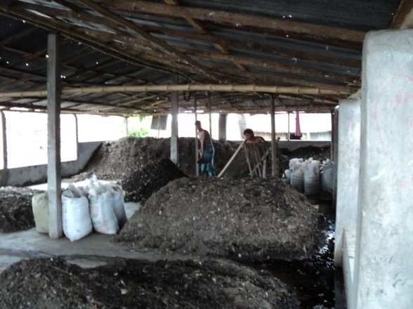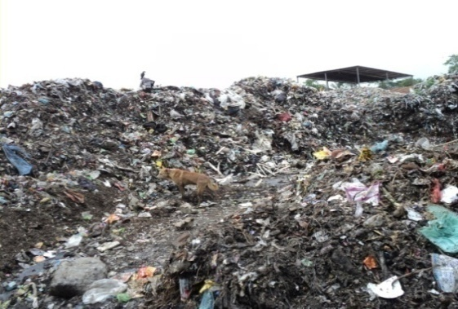
Figure 1: Unattended organic waste potential for composting (left) and composting by RUSTIC at Rajbandh landfill site (right)

Reference:
- Roy, T.K., Socio-economic, Environmental and Health Sustainability of the Children Involved in NGO-CBO Operated Municipal Solid Waste Management System of Khulna City, WasteSafe 2011, 2nd International Conference on Solid Waste Management in the Developing Countries, Khulna, Bangladesh.
- Roy, T. K., Rahman, S. and Dev, P. K., (2013) “Compost Fertilizer from Municipal Solid Wastes and its Application in Urban Agro-forestry Nurseries: A Case Study on Khulna City” Journal of Bangladesh Institute of Planners, BIP, Dhaka, Bangladesh, Vol. 6., pp. 191-199.
- Roy, T. K., Haque, S. M., Hossain, S. T., Islam, T., & Sikder, S. (2018). Prospect of Climate Mitigation by Integrated Solid Waste Management: A Case Study of Khulna City, Bangladesh. In S. K. Ghosh (Ed.), Waste Management and Resource Efficiency. Springer Nature Singapore.

Biography:
Tusar Kanti Roy is an Assistant Professor in the Department of Urban & Regional Planning (URP) of Khulna University of Engineering & Technology (KUET), Bangladesh since 2011. He completed his Master of Urban and Rural Planning (MURP) and Bachelor of Urban and Rural Planning (BURP) from Khulna University. He has more than 20 years work experience in teaching, research and development. He has published 30 research papers including 13 papers on solid waste management (SWM) in reputed journals and international conference proceedings. His research areas of interest are waste management, sanitation, urban planning and environment.

Presenting author details
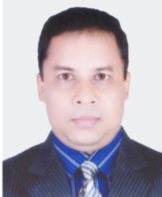

Full Name: Tusar Kanti Roy
Contact number: +8801716717443
Email: tusarkroy@urp.kuet.ac.bd
Session name/number:
Category: Oral presentation
Passport Number: BA0489855

